An Introduction to InScribe 6

An Introduction
InScribe 6 includes all of the functionality you have come to know and love in InScribe 4, presented in an organized ribbon menu layout for more intuitive navigation throughout the application with enhanced application performance. AutoText and user dictionaries will be copied from InScribe 4 to make the transition as smooth as possible. Most shortcut keys have remained unchanged, but with the introduction of a Jump feature, some navigational shortcuts are no longer available or have changed.

Requirements

Operating Systems – Windows 7 or higher is recommended
- Windows Vista
- Windows 7
- Windows 8

Web Browsers – Internet Explorer 10 or higher is recommended
- Internet Explorer 9 or higher

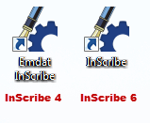
Getting Started
InScribe 6 can be installed independently or concurrently with InScribe 4. The desktop icon looks the same between both versions, but the labels are slightly different. InScribe 4 is labeled as Emdat InScribe and InScribe 6 is labeled as InScribe, by default. Though both versions can be installed and running at the same time. We do not recommend logging into both versions at the same time with the same username. Logging into InScribe 6 requires the same credentials used in prior versions of InScribe.

Ribbon Menus
The most visual change in InScribe 6 is the new ribbon menu. All features and options have been logically organized into six tabs within the ribbon menu to help you quickly find the commands you need to complete the transcription.

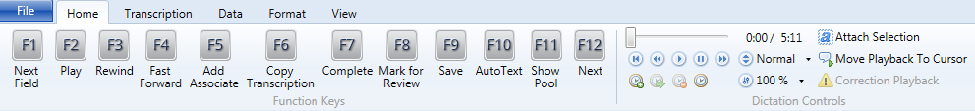
Home tab

The Home tab is the default tab that opens upon logging into InScribe. It includes the configurable Function keys and the dictation playback controls and, typically, contains the most frequently-used controls for transcribing or editing in InScribe.

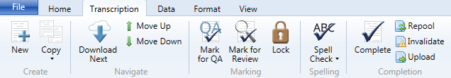
Transcription tab

The Transcription tab includes all options related to a transcription document as a whole. This includes creating new transcriptions, downloading new work from your pool, marking transcriptions for QA or Review and completing transcriptions.

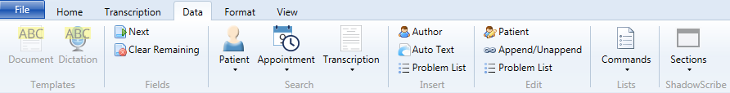
Data tab

The Data tab houses all options related to data attached to transcriptions. You can find document and dictation templates, navigate/delete template fields, search for patients, appointments or prior transcriptions, insert AutoText, and add/edit ShadowScribe sections.

Format tab
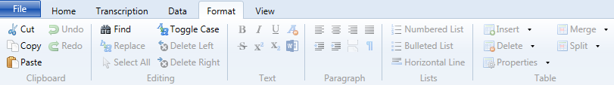
The Format tab includes all options related to editing and formatting transcription text. If you don’t know or can’t remember the shortcut for a given formatting command, it can easily be found on this tab.

View tab
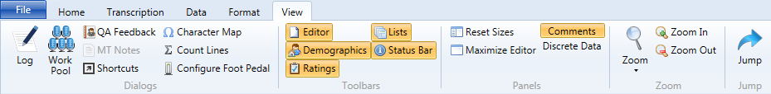
The View tab houses options to manipulate your view of InScribe and to open additional dialogs, such as your transcription log, work pool and QA Feedback. You can also open the Shortcut reference page and activate the Jump navigation feature.

File tab
The File tab includes options to save and preview transcriptions as well as open and back up your personal files. The Options menu is accessed here as well.

Options
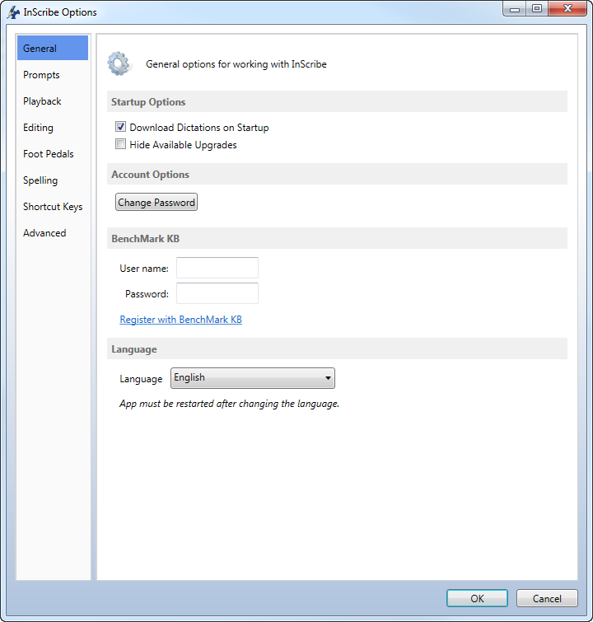
The Options window, accessible from the File tab, gives you access to settings and configurations applied throughout InScribe.

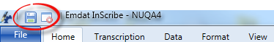
Quick Access Features

We have added two quick access buttons above the ribbon tabs to give you easy access to the Save and Stop Downloads features. Clicking on the Stop Downloads button will toggle downloads on and off.

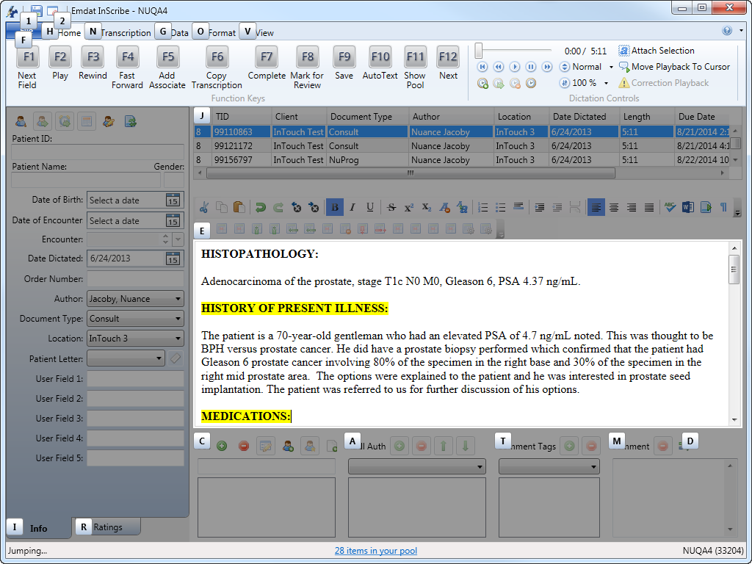
We also added a new jump feature which allows you to quickly navigate to any part of the application with only a couple of keyboard commands. Simply press the Alt+J keys to activate the jump shortcuts. Helpful shortcut labels will appear, allowing you to navigate to any area of the application without taking your hands off the keyboard. Type the corresponding letter or number to select the desired menu or application area. Subsequent shortcut letters will appear until you’ve selected the desired field or option in the application.

Creating a Help Desk Ticket
Should you come across any issues or concerns, we ask that you please create a help desk ticket. The easiest way to do this is by selecting the Help menu drop down located in the upper right corner of InScribe 6. Choose the Submit a Ticket option. Enter your contact information and details about the issue you experienced in the Comments section. Pressing submit will create a ticket and automatically attach required information, such as InScribe, IE and Windows versions as well as the current TID.

