Nuance ®

InSync v6
User Guide
August 2017

Nuance InSync
Nuance® Healthcare Solutions User Guide
©2017 Nuance Communications, Inc. All rights reserved. 2
Table of contents
Introduction 4
Requirements 5
1 Installing InSync 6
2 Starting InSync 10
3 System Tray Menu 11
3.1 Dictation Selections 11
3.2 Menu Tab Selections 11
3.3 Other Selections 11
4 Home 12
4.1 Login Menu 12
4.2 Internet Connection Monitor 13
4.3 Recording Dictation 13
4.4 Support Section 14
5 Recording with InSync 15
5.1 Appointment List and Functions 15
5.2 Search for a Patient Appointment 17
5.3 Record a Dictation 18
5.4 Demographics Tab: 20
5.5 History Tab: 21
5.6 Template Tab: 21
6 Dictation Log Tab 22
7 Devices Tab 24
7.1 Device Configuration 24
8 Manual Uploading 27
8.1 Upload Individual Audio File 27
8.2 Batch file 28

Nuance InSync
Nuance® Healthcare Solutions User Guide
©2017 Nuance Communications, Inc. All rights reserved. 3
9 Options Tab 31
9.1 Workstation Settings 31
9.2 Workstation Defaults 32
9.3 Recording Settings 32
9.4 Manage Logins 34
9.5 PACS 34
9.6 Security and File Name Options 37
9.7 My Favorites 38
10 Uninstall InSync 39
11 Support 39
Appendix 1 - Supported Recorders 40
Appendix 2 - InSync Supported Audio File Types 41
Appendix 3 - Installing Nuance PowerMic & Philips SpeechMike 42
Appendix 4 - Installing and Configuring a Foot Pedal 46
Appendix 5 - PACS XML Mapping Integration 47

Nuance InSync
Nuance® Healthcare Solutions User Guide
©2017 Nuance Communications, Inc. All rights reserved. 4
Introduction
InSync is a HIPAA-compliant application for sending encrypted voice recordings from supported hand-held digital recorders between the client and Transcription Company.
The InSync application resides on any PC or notebook computer and runs in the background as long as a computer is turned on, automatically uploading dictations from digital recorders to the Emdat servers. Clinicians don’t have to start the application or click anything. They simply dock the digital recorder and the secure transfer begins. Dictations are verified for completeness and then removed from the digital recorder, allowing the clinician to begin dictating again. A backup copy of all dictations is securely stored on the docking computer for 14 days by default. InSync is also capable of creating dictations on PCs equipped with a microphone.
For a quick start:
Appendix 1 lists the supported recorders.
- Most Olympus professional recorders released in the last 6 years are supported.
- Some older Olympus recorders require the Olympus software to be installed first.
- All supported Philips records require the Philips software to be installed first. Download and install the InSync software. See Section 1.
Log into InSync. See Section 4.1.
Configure a Recorder or Removable Media Device. See Section 7.1.
The rest of this manual addresses the advanced features that you can perform with InSync.

Nuance InSync
Nuance® Healthcare Solutions User Guide
©2017 Nuance Communications, Inc. All rights reserved. 5
Requirements
For InSync to work properly within your Windows environment, the PC must meet the following software and hardware requirements:
Minimum Requirements:
- Windows 7
- RAM: 1 GB (512 MB for Vista Home Edition)
- Hard Drive Free Space: 1 GB
- A monitor capable of displaying a resolution of 1024x768 pixels
- Internet access with IP Ports 80 and 443 open to initiate an Internet communication session.
Recommended Requirements:
- Windows 10
- RAM: 1 GB (32-bit) or 2 GB (64-bit) or more
- Hard Drive Free Space: 1 GB or more
- Sound Card with Speakers (or Stereo Headphones)
- A monitor capable of displaying a resolution of 1024x768 pixels or higher
- Internet access: High Speed Cable or DSL with IP Ports 80 and 443 open to initiate an Internet
communication session.
Please note: Macintosh computers are NOT supported.

Nuance InSync

Nuance® Healthcare Solutions User Guide
Read the license agreement, then check the 'I accept the terms in the License Agreement' check box. Click the Next button. | 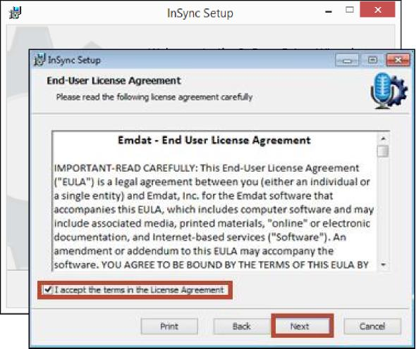

©2017 Nuance Communications, Inc. All rights reserved. 6
1 Installing InSync
On a network with multiple users, please make sure the Windows Login ID has install privileges. If unsure, please contact your PC support Staff. Download the InSync application from the Emdat Software page here:
https://www.emdat.com/software/insync.asp We recommend installing the most recent version.
Steps:
Click the option to Run the InSync Setup software.
Click Next to continue with the installation.

Nuance® Healthcare Solutions User Guide
Unless otherwise required by your IT department, keep the default installation path and click the Next button. | 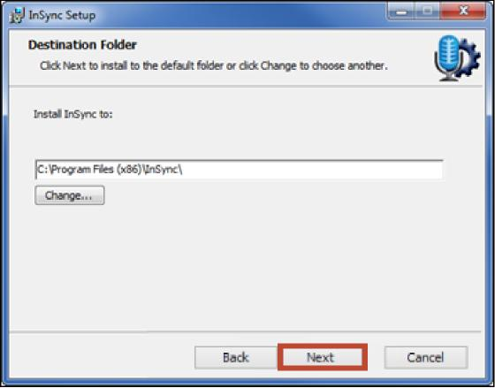

©2017 Nuance Communications, Inc. All rights reserved. 7
Nuance InSync  Unless otherwise required by your IT department, choose the option to Install for all users of this machine. Then click the Next button. | 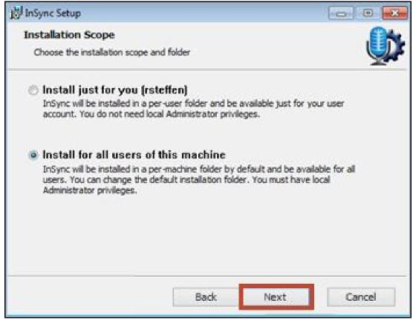

Nuance InSync

Nuance® Healthcare Solutions User Guide

Click the Install button.  InSync will now install automatically. | 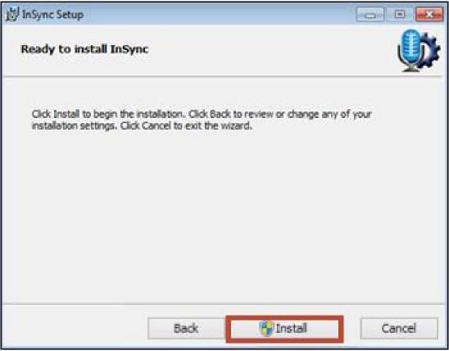

Based on how your User Account control is configured, if it asks whether you want to install the InSync software, click the Yes button.
©2017 Nuance Communications, Inc. All rights reserved. 8
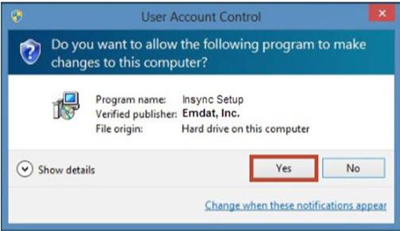

Nuance® Healthcare Solutions User Guide
Nuance InSync
If you will be using InSync to upload dictations from hand-held devices, we recommend that you enable:  - Launch InSync Now , and  - Start InSync with Windows. This starts InSync every time to start your PC.  Click the Finish button to complete the installation. | 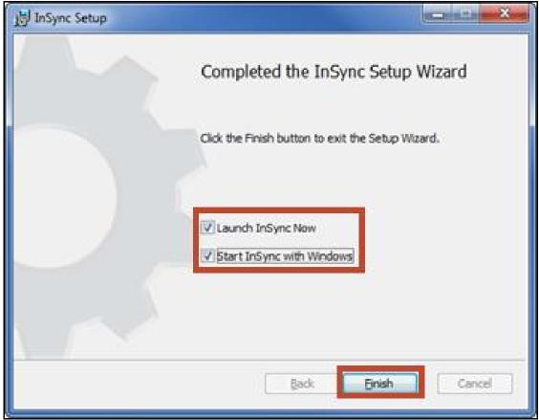

©2017 Nuance Communications, Inc. All rights reserved. 9

Nuance InSync
Nuance® Healthcare Solutions User Guide
©2017 Nuance Communications, Inc. All rights reserved. 10
2 Starting InSync
If you didn’t choose to “Start InSync with Windows” during installation (Section 1), you can manually start InSync
as you need it.  - Windows Vista or Windows 7  Start the program by clicking on Start button then expand All Programs. Choose the InSync folder and click on the InSync program. | 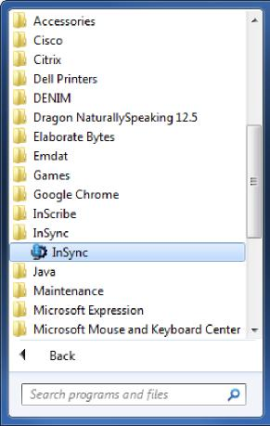
 | Windows 7 or earlier

- Windows 8  Click the Windows Button or press the Windows key.  Type “insync” on the Start screen and click on the InSync program. | 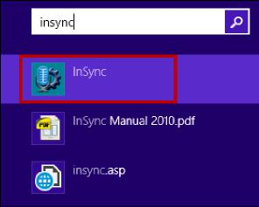
 | Windows 8

- If InSync is already running a small icon in the System Tray area will be present.
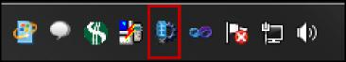

Nuance InSync
Nuance® Healthcare Solutions User Guide
3 System Tray Menu
When InSync is running, the InSync icon will display in the System Tray.
Click on the InSync icon in the System Tray to access shortcuts to InSync functions.

Please note:
- Several of the InSync functions require a user to be logged in for the function to work.
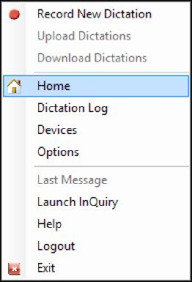
- InSync will automatically upload dictations from configured hand-held recorders without a user logged in.
3.1 Dictation Selections
- Record New Dictation: This shortcut will open the Recording tab of InSync (covered in Section 5).
- Upload Dictations: This shortcut will force InSync to send any files that are waiting to be uploaded.
- Download Dictations: This shortcut will force InSync to check any connected recorders for dictations waiting to be uploaded.
3.2 Menu Tab Selections
Menu selections link to four of the InSync tabs.

- Home: The Home tab provides an overview of InSync (covered in Section 4).
©2017 Nuance Communications, Inc. All rights reserved. 11
- Dictation Log: The Dictation Log provides a record of uploaded dictations (covered in Section 6).
- Devices: The Devices tab shows a list of connected devices that can be configured with InSync (Covered in Section 7).
- Options: Configuration settings for the InSync application are located on this tab (covered in Section 8).
3.3 Other Selections
- Last Message: This will display the last message InSync displayed, such as “Completed Uploads” or “Device Detected.”
- Launch InQuiry: A shortcut to the InQuiry website: https://www.emdat.com/inquiry/
- Help: This links to the Emdat ticket system: https://www.emdat.com/ticket/
- Logout: This logs you out of the user account you are using for InSync. Please note that InSync is still running in the background and will automatically upload dictations from supported hand-held recorders that have been configured with InSync. However, once logged out, many of the functions of the InSync application are no longer available.
- Exit: Closes the InSync application. The audio files from connect recorders will not be automatically uploaded to the Emdat servers.

Nuance InSync
Nuance® Healthcare Solutions User Guide
©2017 Nuance Communications, Inc. All rights reserved. 12
4 Home
The Home tab provides an overview of InSync and the status of any unsent dictations. To access all of the features on the Home tab a user must be logged into the application.
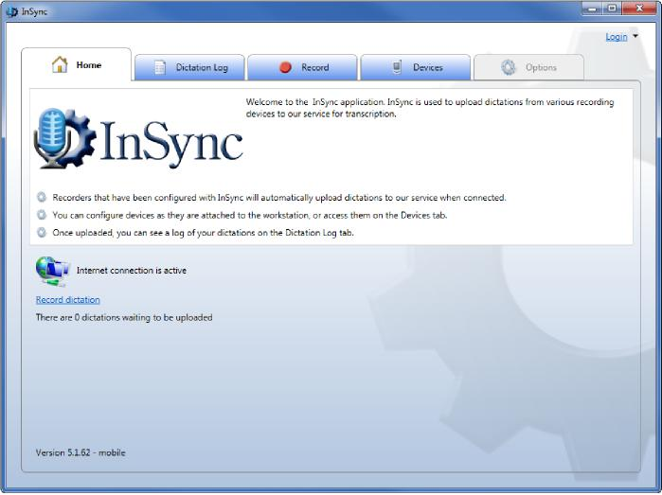
4.1 Login Menu  - Click on the Login link in the upper right hand corner of the InSync Home Tab and then the Login command. | 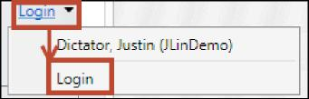

- On the InSync Login window, enter your Username, Password, and Client code. These are the same credentials as for InQuiry.  - InSync can remember your Usernames and Password on this PC although your facility may turn off the feature to remember your password. | 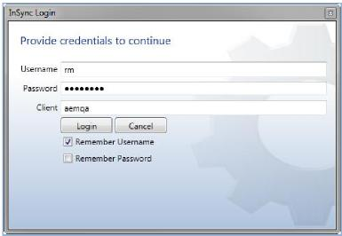

Nuance® Healthcare Solutions User Guide
Nuance InSync  - If any Usernames have been saved on this PC, a dropdown arrow to the right of the login link will contain the saved Usernames. | 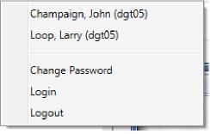

- Once logged in, a user can choose to logout by clicking on the down arrow and clicking Logout.  o Alternatively, you may right click on the InSync icon in the  system tray, then click Logout | 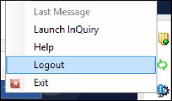

- Logged in users can also change their passwords. Please note that this also changes their password for InQuiry and Nuance Transcription Mobile.
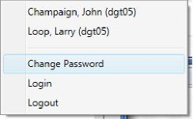
4.2 Internet Connection Monitor
The internet connection monitor verifies that InSync is connected to the internet and that the ports that InSync uses to transmit data are open. In order for InSync to communicate with the server, the Internet connection must register as active.
4.3 Recording Dictation

©2017 Nuance Communications, Inc. All rights reserved. 13
The home page contains a link to the Recording tab, as well as a quick view of any dictations that are on hold or waiting to be uploaded. Recording functions are covered in Section 5. | 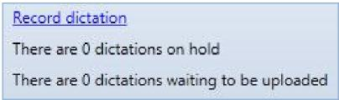

Nuance InSync
Nuance® Healthcare Solutions User Guide
©2017 Nuance Communications, Inc. All rights reserved. 14
4.4 Support Section
This provides quick links to InQuiry, the helpdesk telephone number, a link to the Emdat ticket system, and a link to this InSync Manual.

Nuance InSync
Nuance® Healthcare Solutions User Guide
©2017 Nuance Communications, Inc. All rights reserved. 15
5 Recording with InSync
Users can record a dictation with a PC-attached microphone by accessing the Record Tab in InSync. A user must be logged into InSync in order to use the features of the Record Tab. Their user account must also be configured to be a dictator.
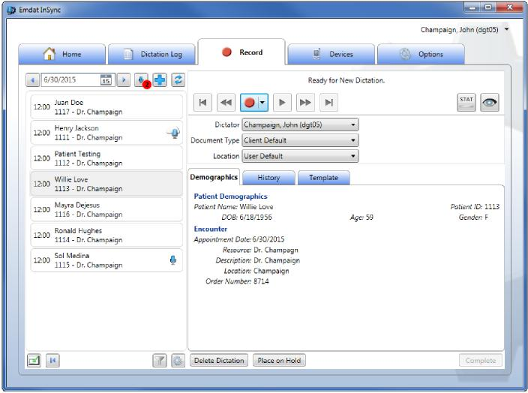
- Right click the InSync Icon in the system tray and select Record New Dictation
- Click the Record dictation link on the InSync Home Tab.
- Select the Record tab in the InSync application to begin recording.
5.1 Appointment List and Functions
The left half of the screen displays the dictator’s appointment schedule. Similar to the mobile application, the appointments will populate with the information sent to Emdat from the scheduling system used by the facility.
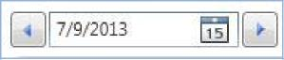 | Use the Left Arrow and Right Arrow buttons to decrease or increase the selected day by one. Type a date into the box, or select a date from the calendar by clicking the Calendar icon.

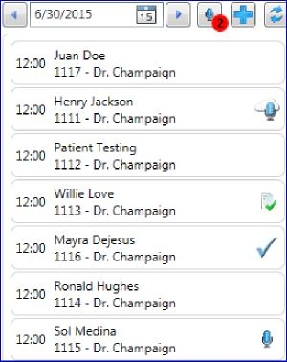 | The number in the red circle over the On Hold icon indicates how many dictations are on hold across all appointment days.  - Click the On Hold icon to display only dictations on hold. It shows on-hold dictations for all days.  - Click the On Hold icon again to display all appointments for the selected day.  - IMPORTANT: When you first enter the Dictation Tab, it will show you all On-Hold Dictations. Click the On Hold button to show today’s appointments.  A microphone icon indicates a dictation on hold which needs to be completed.

Nuance InSync
Nuance® Healthcare Solutions User Guide
©2017 Nuance Communications, Inc. All rights reserved. 16
The microphone over the cloud means a dictation was made on another device. That dictation cannot be accessed here.
The check mark indicates that a dictation has been made and uploaded for transcription.
The page with check mark indicates the transcription has been completed and is ready for review.
Click on an appointment to start the dictation process for that appointment.

Click the Add New Dictation button to start a dictation on a patient not on the Schedule. You can search for the patient in the demographic panel (see Section 5.2).
Click the Refresh button to get the most up to date Appointment list from the server.
The bottom of the Appointment List contains:
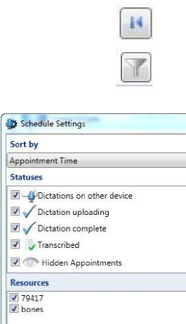

- Move to First Dictation: Move to the first (oldest) appointment date with a dictation on hold.
- Schedule Settings: click this icon to open up the Schedule Settings menu. Options
include:
- Sort By: Sort appointments by: Appointment Time, Patient Full Name, Patient Last Name then First Name, or Patient First Name then Last Name
- Statuses: Show appointments that have: Dictations on other Devices, Dictation Uploading, Dictation Completed, Dictation Transcribed, and Hidden Appointments.
- Resources: Display appointments based upon the Resource ID assigned to the appointment.
- Switch View: Click this button to display InSync in the minimized view so as to not clutter up your PC screen while dictating. If you do not have a microphone connected and enabled on your PC, the minimized view is not available.

Nuance® Healthcare Solutions User Guide
Nuance InSync
- Recording Settings: This button opens a dialog to adjust the recording options. These settings can also be accessed on the Options tab and are discussed in Section 9.3.

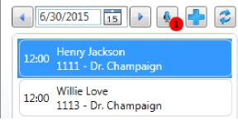 | Click on a patient appointment record to start the dictation process.  When an appointment is selected, the patient appointment details are displayed in the Demographics tab.

5.2 Search for a Patient Appointment
There are times when you may need to dictate on a patient that is not on your appointment list. For example:
- The mapping of appointments to resources and dictators are not set up in the Emdat platform.
- The patient appointment is with another doctor.
- The appointment schedule does not include who sees the patient.
NOTE: Many field labels on the Demographic tab are customizable. To start a Search, click on the Add New Patient button.

On the Demographics tab, enter the search criteria
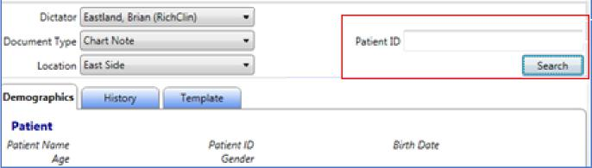
and click the
Search button. Note that the search field is customizable and may change, based on the selected document type. Or, you can just click the Search button.

Select a record in the search results and click OK. The Patient information updates the Demographics tab, then the Appointment search appears.
©2017 Nuance Communications, Inc. All rights reserved. 17
Select an appointment and click the OK button.
The Search Appointments window will close, and this appointment will be added to your list in InSync.

Nuance InSync

Nuance® Healthcare Solutions User Guide
©2017 Nuance Communications, Inc. All rights reserved. 18
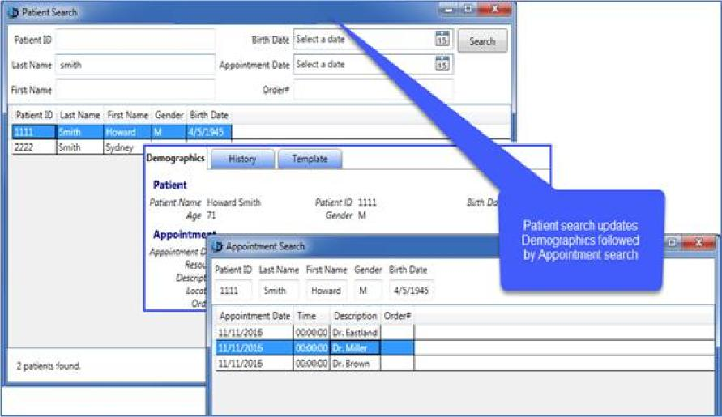
5.3 Record a Dictation
Select a patient from the Patient List.
• Or click the Add Patient button, then Search for a patient and add to your patient list. (Section 5.2).
- Or just click the Add Patient button. You will need to dictate the required Patient ID, name, appointment date, etc. in your dictation.
Select the dictator. Typically, only your name is available here. However, if your dictation account has been given ‘Proxy’ (allowed to dictate for another) to another account, select the appropriate account.
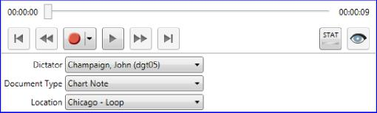
Select the Document Type and Location from the drop
down menu. These two lists show all the document types and locations that are available to you. You can shorten these lists by defining favorites in the Options Tab under My Favorites, described in Section 9.7.
Click the Record button to start your dictation.
- Slider Bar: This shows you where you are in playback mode, or where dictation will be inserted when recording. The number on the left is the time position into the recording. The number of the right is the total time of the recording.
- Jump to Start and Jump to End: Move the playback position to the beginning or end of the dictation.

Nuance® Healthcare Solutions User Guide
©2017 Nuance Communications, Inc. All rights reserved. 19
Nuance InSync  - Rewind and Fast Forward: Move the playback position backward or forward 5 seconds. This number can be changed in the Options Tab > Recording Settings (Section 9.3).  - Record: Record audio. Selecting the drop down arrow allows you to change how the record button behaves.  - Append Recording: New dictation is added to the end of the audio file when recording.  - Insert Recording: New dictation is inserted into existing dictation at the point indicated by the slider bar. No dictation will be overwritten or deleted.  - Overwrite Recording: New dictation is added to the point indicated by the slider bar. Existing dictation is overwritten. | 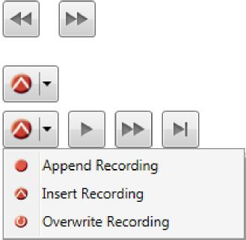
- Play: Plays the dictation from the current position.
- STAT: Make this dictation a STAT priority. STAT dictations are transcribed faster and may have an additional costs.
- Hide Appointment: Remove an appointment from the list. Hidden appointments can be viewed by displaying Hidden Appointments in the Schedule Settings. Appointments with a dictation cannot be hidden.
The recording buttons can be linked to specific hot keys on the keyboard for your convenience. This is especially important when using a foot pedal for hands-free recording.
It is also possible to configure Audio Cues to play during various stages of the recording process. These Shortcut Keys and Audio Cues can be configured in the Options tab (Section 9.2).
- Delete Dictation: Discards the recorded file. Note: It is not possible to retrieve a deleted dictation.
- Place on Hold: Holds the dictation for further changes. Dictations placed on hold will not upload to the Emdat server but are saved in an encrypted format on this PC.
- Complete: This button completes the current dictation and uploads it to the Emdat server.
If your recorder is not recognizing the sound input from your microphone, check to see if your microphone is set as the Default Recorder. Right click on the speaker icon on your Windows taskbar, and click Recording devices. | 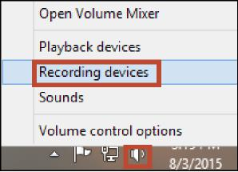

Nuance InSync
Nuance® Healthcare Solutions User Guide
Make sure that your microphone has some designation that says it is the Default Device. If set up properly, the bars to the right should react to any sound input. | 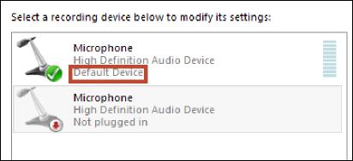

If your microphone is not the default device, right click on it and select Set as Default Device. Test the input by seeing if the green bars on the right react to your sound input. If the test works, it should work with InSync. | 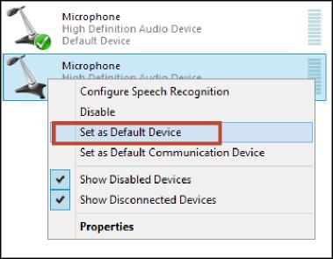

5.4 Demographics Tab: |  |  | Review the detailed patient and appointment information for the appointment you selected from the Appointment List.  o Or Enter a Patient ID and click the Search button to  start a search of the patient and appointments in the database. (Section 5.2).
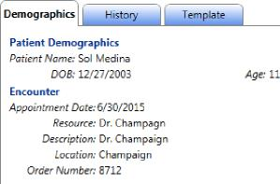

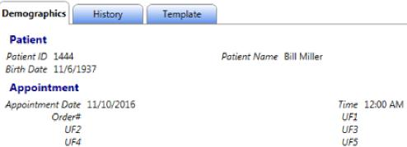
When a document type has a patient order display configured, the order information will appear within the demographics tab.

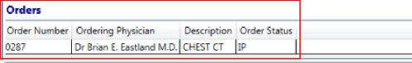
©2017 Nuance Communications, Inc. All rights reserved.
20

Nuance InSync
Nuance® Healthcare Solutions User Guide

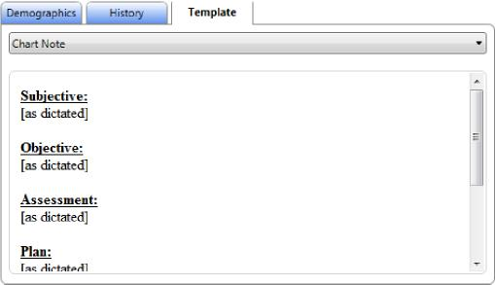 | The Template Tab will display the document template for the document type you have selected.  Click the drop down box showing the document type name to also see the dictation templates that are available for your use.

©2017 Nuance Communications, Inc. All rights reserved. 21
5.5 History Tab:
5.6 Template Tab:
View prior transcriptions for this patient. Clicking on the History Tab will display a list of prior transcriptions for the selected patient. Double click on a listed transcription to open it in a new window.

Nuance InSync
Nuance® Healthcare Solutions User Guide
©2017 Nuance Communications, Inc. All rights reserved. 22
6 Dictation Log Tab
InSync maintains a log of all dictations that have been uploaded to the Emdat servers. By default, the dictation log is saved for 14 days. This retention range can be adjusted in the Options Tab, under Workstation Settings (Section 9.1).
The Dictation Log allows a range of records to be displayed based on the date of dictation as well as for all dictators or a specific dictator. Results can be sorted by clicking on any of the column headings.
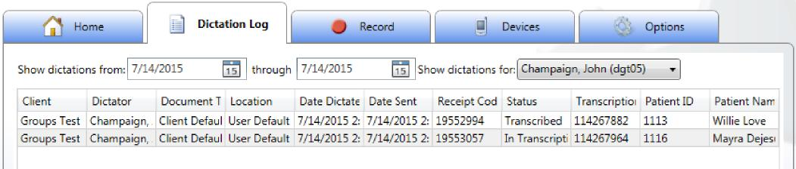
Two new columns have been added to the right of Patient Name: Account number and Order number (the client’s custom labels will be used). Clicking on the column title will sort the information in the log by that column.
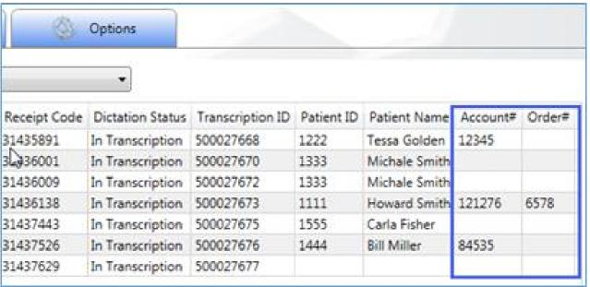
Available Options are:
Select a record from the Dictation Log and click the Save button. This will save an unencrypted
copy of the audio file to your PC. It will allow you to choose where to save it. This button is greyed out until the “Enable Dictation Saving:” option is enabled in Options > Security and File Name Options (Section 9.6).

Nuance InSync
Nuance® Healthcare Solutions User Guide
©2017 Nuance Communications, Inc. All rights reserved.
23
Select a record from the Dictation Log and click the Send to Support button. This creates
a Help Desk Ticket in the Emdat platform, encrypts the audio file and activity log for the audio file, and uploads them to be part of the ticket. It also creates the ticket in the name of the user signed into InSync.
If the internet connection was down when files were to be uploaded, then they are held in
queue for uploading in the future. If additional files are uploaded and the internet is available, then all queued dictation files are also automatically uploaded. However, if additional files are not processed, then the original files in queue are still in queue. If this occurs, click the Upload Dictations button to upload all dictation files held in queue.
Click the Print button to print this Dictation Log to a locally attached printer.

Click the Refresh button to immediately update the Dictation log. The log also auto refreshes every 5 minutes to show the latest results.

Nuance InSync
Nuance® Healthcare Solutions User Guide
©2017 Nuance Communications, Inc. All rights reserved. 24
7 Devices Tab
The Devices tab lists all of the connected devices that are compatible with the InSync application.
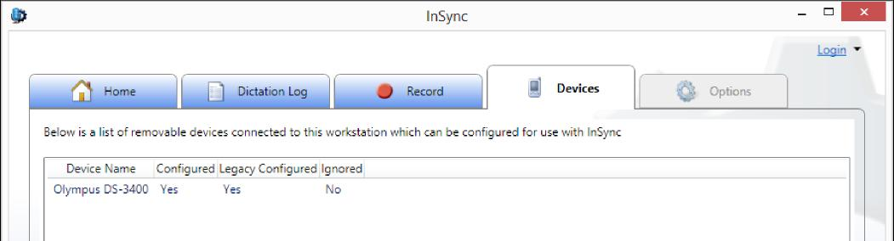
This displays all connected devices and their current InSync status.
- Device Name: Provides the name of the connected device when available. Not all devices can identify themselves to InSync. Those are displayed as “removable media” with an accompanying Drive letter.
- Configured: Indicates if the device has been configured for InSync version 5 or greater.
- Legacy Configured: Indicates if the device has been configured for InSync version 4.
- Ignored: Indicates if the device has been configured to be ignored by InSync. These devices are typically USB memory sticks that are not used with dictations. Ignored devices have two hidden files installed on them which are read by InSync when the device is plugged into the PC and InSync determines they should be ignored. This keeps the InSync from asking you to configure a device each type it is used on the PC.
7.1 Device Configuration
Almost any device with storage space that can connect to a PC as Removable Media can be configured to work with InSync. Available devices are displayed on the Devices Tab of the InSync User interface.
To configure a device, connect it to the PC with USB and open the Devices Tab. Select the device from the list and press the “Configure Device” button at the bottom of the screen.
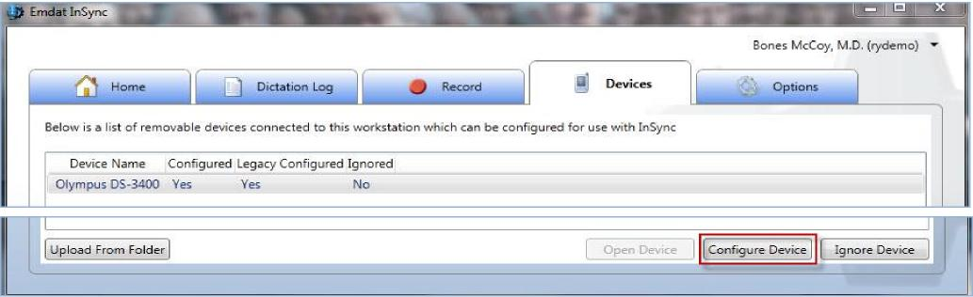

Nuance InSync
Nuance® Healthcare Solutions User Guide
©2017 Nuance Communications, Inc. All rights reserved. 25
Next, select the name of the provider that the recorder belongs to. The recorder can be configured to Always ask me for a user when I sync this device.
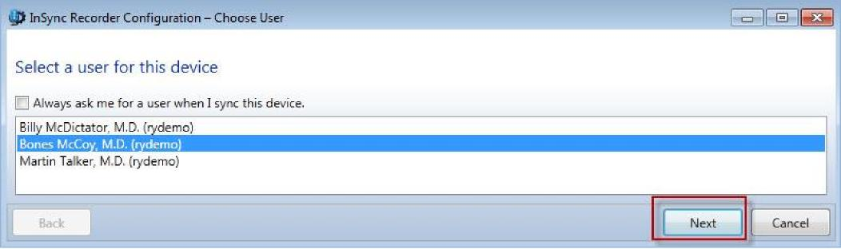
When this configuration is selected, a pop-up list of user names is displayed when the recorder is plugged into the PC. The user must select one name in order to upload the dictations.
Note: The names on this list are the users the logged in user has proxy access to, which is a configuration option in the client setup. Please talk to your implementation specialist for more details.
Next select the document types to be assigned to the recorder. The number of document types that can be assigned to a recorder varies based on the recorder model.
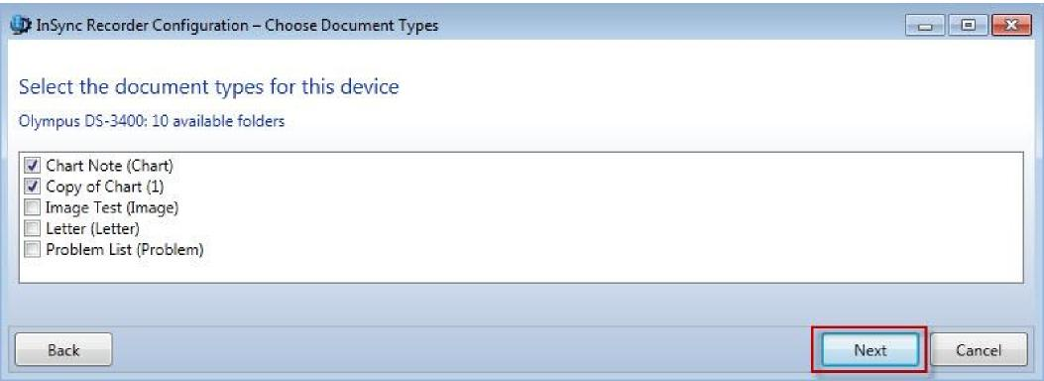
- The recorder configuration should only be assigned the document types that the user will be using.
o Each recorder model can save a different number of document types ranging from 3 to 99.
- You do not have to select the maximum number of document types.
- This list of document types is controlled by the signed-in user’s Document Security configuration. Document Security limits what document types are available for dictation for each dictator. Please see your administrator or MTSO for assistance with Document Security.

Nuance InSync
Nuance® Healthcare Solutions User Guide
©2017 Nuance Communications, Inc. All rights reserved. 26
Next select any additional options. There are four options for Location selection.
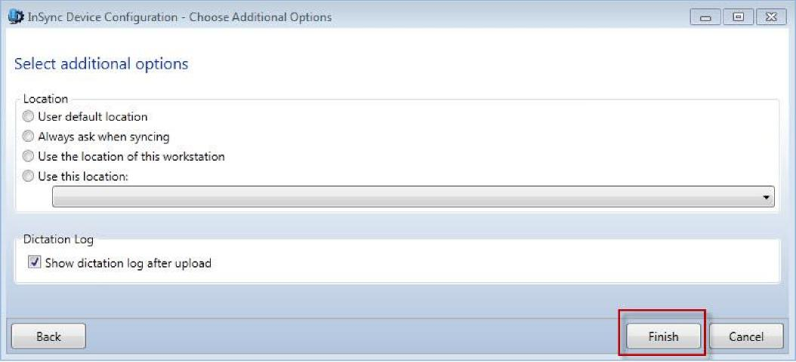
- User Default Location: This will use the default location as configured for the Dictator or the Client. This is the most commonly selected option.
- Always ask when syncing: A pop-up window asks the user every time this recorder is synced to select from a list of locations.
- Use the location of this workstation: Use the location specified in the InSync Workstation Defaults settings (Section 9.2) for on this PC.
- Use this location: Select a specific location to assign for all recordings from this recorder. Dictation Log option
- Show dictation log after upload: When enabled, the dictation log will automatically be displayed after the files have been moved from the recorder to the PC. As the files are uploaded to the Emdat servers, the receipt code and TID will be displayed on each record.
Click the Finish button to complete the configuration process.

Nuance InSync
Nuance® Healthcare Solutions User Guide
8 Manual Uploading
InSync has the capability to manually upload dictation files stored on the PC in two different ways. InSync can upload files individually, or in batch from a specified Windows folder.
8.1 Upload Individual Audio File  You need to be logged in to InSync to use this feature.  Step 1: Use Windows Explorer to find the audio file.  Right Click on the file to bring up the context sensitive menu. Select Upload with InSync.  Note: Please see Appendix 2 for list of supported audio formats. | 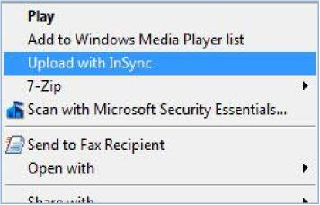

Step 2: If you are not already signed into InSync, you will get a login screen. Please log in to upload the audio file. | 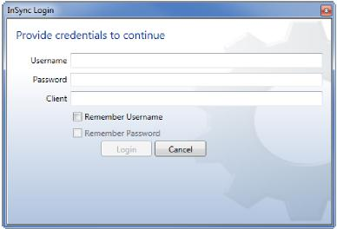

Step 3: Select the dictator from this list and click the Apply button.
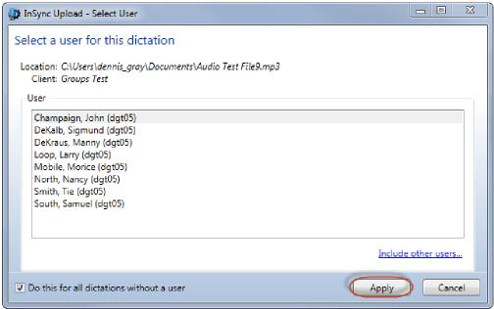
©2017 Nuance Communications, Inc. All rights reserved. 27
- Typically, there is only one name of this list; that is the name of the dictating user who is signed into InSync.
- InSync can be used by an administrator who does not have dictation privileges. The Administration User is given “Proxy” to specific Dictating Users. Proxy is a configuration option in the client setup. Please talk to your implementation specialist on how to accomplish this configuration. The administrator is now able to upload dictation files for specific dictators.

Nuance® Healthcare Solutions User Guide
Nuance InSync
Step 5: Select a Location for the dictation file to be uploaded and click the Apply button.  The dictation file is removed from the folder, encrypted, and queued to be uploaded. If an internet connection is available, the file will be immediately uploaded to the Emdat servers. | 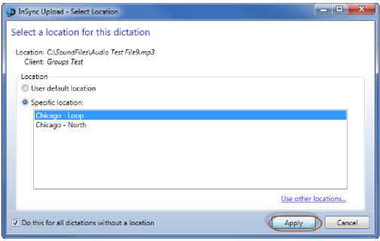

8.2 Batch file
Batch file uploading is available by navigating to the Devices Tab and selecting the Upload From Folder button. | 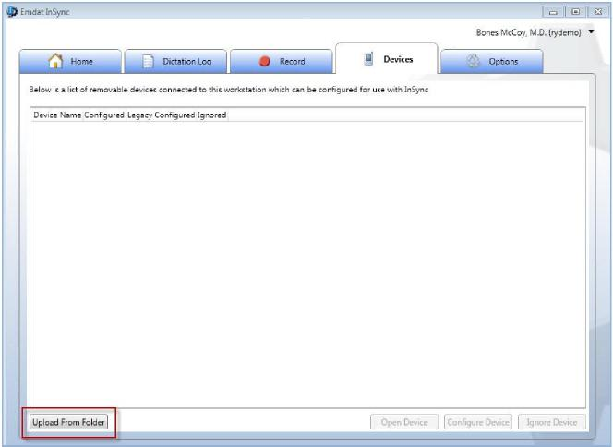

Step 4: Select a document type for the dictation file to be uploaded and click Apply.
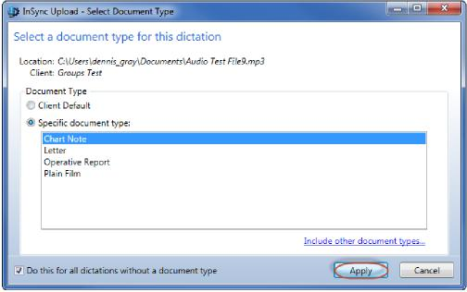
©2017 Nuance Communications, Inc. All rights reserved. 28

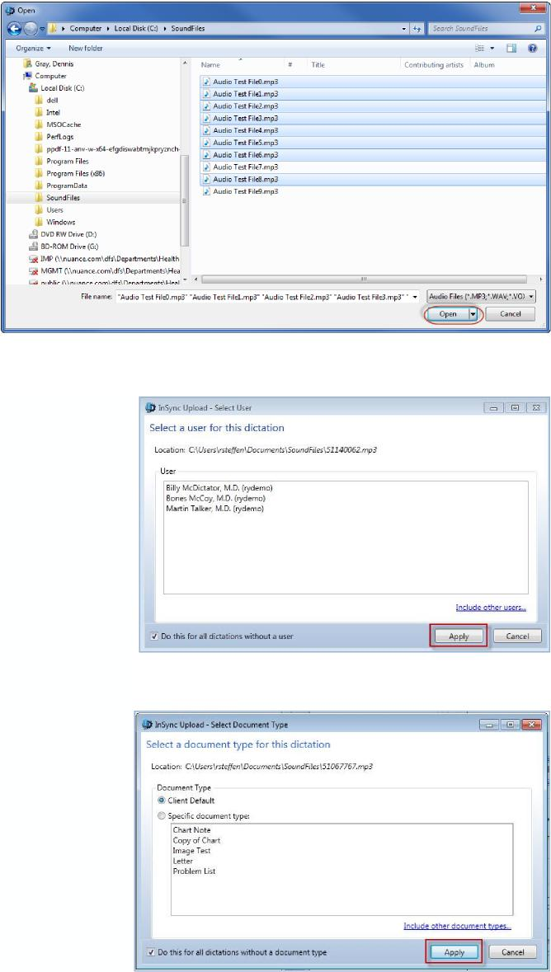
Nuance InSync

Nuance® Healthcare Solutions User Guide
Navigate to the Folder that contains the audio files.
Select files to upload:
- CTRL + A selects all files.
- Shift + Click selects files in a series.
- CTRL + Click select multiple individual files.
When the selection is complete, click the Open button.
Select a user as the dictator and click the Apply button.

Select the document type for these dictation files and click the Apply button.
©2017 Nuance Communications, Inc. All rights reserved. 29

Nuance® Healthcare Solutions User Guide
Nuance InSync
Select the Location for these dictation files and click the Apply button.  The files are removed from the folder, encrypted, and queued to be uploaded.  If an internet connection is available, the audio file are encrypted and uploaded to the Emdat servers. | 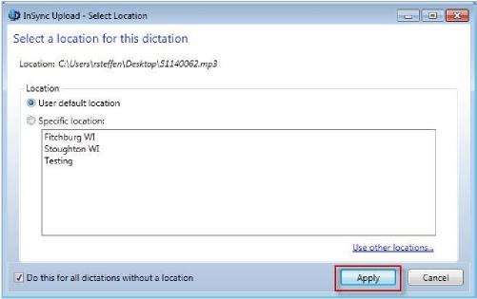

©2017 Nuance Communications, Inc. All rights reserved. 30

Nuance InSync
Nuance® Healthcare Solutions User Guide
9 Options Tab
9.1 Workstation Settings

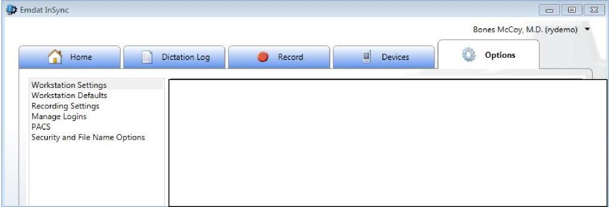
The Options Tab contains six configuration groups that allow you to customize how InSync behaves. These options are defined in detail as follows.
Please note that the displayed images includes the options default value.
Workstation Settings are specific to the local machine and allow you to configure startup options and retention times for log records and saved encrypted dictation files.
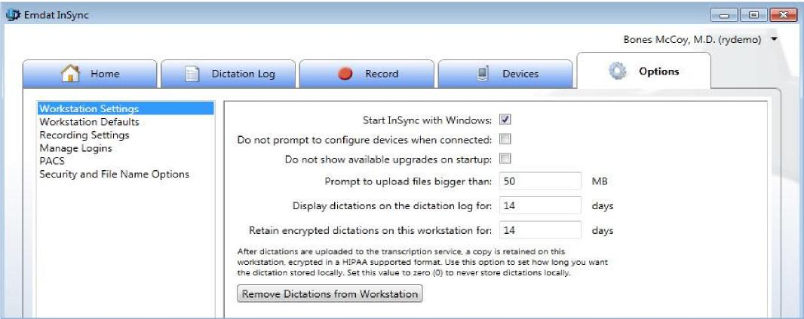
- Start InSync with Windows: Check this box to start InSync each time that Windows starts.
- Do not prompt to configure devices when connected: Check this box to suppress the pop-up window to configure a device each time they are connected to the PC via the USB port.
- Do not show available upgrades on startup: This will disable any notifications of newer InSync versions when starting InSync.
- Prompt to upload files bigger than __ MB: This triggers a warning message if a dictation file exceeds this number. Each MB represents 3 to 5 minutes of dictation. Files exceeding this limit may not be valid dictations. Very large audio files also present risks in getting them to successfully upload.
- Display Dictation on the dictation log for __ days: Set the number of days to retain the log entries of uploaded dictations.
- Retain encrypted dictations on this workstation for __ days: Set the number of days to retain copies of the uploaded dictation files in an encrypted format.
©2017 Nuance Communications, Inc. All rights reserved. 31

Nuance InSync
Nuance® Healthcare Solutions User Guide
- Remove Dictations from Workstation: Remove all saved encrypted dictation files from the Hard Disk Drive. This will also clear the Dictation Log.
9.2 Workstation Defaults
Workstation Defaults allows you to choose a default client and location for dictations uploaded from this PC. These options are not required, but can be used by the Record screen or by recorders that are configured to upload based on these settings.
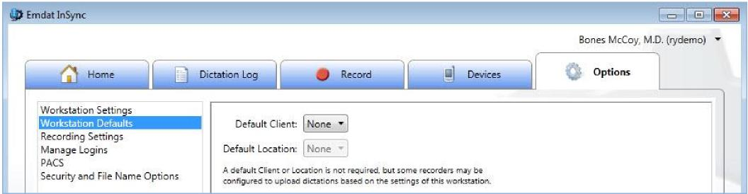
- Default Client: Specifies the client to assign to each dictation when uploading from a recorder if the recorder is configured to use this value.
- Default Location: Specifies the location to assign to each dictation when uploading from a recorder and the recorder is configured to use this value.
9.3 Recording Settings
Recording Settings configure the behavior of the InSync Record Tab found in Section 5 of this manual.
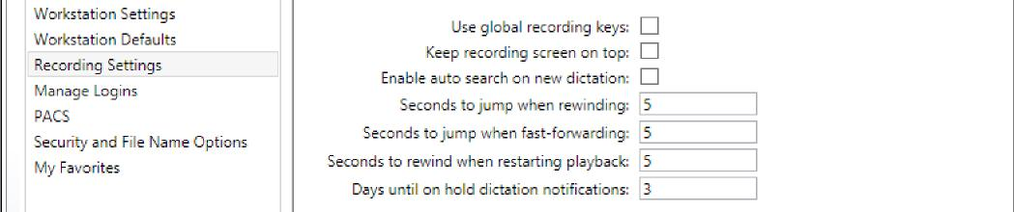
- Use global recording keys: Enabling this allows users to control the InSync recording application even when InSync is not the active window using the recording hotkeys. This allows dictators to use other applications while still controlling the recording in InSync.
- Keep recording screen on top: Checking this box will keep the InSync recording window on top of any other open application or window.
- Enable auto search on new dictation: When the “New Dictation” button is clicked and this option is enabled, InSync will display a pop-up window asking the user to enter patient information to use to search for a patient and appointment to assign to this dictation. If this option is disabled, no pop-up window automatically occurs. (See Section 5.2 to add a new dictation.)
©2017 Nuance Communications, Inc. All rights reserved. 32

Nuance InSync
Nuance® Healthcare Solutions User Guide
©2017 Nuance Communications, Inc. All rights reserved. 33
- Seconds to jump when rewinding: This defines how many seconds of dictation are skipped backward each time the Rewind button is clicked.
- Seconds to jump when fast-forwarding: This defines how many seconds of dictation are skipped forward each time the Fast Forward button is clicked.
- Seconds to rewind when restarting playback: Each time the recording is paused, the recording will start playback this number of seconds before the current playback position when the Play button is clicked.
- Days until on hold dictation notifications: The InSync user will receive a warning message when on on-hold dictation equals or exceeds this number of days.
Hot Keys allows the user to define the keyboard shortcuts for the various recording functions.
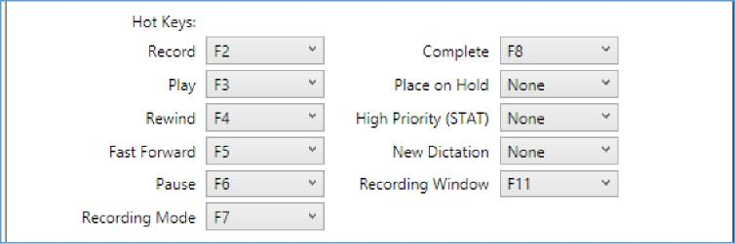
(Note: Due to Windows limitations, the F12 key may not be used.)
Use Audio Cues: This allows the user to redefine the sounds that are played when a specific action button is clicked (or the assigned “F” key is pressed).
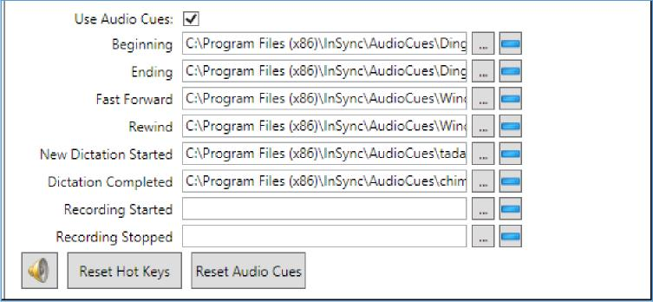
- Select File: Can be used to select a specific audio file to play for the Audio Cue.  - Clear File: Used to clear the selection of the sound file for the specific event and disable playing a sound.  - Sound Settings: The speaker icon is a shortcut to Windows audio settings applet. This will allow you to select your microphone and speakers.  - Reset Hot Keys: Click this button to reset the Hot Keys back to their default assignments. | 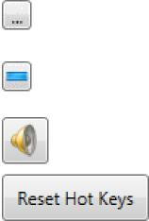

Nuance® Healthcare Solutions User Guide
©2017 Nuance Communications, Inc. All rights reserved. 34
Nuance InSync
- Reset Audio Cues: Click this button to reset the Audio Cues back to their default assignments.

9.4 Manage Logins
Users have the option to save their login IDs and passwords while using InSync. This information can be removed under the Manage Logins tab.
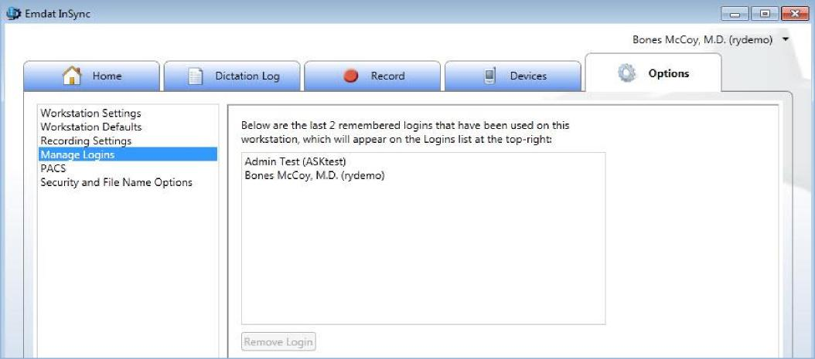
- Select the user’s name and click the Remove Login button. 9.5 PACS
InSync can be integrated with a Picture Archiving and Communication System (“PACS”) via the following two methods.
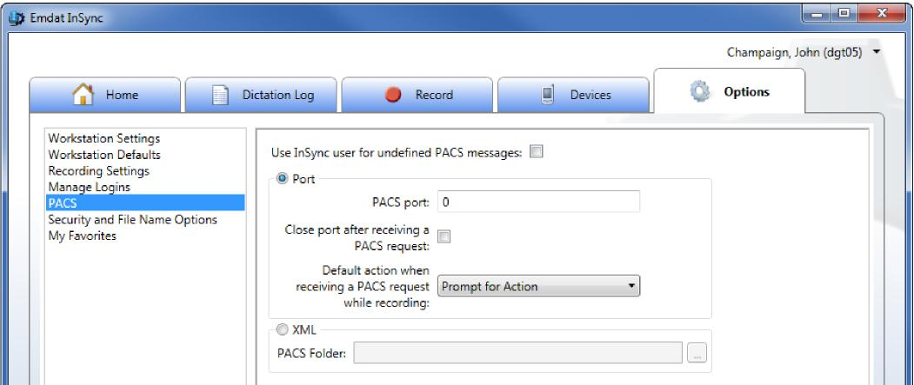

Nuance InSync
Nuance® Healthcare Solutions User Guide
©2017 Nuance Communications, Inc. All rights reserved. 35
This first method was developed over ten years ago and is included in InSync for backwards compatibility. The radiologist starts the dictation process by clicking on a dictation icon within the PACS while viewing an image. The PACS workstation connects to the IP and port that InSync is listening to. (The port number is defined in PACS port: field.) The message sent is a string in this format:
[USERNAME]|[PATIENTID]|[ORDERNUMBER1],[ORDERNUMBER2],[ORDERNUMBER3]
Once this string has been sent across to the IP port, the connection is expected to be terminated. This functionality is not meant for active connections. Once the connection is terminated, the InSync Recording Tab will appear for the radiologist to begin dictating. This process is repeated for each dictation.
USERNAME information: This is the Username for the dictator as defined in Emdat.
- It can be missing from the string although the pipe character (“|”) needs to be present to define the end of the Username field. In this case the “Use InSync user for undefined PACS messages:” option should be enabled. The dictation is then assigned to the InSync user who is logged into InSync.
Otherwise:
- If the received USERNAME matches to the account logged into InSync, it will map to that user appropriately.
- If the username matches to an account that the logged-in user has proxy to, it will map appropriately.
- Otherwise, it will bring up a dialog window with the username prefilled with the value sent.
PATIENTID information: The value received is used to look up the patient demographic by search on the Emdat Patient ID field. If found, the remaining patient information will populate the patient demographic information on the Record Tab > Demographic Tab.
ORDERNUMBER -If there is more than one order associated with the dictation, it must be sent in the string separated by a commas. If there is only one order, just the single order number will be necessary in the string.
- Order Number 1 is mapped to the Emdat Account field.
- Order Number 2, Order Number 3, etc. are placed in the Emdat User Field 4 field separated by commas.
Additional Options for this method include:
- Default action when receiving a PACS request while recording: Specifies what action InSync takes when it receives a PACS message while the user is recording a dictation with InSync. Options are:
- Prompt for Action: Ask the InSync user to place the current dictation on hold and start a new dictation for the last PACS message.
- Place on Hold: Place the current dictation on hold and start a new dictation based on the latest PACS message.
- Reject PACS dictation: Do nothing. Continue with current recording. Do not start a new dictation from the latest PACS message.
XML
The second method is for the PACS system to place an XML file on the PC running InSync.
The PACS Folder value defines the location of the folder for InSync to monitor.

Nuance InSync
Nuance® Healthcare Solutions User Guide
©2017 Nuance Communications, Inc. All rights reserved. 36
The file button is used to open up a dialog box to search the PC’s disk directory and find the location for the .XML files.
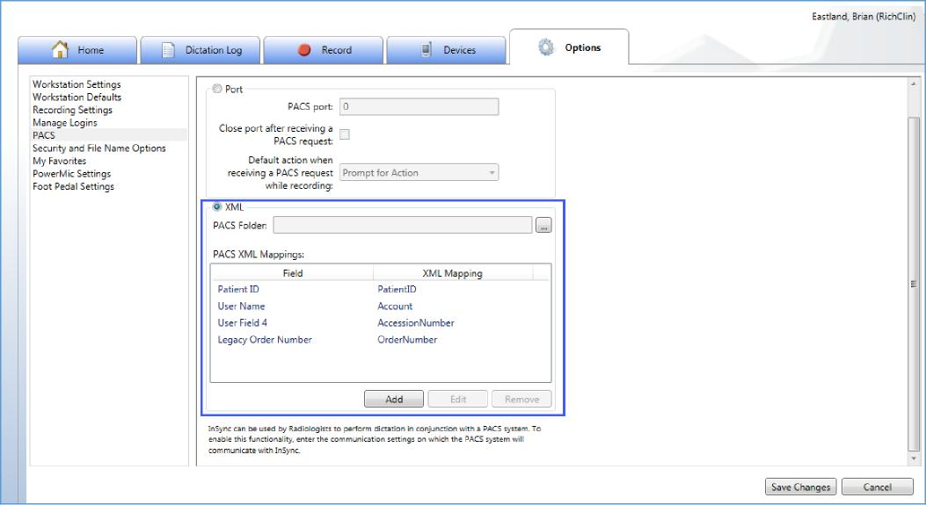
To work with this configuration, you must have a file definition from PACS. The definition must contain the XML fields you wish to map back to InSync.
- In the PACS Folder path, add the location to the PACS file on the PC.
- Use the PACS Mappings box to map the XML field to the InSync Field.
a. Click the Add button to add a new mapping.
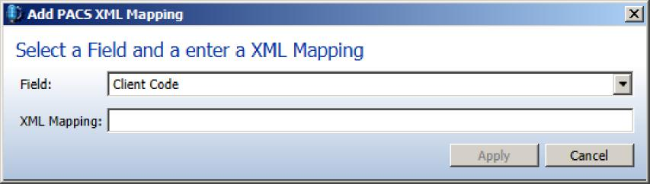
- Use the Edit button to edit an existing mapping.
- Use the Remove button to remove an existing mapping. NOTE: The order of the XML mapping to InSync fields does not matter.

Nuance InSync

Nuance® Healthcare Solutions User Guide
9.6 Security and File Name Options
After an audio file has been uploaded to the Emdat servers, it can be automatically saved on the user’s PC in the InSync folder. This feature is controlled in Options > Workstation Settings > “Retain encrypted dictations on this workstation for: __ days”. This option defaults to 14 days during installation, but can be adjusted to none (“0”) or a very large number of days.
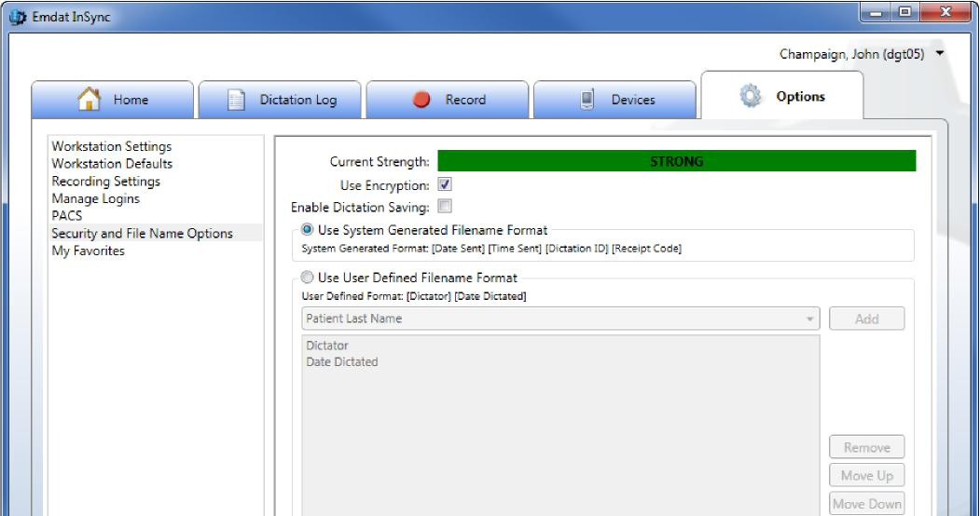
When encryption is enabled (it is enabled by default during installation), the folder is encrypted using 256-bit AES encryption. This folder cannot be read by any other PC application.
The Security and File Name Options customize how InSync stores files in the folder.
- Current Strength: This provides a summary of the privacy for audio files on the PC; both the Archive folder and unencrypted files saved by the user.
- Use Encryption: When enabled, any audio files saved in the Archive are encrypted with 256 bit AES encryption.
- If this option is disabled by the user, the action is recorded in the system logs on the Emdat Server.
- Enable Dictation Saving: If enabled, the user logged into InSync can save an unencrypted copy of the dictation to a storage device (e.g. hard disk, thumb drive) on the PC from the Dictation log.
- This setting does not affect the Security strength determination.
- If this option is enabled by the user, the action is recorded in the system logs on the Emdat Server.
- When the audio file is uploaded, it is saved within the InSync folder with a filename that is determined by the following radio button controls.
- Use System Generated Filename Format: File name is saved with these four values. Spaces separate each value. [Date Sent] [Time Sent] [Dictation ID] [Receipt Code].
- Use User Defined Filename Format: Allows users to define a custom file name.
- Select a Transcription demographic value (such as Patient ID or Patient Name) from the drop down box and click the add button to add that value to the file name.
©2017 Nuance Communications, Inc. All rights reserved. 37

Nuance InSync
Nuance® Healthcare Solutions User Guide
©2017 Nuance Communications, Inc. All rights reserved. 38
- Select any item it the large box and click the Move Up or Move Down button to change the order of the demographic value in the file name.
- (Note: Some options will reduce security strength, especially demographics that contain patients' identifying information.)
If Enable Dictation Saving is enabled, a user logged into InSync can go to the Dictation Log, select a log entry, and click the Save button. The dictation is saved to the PC in an unencrypted format using the file name convention established for the folder.
9.7 My Favorites
New appointments created in the Record tab will start with the Default Document Type and Default Location that are defined in My Favorites tab.
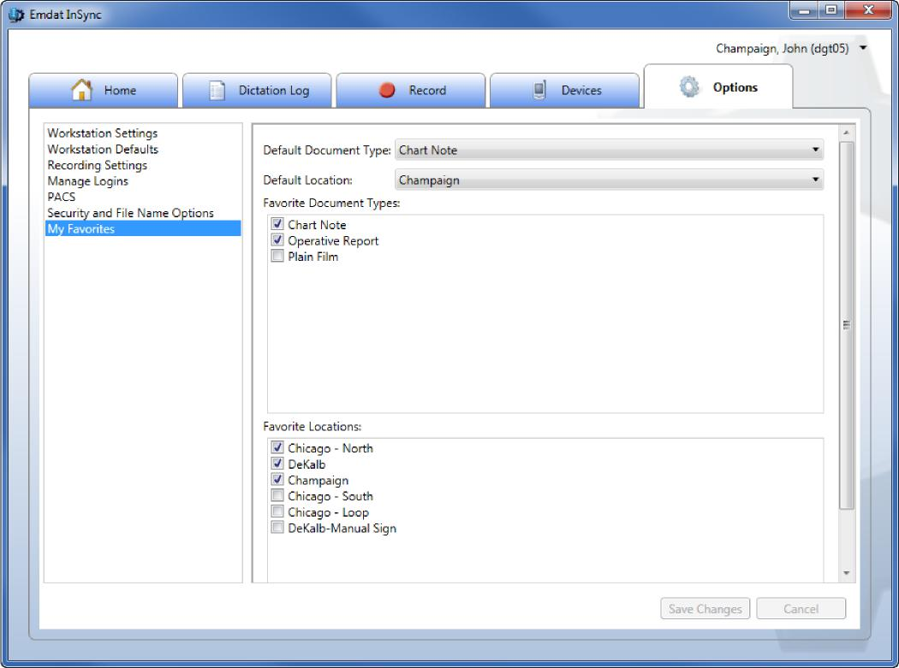
This tab shows all the Document Types and Locations that are available to the dictator. The user can control which Document Types and Locations show if the Demographic sub-tab of the Record tab.
- When a new dictation is started, the favorites only show in the Document Types and Locations drop-down controls.

Nuance InSync
Nuance® Healthcare Solutions User Guide
- Both controls also have a Show All as their last entry that if selected, will display all the available Document Types or Locations. When changed to “Show All” mode, the last entry becomes Show Favorites to change back to displaying only the Favorites.
Defaults and Favorites are saved by user account on each PC.
10 Uninstall InSync
On a network with multiple users please make sure the Windows Login ID has installing and uninstalling privileges. If unsure please contact PC Support Staff.
Windows Vista, Windows 7
- Click on “Start” button and select Control Panel.
- Click on Programs and Features.
- Right click on InSync and select the Uninstall command.
- (Note: InSync Installers can be deleted as well, if they exist for earlier versions of Windows and InSync)
- If you get a pop-up message asking “Are you sure you want to uninstall InSync?”, click the Yes button.

Windows 8
- Click the Windows icon on your taskbar or press the Windows key on your keyboard
- Type the word “uninstall” on the Windows start page to search for the Uninstall program. Click Uninstall a program.
- Right click on InSync and select the Uninstall command.

- If you get a pop-up message asking “Are you sure you want to uninstall InSync?”, click the Yes button.
©2017 Nuance Communications, Inc. All rights reserved. 39
11 Support
Please contact Nuance support if you need further assistance with InSync.

Appendix 1 - Supported Recorders
©2017 Nuance Communications, Inc. All rights reserved. 40
Please check with Olympus or Philips for the most up-to-date operating system support.
Recorder Name | Win Vista  (32 bit) | Win Vista  (64 bit) | Win 7  (32 bit) | Win 7  (64 bit) | Win 8  (32 bit) | Win 8  (64 bit) | Win 10 (32 bit) | Win 10 (64 bit)
Olympus Recorders
DS-2 | Yes | Yes | Yes | Yes | Yes | Yes | Yes | Yes
DS-330¹ | Yes | No | No | No | No | No | No | No
DS-660¹ | Yes | No | No | No | No | No | No | No
VN-702pc | Yes | Yes | Yes | Yes | Yes | Yes | Yes | Yes
DS-2200 | Yes | Yes | Yes | Yes | Yes | Yes | Yes | Yes
DS-2300 | Yes | Yes | Yes | Yes | Yes | Yes | Yes | Yes
DS-2400 | Yes | Yes | Yes | Yes | Yes | Yes | Yes | Yes
DS-2500 | Yes | Yes | Yes | Yes | Yes | Yes | Yes | Yes
DS-3000¹ | Yes | No | No | No | No | No | No | No
DS-3300 | Yes | Yes | Yes | Yes | Yes | Yes | Yes | Yes
DS-3400 | Yes | Yes | Yes | Yes | Yes | Yes | Yes | Yes
DS-3500 | Yes | Yes | Yes | Yes | Yes | Yes | Yes | Yes
DS-4000 | Yes | Yes | Yes | Yes | Yes | Yes | Yes | Yes
DS-5000 | Yes | Yes | Yes | Yes | Yes | Yes | Yes | Yes
DS-7000 | Yes | Yes | Yes | Yes | Yes | Yes | Yes | Yes
Philips Recorders
DPM-9350² | Yes | Yes | Yes | Yes | No | No | No | No
DPM-9370² | Yes | Yes | Yes | Yes | No | No | No | No
DPM-9380² | Yes | Yes | Yes | Yes | No  No | No  No | No | No
DPM-9400i² | Yes | Yes | Yes | Yes |  |  | No | No
DPM-9450² | Yes | Yes | Yes | Yes | No | No | No | No
DPM-9500² | Yes | Yes | Yes | Yes | No  Yes | No  Yes | No | No
DPM-9600² | Yes | Yes | Yes | Yes |  |  | Yes | Yes
SpeechMike³ | Yes | Yes | Yes | Yes | Yes | Yes | Yes | Yes
Nuance Recorders
PowerMic | Yes | Yes | No | Yes | Yes | Yes | Yes | Yes
PLEASE NOTE: Any recorder that connects to a Windows computer as a "Removable Drive" and records in a standard audio format can be configured and supported by InSync.
Please call the Help Desk at (800) 858-0080 for installation instructions on:
- (1) Olympus DS-330, DS-660, and DS-3000.
- (2) all Philips recorders
- (3) Installation instructions for the Philips SpeechMike are included in Appendix 3

Appendix 2 - InSync Supported Audio File Types
©2017 Nuance Communications, Inc. All rights reserved. 41
InSync supports the following file formats.
DSS | Audio file saved by a digital voice recorder or speech recognition program; stores voice audio data in a highly-compressed format; commonly used for professional transcript environments.
DS2 | A newer version of the DSS audio format.
MP3 | MP3 is popular compressed audio file format popular with digital music downloads. MP3 files are typically about one tenth the size of uncompressed WAVE or AIFF files, but maintain nearly the same CD-quality sound.
SRI | Audio file extension is used by Dragon NaturallySpeaking.
WAV | Standard digital audio file format used for storing waveform data; allows audio recordings to be saved with different sampling rates and bitrates.
WMA | Audio file compressed with Windows Media compression; proprietary format developed by Microsoft, similar to the .MP3 format; can be converted to other more standardized formats; often used for playing music from the Web.
MSV | Audio file format typically used by Sony Digital Recorders.

Nuance InSync
Nuance® Healthcare Solutions User Guide
©2017 Nuance Communications, Inc. All rights reserved. 42
Appendix 3 - Installing Nuance PowerMic & Philips SpeechMike
InSync is compatible for use with some specialized handheld microphones, such as the Nuance PowerMic and the Philips SpeechMike.
Nuance PowerMic
The Nuance PowerMic (formerly known as Dictaphone) can either be used as configured, or can be modified to use personalized settings.
To use as configured, you can usually just plug the device into your computer, and after a brief initial automatic installation, the buttons (such as record, play/stop, fast forward, rewind, and complete job) will be compatible for use with InSync’s Record tab functionality. Open the Record tab as usual, log in with a valid user/client, and use the buttons on the PowerMic to begin recording, in place of where you would usually click or use hotkeys to trigger the recording controls.
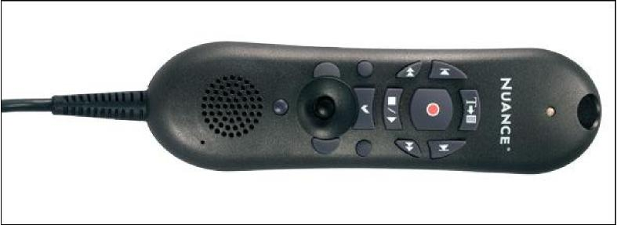
The following summarizes the automatic InSync button programming associated with PowerMic:
PowerMic Button | Image |  | InSync Function | Default Equivalent
Transcribe |  |  | Complete | F8
Dictate |  |  | Record | F2
Navigate Backward |  |  | To Start of Recording | -
Navigate Forward |  |  | To End of Recording | -
Rewind |  |  | Rewind | F4
Fast Forward |  |  | Fast Forward | F5

Nuance InSync
Nuance® Healthcare Solutions User Guide
©2017 Nuance Communications, Inc. All rights reserved. 43
Stop/Play |  |  |  | Toggle Playback | F3 (play) / F6  (pause)
Enter/Select | (left side) |  |  | Stat | -
Custom Left |  |  |  | On Hold/New | -
Custom Right | (right side) |  |  | Cycle Recording Mode | F7
Scan | (bottom) |  |  | Unused | -
Mouse Controls |  |  |  | Left Click, Mouse  control, Right Click | Mouse alternative

The PowerMic can also be manually configured. (The graphical display below shows the default functions. It is only for reference and does NOT change dynamically when a configured button option is changed.)
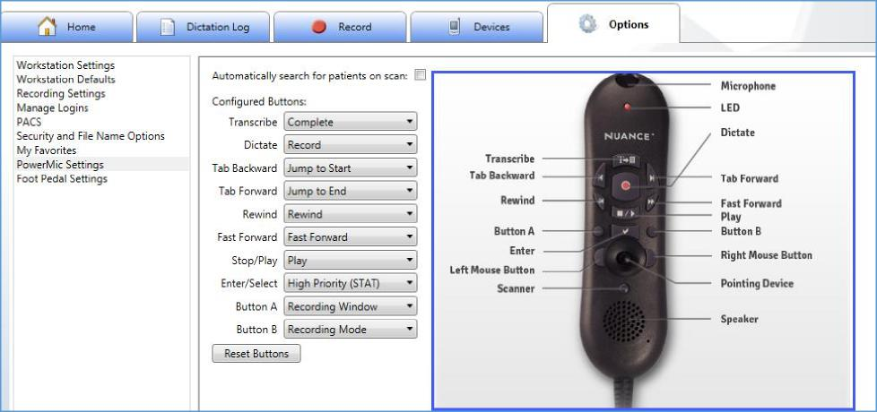
Search for Patients on Scan
When the 'Automatically search for patients on scan' box is checked, InSync will automatically run a patient search under the Record Tab. Use the scanner button to read a one dimensional barcode. The scanner will not work on 2 dimensional barcodes.
Note: Only the PowerMic II model has an optional scanner.

Nuance® Healthcare Solutions User Guide
Nuance InSync
The ID or information is automatically placed in the text box that has cursor focus.
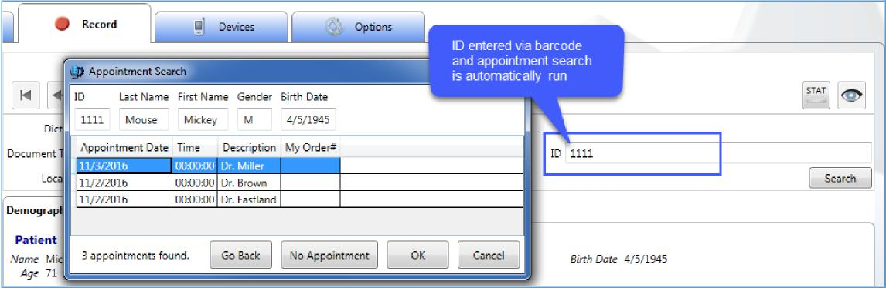
For additional support using the Nuance PowerMic, please refer to their official support documentation (http://www.nuance.com/healthcare/pdf/dsDNS10PowerMic.pdf)
©2017 Nuance Communications, Inc. All rights reserved. 44

Nuance InSync
Nuance® Healthcare Solutions User Guide
©2017 Nuance Communications, Inc. All rights reserved. 45
Philips SpeechMike and other Handheld Microphones
The Philips SpeechMike, and possibly other brands of handheld microphone, can be manually configured to similarly trigger the recording controls. To use the Philips SpeechMike with InSync, first you will need to install the Philips SpeechMike software onto your computer. Then you will need to go the Options tab > Recording Settings > Hot Keys (Section 9.3) to map the functionality of the record functions with specific keyboard hot keys. (Keeping the default settings is usually fine)
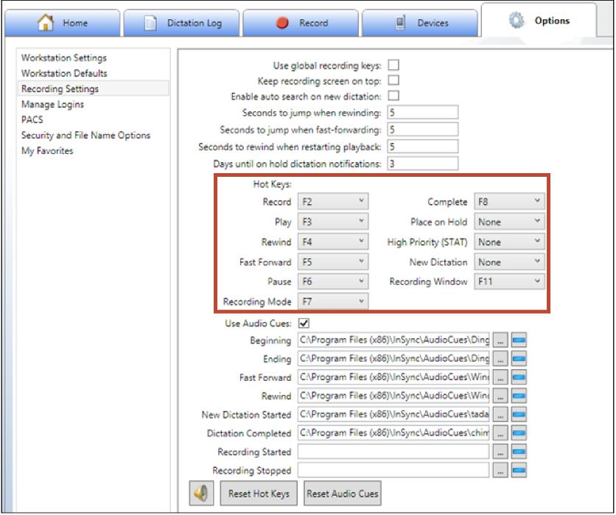
Within the Philips SpeechMike software, you will need to match the button functionality from the Philips device with the same Hot Key inputs in InSync. This can allow you to match the SpeechMike buttons with specific recording functions such as record and play. Please refer to your SpeechMike and Philips Device Control Center documentation for device-specific information on how this setup can be optimized.
For additional assistance with Speech Mike, or any other InSync setup, contact our Help Desk (Section 11).

Nuance InSync
Nuance® Healthcare Solutions User Guide
©2017 Nuance Communications, Inc. All rights reserved. 46
Appendix 4 - Installing and Configuring a Foot Pedal
Similar to the Philips SpeechMike, foot pedals can also be configured to respond to the F-keys (F1, F2, etc.) and linked to the same recording controls in InSync. This setup is becoming increasingly popular for clinicians who need to be able to record dictations while their hands are busy. The foot pedal would be used in conjunction with any Windows-compatible microphone that is plugged in to receive audio, and set up as the Default Recording Device on your computer. The key functionality required of the foot pedal is that it must be able to deliver hotkeys to the computer, as if the pedals were like duplicate keys of ones found on the keyboard.
You will need to go the Options tab > Recording Settings > Foot Pedal Settings to map the functionality of the record functions (Record, Play, FF, etc.) with pedals.
For foot pedal setup where the workstation is not near a computer, oftentimes foot pedals can be used to directly control the record features of a recorder. After recording, the recorder can be connected to InSync on the computer to automatically upload dictations (when already configured). This uses the InSync software only during upload. Please see your documentation for your recording device and your foot pedal hardware for information about if this configuration may be possible when appropriate for your workflow.
To configure the foot pedal, press it and choose a corresponding action.
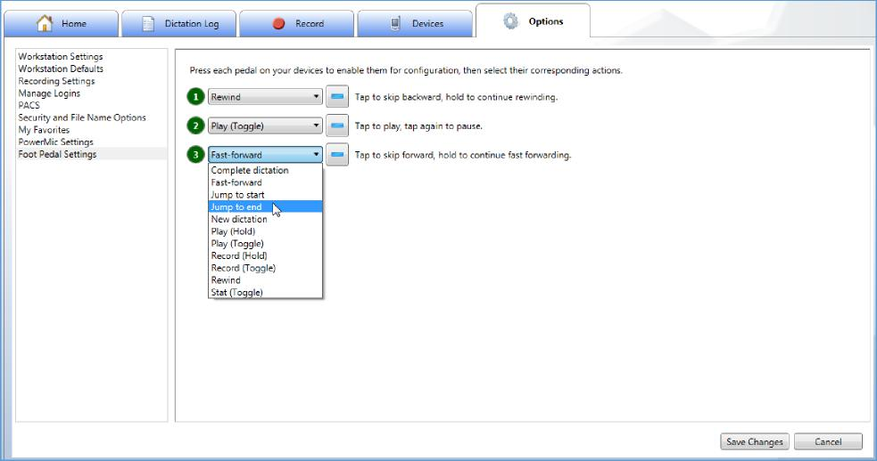

Nuance InSync
Nuance® Healthcare Solutions User Guide
©2017 Nuance Communications, Inc. All rights reserved. 47
Appendix 5 - PACS XML Mapping Integration
InSync now supports XML mappings to PACS, providing a more convenient method for setting up PACS XML mappings.
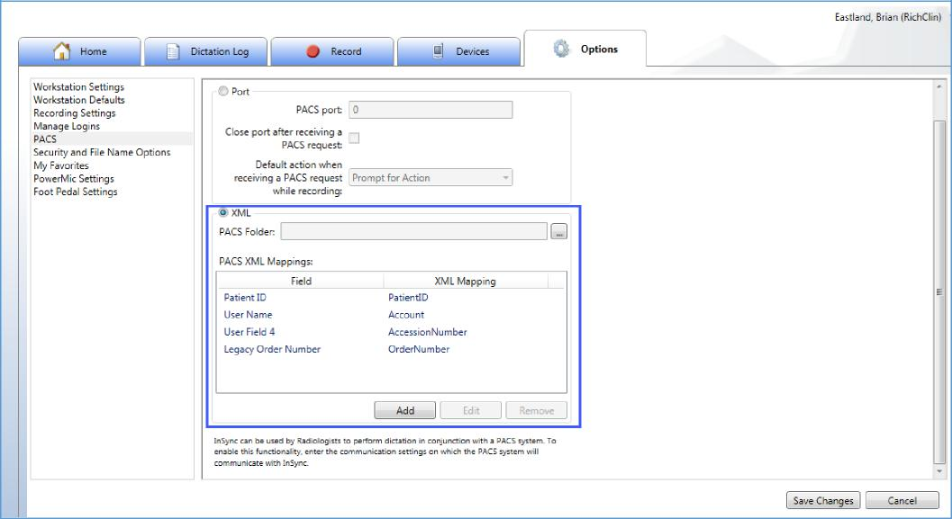
To work with this configuration, you must have a file definition from PACS. The definition must contain the XML fields you wish to map back to InSync.
- In the PACS Folder path, add the location to the PACS file on the PC.
- Use the PACS Mappings box to map the XML field to the InSync Field.
a. Click the Add button to add a new mapping.
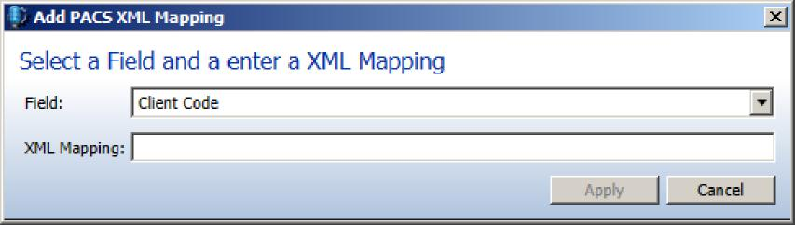
- Use the Edit button to edit an existing mapping.
- Use the Remove button to remove an existing mapping.
NOTE: The order of the XML mapping to InSync fields does not matter.

eserved
Copyright © 2017 Nuance Communications, Inc. All rights reserved. Nuance, and the Nuance logo, are trademarks and/
48
or registered trademarks, of Nuance Communications, Inc. or its affiliates in the United States and/or other countries. All other brand and product names are © 2013 trademarks Nuance or registered Communications, trademarks of Inc their All rights respectiv reserved.companies.

