InScribe 6 User's Guide

Table of Contents
Table of Contents 2
Introduction 3
Highlights of InScribe include: 3
Requirements 4
1. Installing InScribe 5
2. Using InScribe 6
2.1 Login 6
2.2 Download Dictations 7
2.3 Function Keys 8
2.4 Info Pane 9
2.5 Print and Document Template Demographics 10
2.6 Carbon Copies 11
2.7 Additional Authenticators 11
2.8 Comments and Comment Tags 12
2.9 File Tab 12
2.10 Home Tab 13
2.11 Transcription Tab 14
2.12 Data Tab 14
2.13 Format Tab and Editing Window 17
2.14 View Menu 18
2.15 Advanced Table Functions 21
3. Options 22
3.1 General 22
3.2 Prompts 23
3.3 Playback 23
3.4 Editing 24
3.5 Foot Pedals 25
3.6 Spelling 27
3.7 Shortcut Keys 27
3.8 Advanced 28
4. AutoText 28
4.1 Adding and Removing Entries 29
4.2 Quick Add Feature 29
4.3 AutoText Editing 29
4.4 Fields and Functions 29
5. Rating a Transcription in InScribe 30
5.1 Rating Process 30
5.2 Let QA Decide / Feedback Only 31
6. Reviewing Feedback 31
6.1 Navigating the Feedback List 31
6.2 Transcription Feedback 32
6.3 Score Card 33
7. The Quick Access Toolbar 34
8. Help Menu 34
9. Removing InScribe 35
10. Support 36
11. A Note on Performance 36

Introduction
InScribe is a HIPAA-compliant typing application designed by transcriptionists for transcriptionists.
InScribe is a single, integrated application with sections (demographics, body, cc, signatures, comments, etc.), designed for heads down production. You have everything at your fingertips — demographics, referring physician information, AutoText (word expander), spell check — and can easily and quickly complete a quality document. Over the course of many years InScribe has grown into a tool that helps you produce a higher number of lines than with traditional word processing applications, which is essential when you are paid on a per-line basis. You are no longer required to perform research, print transcriptions, cover letters or envelopes. Since transcriptionists are paid by the number of lines produced, this software was designed to allow you to be in production mode most of the time.

Highlights of InScribe include:

Demographics
Demographic information (patient name, MRN, etc.) in many cases is imported using an interface with the hospital. When you input the unique patient MRN or name, the system automatically searches for and presents you with matches. When the patient is selected, the system displays the corresponding appointment dates and imports all available demographics.

Referring Clinician Information
Primary care physicians, attending physicians and other individuals can be designated to receive copies of a transcription electronically, via auto-fax, or by standard mail. You have access to an online database of referring clinicians to easily assign recipients per the dictation. No time is wasted researching names and addresses.

Body of Document
The body of an InScribe document is built from templates (dictation or document), AutoText (word expander), and free hand typing. Document templates automatically load into the body of the transcription based upon a combination of author, document type, and location. Dictation templates are retrieved from the server based upon what an author dictates (e.g. “normal left wrist”). No time is wasted finding the proper template.

Authorizations
When transcriptions require approval by more than one clinician, InScribe’s online database of dictating clinicians makes it easy for you to select the appropriate clinician and assign the order of authorization.

A Note on Hot Keys
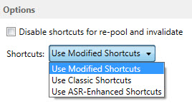
The hotkeys displayed in red are the default hotkeys assigned when InScribe is first installed. They are known as the “Modified Shortcuts.” There are two other configurations available called “Classic Shortcuts” and “ASR Enhanced Shortcuts.”

Requirements
For Emdat InScribe software to work properly within a Windows environment, you are required to meet the following software and hardware requirements:
(Macintosh computers are NOT supported by Emdat)

Minimum Requirements:
- Windows Vista (Note: Windows 98, 2000, NT4 and XP users - Emdat does not support any versions of Windows prior to Windows Vista, please upgrade Windows before calling Emdat)
- RAM: 2 GB
- Processor: 1 GHz or faster (32 or 64 bit Architecture)
- Hard Drive Free Space: 1 GB
- Sound Card with Speakers (or Stereo Headphones)
- Windows Internet Explorer 9 or higher
- A monitor capable of displaying a resolution of 800 x 600 pixels
- Internet Connection: Dial up

Recommended Requirements:
- Windows 7 or higher
- RAM: 4 GB or higher
- Hard Drive Free Space: 1 GB
- Sound Card with Speakers (or Stereo Headphones)
- Windows Internet Explorer 10 or higher
- A monitor capable of displaying a resolution of 1024x768 pixels or higher
- Internet Connection: High Speed Cable or DSL

Installing InScribe
Note: Users working on a domain network may need administrator privileges to install Emdat or any other programs.
Download the InScribe application from the Emdat Software page here: www.emdat.com/software/inscribe.asp
- Select the version of InScribe you would like to install by clicking the Install Link
Note: Contact the transcription company manager to verify which version to install.
- Select “Open” or “Run”.
- The “What’s New” screen provides a summary of changes in prior versions and recently added bug fixes, features, or improvements.
- Select “Continue”.
- Click next to begin the installation process.
- Select an installation folder. Emdat recommends using the default location. Click “Next” to advance to the next window, to confirm this file path. Click “Next” to complete the installation.
- Select “Close” on the two following screens. The installation is now complete.

Using InScribe
Note: Obtain a username and password from the transcription company's system administrator prior to logging into InScribe.
Start the InScribe program by using the shortcut created on your desktop.
An additional short cut is located under the “Programs” Menu.
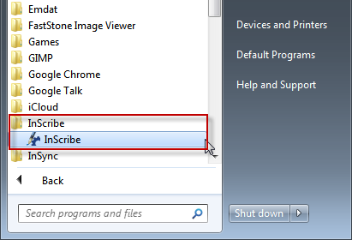
Click on “Start” then “Programs.” Expand the “InScribe” folder and click “InScribe”.

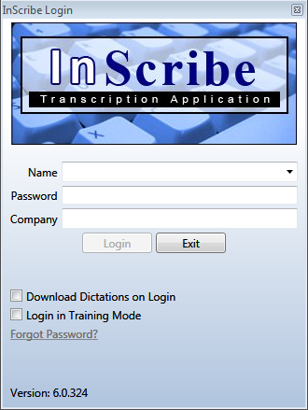
- The “Emdat InScribe Login” window will appear. Type in User Name, Password, and Company Code as supplied by the transcription company’s system administrator and press “Login”.

Login

Login Credentials
- Name: Login credential to identify a transcriptionist.
- Password: Authenticating word or passphrase for secure login.
- Company: Abbreviation or Acronym identifying the transcription company.
- Download Dictations on Login: Enable this option to download dictations automatically upon login.
- Login in Training Mode: Log into Training Mode to access the training files that can be downloaded and installed from the Emdat Software site.
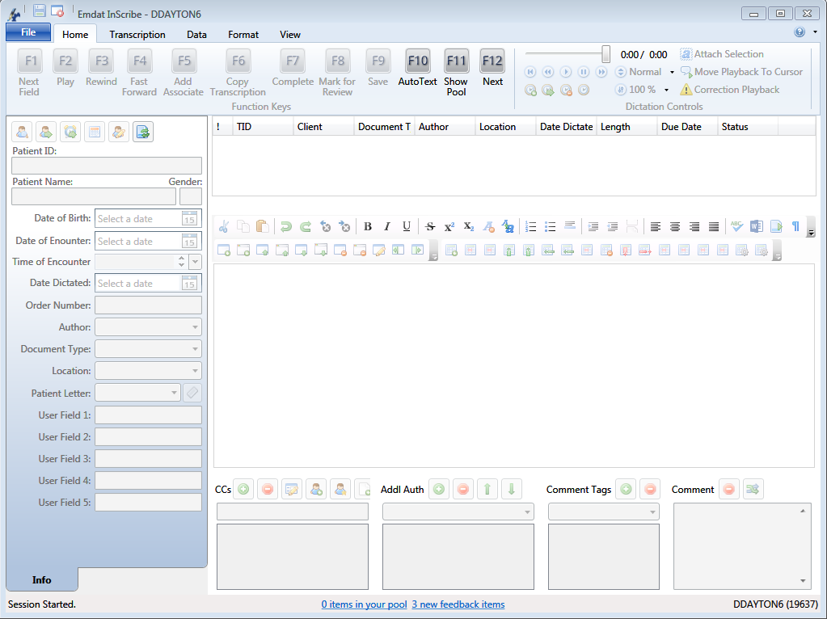
The initial InScribe Screen:

Download Dictations
Downloading Dictations: Upon logging into InScribe, a request for dictations is made to the Emdat Server. This option can be disabled by unchecking the option “Get Dictations on Login” on the login screen or in File > Options > General > Startup Options. If this option is disabled press “Next” (Hotkey: F12) to start downloading jobs. A status bar appears to track the download process in the bottom left hand corner. Once the first file has been completely downloaded, transcription work can be started with future downloads occurring in the background.
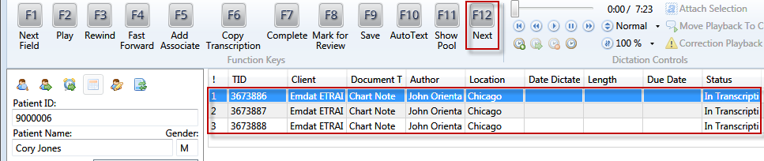
Downloaded dictations appear at the top of the screen. By default, the maximum number of dictations is three.

Function Keys
Function Key: Downloading a transcription will enable the Function keys arranged at the top of InScribe. It is important to note that you have the opportunity to customize the function key actions. (File > Options > Shortcut Keys) The options below are the defaults and are the most commonly used functions.
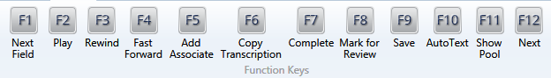

< F1 > Next Field: Skip to the Next [Field] within the transcription.
< F2 > Play: Play and Pause the dictation playback.
< F3 > Rewind: Rewinds the dictation playback.
< F4 > Fast Forward: Fast Forward the dictation playback.
< F5 > Add Associate: Add a carbon copy recipient.
< F6 > Copy Transcription: In the event that several patient dictations are dictated in one recording, copy the selected dictation and transcription text to a new transcription to transcribe the additional report.
< F7 > Complete: Mark the selected transcription as “Done” or “Completed.”
< F8 > Mark for Review: Mark the selected transcription as "Marked for Review."
< F9 > Save: Save the selected transcription.
< F10 > AutoText: Create macros and text expansions.
< F11 > Show Pool: Display work currently available for transcription.
< F12 > Next: Advance to the next dictation, download new files if available, and upload completed work.

Info Pane
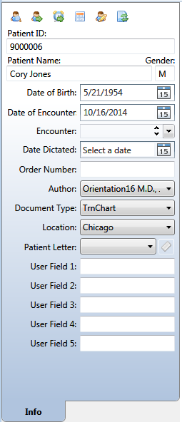
Demographic Information: Patient demographic information is located on the left side of the InScribe screen. Depending on the dictation device used by the author, demographic information may auto populate when downloading the audio file. When demographic information is not automatically available, search for a patient using the Patient ID and Patient Name fields. To search by Patient ID enter the exact number and press “Tab.” To search by patient name enter the entire, or any part of, the patient’s name and press “Tab.”
If appointment information isn’t available, information can be entered manually.
If the Patient has multiple appointments, the “Appointment Listing” window will appear. Choose the appropriate appointment for the dictation, based on the dictating physician and the date. Use the arrow keys and “Enter” or the mouse to select the appointment.
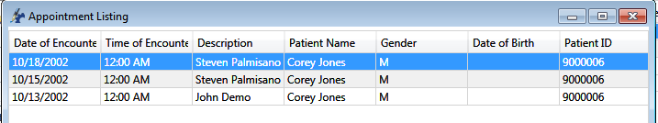

Info Pane Functions
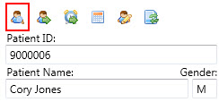
Patient Name Search: If the Patient ID dictated does not match the name dictated, find the patient with a Name Search. To look up a patient name press the “Patient Name Search” icon. (Hotkey: Ctrl+F)

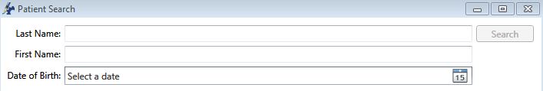
The “Patient Search” window will appear. Search by Last Name, First Name, and Date of Birth. The search function is capable of searching for partial names. For example, searching for “and” in the last name field will return results for “Anderson” and “Sanderson.”
Patient ID Search: Search the patient database by ID for available Appointments. (Hotkey: Ctrl+N)
Appointment Search: Search the patient database for available Appointments based on the Patient ID in the demographics
Clinician Appointment Listing: Search for all appointments by Clinician and Appointment Date based on the Appointment Date and Clinician selected in the demographics. (Hotkey: Ctrl+Shift+L)
Edit Patient: Edit patient Demographic and Contact information. (Hotkey: Ctrl+Alt+E)
List Document Types by Description: Toggle between the short name and the long description in the Document Type drop down list. (Hotkey: Ctrl+Alt+X)

Print and Document Template Demographics
Choosing the correct Clinician, Document Type, and Location are critical to generate a properly formatted document. These three demographics determine which template is loaded. The print template, which includes any headers, footers, and letterhead will automatically update when a new combination of Clinician, Document Type, and Location is selected. The finished document is built by combining the print template with the document template and transcribed text.
If the clinician, document type, and/or location change after the document template has been loaded, InScribe users will need to decide what to do with the existing transcription in the main editing window. If the new combination has no document template associated with it, existing transcription will remain.
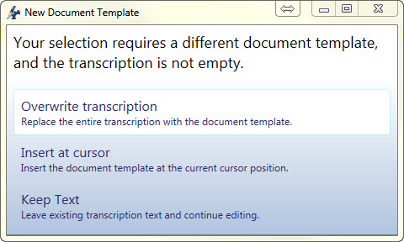
- Overwrite Transcription: Delete all existing document template and any existing transcription. Any existing text will be replaced by the new Document template.
- Insert at Cursor: Insert the new document template at the location of the cursor.
- Keep Text: Keep the existing transcription without loading the new Document Template.

Clinician
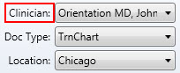
Select from a list of possible dictators. The clinician field typically populated with the dictators when a file is loaded into InScribe, but can be changed. (Hotkey: Alt+R)

Document Types
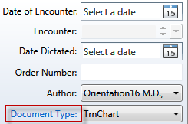
Choose from a list of possible document types available for the author. The author selects a document type during the dictation process. If an author selects the wrong document type, or does not choose one, a new document type can be selected from the list. The list of available document types will change based on the author. Once a document type is selected a Document Template will automatically load into the body of the transcription based on the combination of Author, Document Type, and Location. (Hotkey: Alt+W)

Location
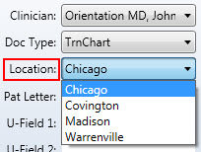
The location demographic can be used to specify a specific physical location (South Clinic) or a department or organizational division (Cardiology Department). Most dictation methods allow or require the clinician to select a location. (Hotkey: Alt+L)

Carbon Copies
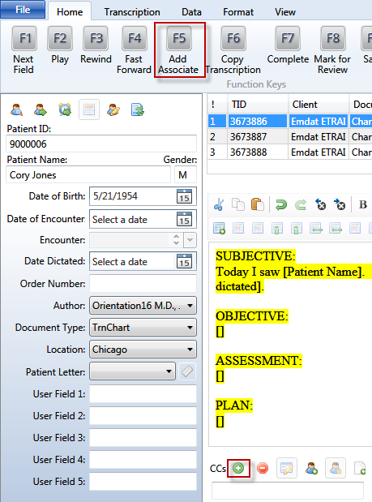
Add CC: When an author needs to send a copy of the transcription to another person, the recipients are called Associates and are added in the CCs panel. To search for an associate press “Add Associate” at the top of the screen, or click on the Green “+”. (Hotkey: F5 or Ctrl+Alt+N)
To initiate a search, some or all of either the Associate’s first or last name must be entered. Additional information in the form of specialty, City, State, and Zip Code is optional. If you have a BenchMark KB subscription, you will also be able to search the national physician’s database. Click for more information: www.emdat.com/interfix-partnership.html
Press search to initiate a search.
Select a name from the results to move onto the Associate Details window.
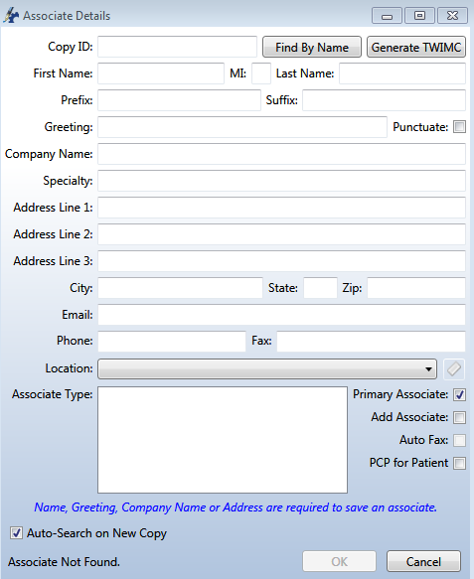
- Primary Associate: One Primary associate is allowed per Transcription. This is the associate the document will be primarily addressed to. It is possible to have a document without a primary associate.
- Add Associate: Add the new Associate to the database, or update an existing associate’s information. This option must be enabled by the Transcription Company.
- AutoFax: AutoFax status can only be changed with the Add Associate box active. When AutoFax is active the associate will receive a fax via the Emdat AutoFax feature. A valid 10 digit fax number must also be present.
- PCP for Patient: Add an associate as the Primary Care Provider. The Primary Care Provider is automatically copied on any future transcriptions for the same patient.
Delete CC: Remove the selected associate from the CC list. (Hotkey: Ctrl+D)
Edit CC: Open the Associate Details window for the selected associate. (Hotkey: Ctrl+E)
Insert To Whom It May Concern Associate: Insert a generic “To Whom It May Concern” as the addressee.
Make the Selected Associate the Primary Associate: Promote the selected associate to the status of the Primary Associate. (Hotkey Ctrl+1)
Create Associate From Patient: Convert the Patient’s information into an associate entry. (Hotkey Ctrl+2)

Additional Authenticators
Additional Authenticators are added when a document requires more than one physician’s signature on the document. This frequently occurs when resident physicians are being overseen by attending physicians, but additional authenticators are added in a variety of situations. The drop down list contains the all available dictating users for the Client.
- To add an additional authenticator select a provider’s name from the drop down list and press the button. (Hotkey Ctrl+Alt+A) Note that the authenticator has not been added simply by selecting the name. The button must be pressed to add the name to the transcription.
- To remove an additional authenticator, select the provider’s name from the list and press the button. (Hotkey Ctrl+Alt+D)
- Use the and buttons to Change the order in which the authenticators sign the document and the order in which the signatures appear on the transcription.

Comments and Comment Tags
Comments and Comment tags are used to communicate information that does not appear on the document itself. Comment Tags are canned responses to frequently occurring issues. Healthcare providers researching documents can search and sort by comment tags in the InQuiry application. Comments are used to communicate with either QA personnel or with the healthcare providers. The transcription manager will have specific instructions on how to use the Comment and Comment tag features.
- To add a comment tag, select one from the drop down list and press the button. (Hotkey: Alt+[ )
- To remove a comment tag, select and existing comment tag and press the button. (Hotkey: Alt+] )
- To add comments, enter text into the available space.
- Press the button to erase all comment content.
- Press the button to display available discrete data.

Discrete Data
Some document templates define fields that are specifically named by your transcription company. This allows the text used to replace that field to be referenced by a field later in the document, or by an interface. The Discrete Data window allows you to see what fields have been identified and named, and what values have been associated with each field. Please note that this feature is rarely used.

File Tab
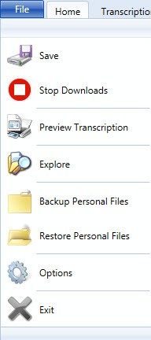
The File menu contains Options and Administrative options.
- Save: Save the contents of the Active Transcription. This performs the same function as the button in the top left corner. (Hotkey: Ctrl+S)
- Stop Downloads: Stops the automatic download of new dictations. The status of downloads is available in the top left corner. (Hotkey: Ctrl+Alt+Z)
  - Indicates dictations have not been blocked from downloading.
  - Indicates dictations have been blocked from downloading.
- Preview Transcription: View the document as it would appear in InQuiry.
  - Show/Hide Labels under the function buttons.
  - Generate a Print Preview as if the document was printed.
  - Refresh the window to display any changes made. Alterations can be made in InScribe while the preview window is open.
  - Close the Transcription Viewer.
- Explore: Explore the contents of the folders where the raw dictation and transcription files are stored. The contents of this folder are primarily viewed when troubleshooting.
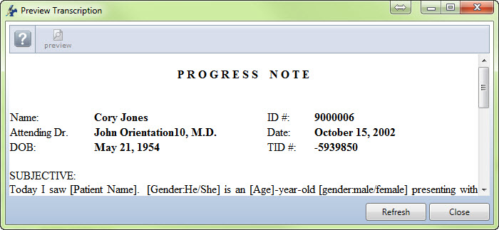
- Backup Personal Files: Create a backup of AutoText entries and words that have been added to the personal dictionary. The backup is placed in the “InScribe 6” folder of the computer’s “Documents.”
- Restore Personal Files: Restore AutoText and Personal dictionary entries from the backup location.
- Options: Customize InScribe behaviors and settings. (See Section 3 for additional information on Options.)
- Exit: Exit and logout from the InScribe application.

Home Tab

Dictation Playback
The controls for dictation playback are located after the F12 icon on the HOME tab. The following controls are in this section:
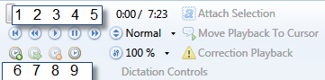
- Play from beginning (Hotkey: Ctrl+Shift+Z)
- Rewind (Hotkey: Ctrl+Shift+C)
- Play (Hotkey: Ctrl+Shift+X)
- Pause (Hotkey: Ctrl+Shift+Q)
- Forward (Hotkey: Ctrl+Shift+V)
- Mark Index (Hotkey: Ctrl+Shift+I)
- Jump to Index (Hotkey: Ctrl+Shift+J)
- Clear Index (Hotkey: Ctrl+Shift+K)
- Insert Time (Hotkey: Ctrl+Shift+T)

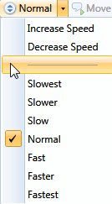
Speed and Playback Rate
The Speed Control is a drop down menu. Adjust the rate of dictation in three different ways.
- You can adjust the speed by clicking on Increase or Decrease Speed. This will flip between Slowest, Slower, Slow, Normal, Fast, Faster or Fastest.
- Keyboard Shortcut (Hotkey: Ctrl+Shift+< ) and (Hotkey: Ctrl+Shift+> )
- You can directly click on the speed desired. To remember the playback rate by author, go into the File tab > Options > Playback and select this option.
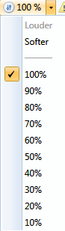
The Volume Control is also a drop down menu and will display the volume setting. Adjust the volume in two different ways. Volume can also be adjusted with the Windows Volume settings.
- Click on the Louder or Softer to scroll through the percentages of total volume.
- Click on the percentage.

ShadowScribe Cursor Functions
These features are only available during ShadowScribe or Voice Recognition jobs that have passed through the ASR engine for initial transcription.
- Attach Selection: Attach the Selection cursor to the Playback cursor. (Hotkey: Ctrl+F12)
- Move Playback to Cursor: Adjust the playback time to match the cursor’s location in the Transcription. (Hotkey: Ctrl+Shift+F12)

Correction Playback
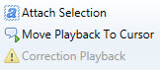
Toggles between the retrieved dictation and the correction dictation when the “Retrieve & Correct” feature is used from Get Prior Transcriptions.
(Hotkey: Ctrl+Shift+R)

Transcription Tab
Transcription Tab buttons are Creation, Navigation, and Completion actions.
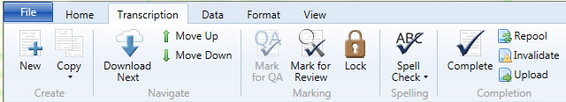
- New: Create a Transcription, or TID, without an audio file. (Hotkey: Ctrl+Shift+N)
- Copy: Create a Transcription with some or all of the properties as the Active Dictation.
  - Copy Transcription: Copy the Dictation Audio, Info Pane Demographics, Carbon Copies, Additional Authenticators, and the Transcription text of the selected Dictation to a new Transcription. (Hotkey: Ctrl+Shift+Y)
  - Copy Dictation and Header: Copy the Dictation Audio, Info Pane Demographics, Carbon Copies and Additional Authenticators.
  - Copy Dictation: Copy the Dictation Audio File only. (Hotkey: Ctrl+Alt+Y)
  - Split Transcription: Copy the Dictation Audio, Info Pane Demographics, and the Transcription text after the cursor to a new Transcription. (Hotkey: Ctrl+Alt+S)
- Download Next: Download the next dictation file from the server if the maximum allowed number of downloaded jobs has not been reached (this is set by the transcription company manager). (Hotkey: F12) or (Hotkey: Ctrl+Shift+Return)
- Move Up/Down: Move between available downloaded dictation audio files. (Hotkey: Ctrl+Alt+Up) and (Hotkey: Ctrl+Alt+Down)
- Mark for QA: Mark the transcription to be routed to the next QA level when available. (Hotkey: Ctrl+Q)
- Mark for Review: Mark the transcription to be routed to the Client Review folder when available. (Hotkey: Ctrl+W)
- Lock: Lock the transcription file to prevent accidental modification or completion. (Hotkey: Ctrl+Alt+K)
- Spell Check: Manually initiate the spell check process. (Hotkey: Ctrl+K)
  - Enable Spell Check as You Type: Check this box to activate real time spell checking.
- Complete: Mark the Transcription as completed and ready to upload to the server. (Hotkey: Ctrl+O)
- Repool: Check the audio file back into the server and save any changes made to Author, Document Type, and Location. (Hotkey: Ctrl+H)
- Invalidate: Mark the Transcription as invalid. Invalid Transcriptions are removed from the standard workflow. (Hotkey: Ctrl+J)
- Upload: Send all Transcriptions marked as complete to the server. (Hotkey: Alt+U)

Data Tab
The Data Tab holds function buttons used to acquire information stored on the database for use during the transcription process.
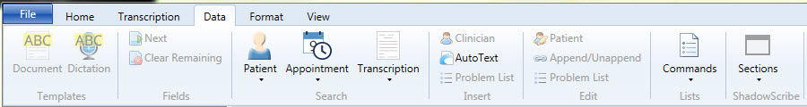

Templates
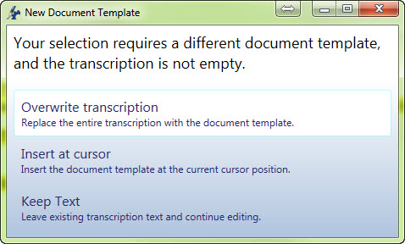
- Document: Download the Document Template for this Author, Document Type, and Location combination.
(Hotkey: Ctrl+Shift+G)

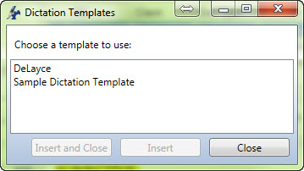
- Dictation: Retrieve a list of available Dictation Templates, or Normals, available to be inserted at the cursor.
(Hotkey: Ctrl+Alt+G)

Fields
- Next: Jump to the next available [Field]. Fields are indicated by the square brackets and may or may not contain text. (Hotkey: Ctrl+G)
- Clear Remaining: Delete any unfilled transcription [Fields]. (Hotkey: Ctrl+[ )

Search
- Patient: Open the Patient Database search window.
  - By Number (Hotkey: Ctrl+N)
  - By Name (Hotkey: Ctrl+F)
- Appointment: Open the Appointment search window.
  - By Patient
  - By Clinician (Hotkey: Ctrl+Shift+L)
- Transcription:
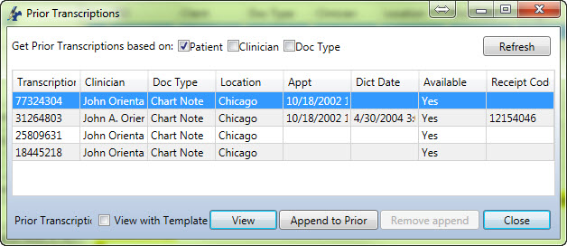
  - Prior: Search for existing transcriptions based upon Patient, Clinician, and/or Document Type. From this window View Prior Transcriptions with or without the Template. Use the Append to Prior button to append the active transcription to a previously typed document, or Remove Append to sever such a connection.
(Hotkey: Shift+F1)
  - Find Existing: Search the local backup directory for existing transcriptions if InScribe crashes or if a TID is accidentally checked in or re-pooled.

Insert
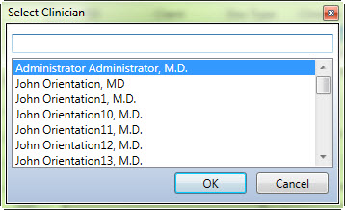
- Clinician: Search the Client for available Authors.
(Hotkey: Ctrl+Shift+Space)
- AutoText: Open the AutoText editing window. (Hotkey: F10)
- Problem List: Insert the problem list, if available, at the cursor. (Hotkey: Ctrl+Alt+I)

Edit
- Patient: Edit Patient Information (Hotkey: Ctrl+Alt+E)
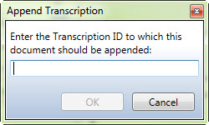
- Append/Unappend: Append or Unappend this transcription to an existing transcription by TID number. (Hotkey: Ctrl+Shift+A)
- Problem List: Open the Problem List editing window. This feature is infrequently used. (Hotkey: Ctrl+Alt+P)

Lists
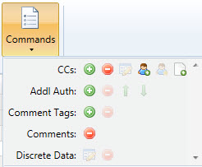
- Commands: View a list of available commands for various InScribe panes including Carbon Copies, Additional Authenticator, Comment Tags, Comments, and Discrete Data.

ShadowScribe
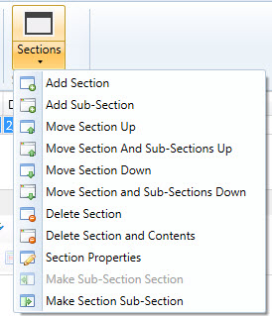
These options are only available when editing ShadowScribe or structured documents.
- Add Section: Add a new Section Heading after the currently selected section. (Hotkey: Ctrl+Alt+H)
- Add Sub-Section: Add a new Sub-Section after the currently selected section. (Hotkey: Ctrl+Alt+J)
- Move Section Up: Re-order the currently selected Section above the previous Section. (Hotkey: Ctrl+Alt+, )
- Move Section and Sub-Sections Up: Re-order the currently selected Section and all child Sub-Sections up above the previous Section. (Hotkey: Alt+Shift+, )
- Move Section Down: Re-order the currently selected Section below the following Section. (Hotkey: Ctrl+Alt+.)
- Move Section and Sub-Sections Down: Re-order the currently selected Section and all child Sub-Sections below the following Section. (Hotkey: Alt+Shift+.)
- Delete Section: Delete the selected Section heading. The contents of the deleted section will be added to the prior Section. (Hotkey: Ctrl+Shift+\)
- Delete Section and Contents: Delete the selected Section heading and the entire contents of the deleted Section. (Hotkey: Alt+Shift+\)
- Section Properties: Edit the Title and Section Code. (Hotkey: Ctrl+F6)
- Make Sub-Section Section: Promote a Sub-Section to Section status. (Hotkey: Ctrl+,)
- Make Section Sub-Section: Demote a Section to Sub-Section status. (Hotkey: Ctrl+.)

Format Tab and Editing Window
The buttons available in the Editing Window are duplicated in the Format Tab for users who choose to hide the Editor bar. Those functions commonly associated with standard text editors are found on this tab, and allow users to organize the document, add tables, lists, and other common document features.
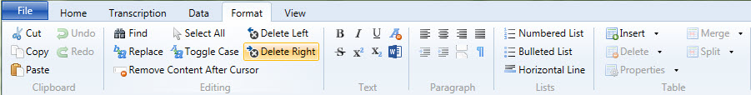

Transcription Functions
- Cut: Copy the selected text to the clipboard, but remove it from the editing window. (Hotkey: Ctrl+X)
- Copy: Copy the selected text to the clipboard and leave the text in the editing window. (Hotkey: Ctrl+C)
- Paste: Paste selected text from the clipboard at the cursor in the editing window. (Hotkey: Ctrl+V)
- Undo: Undo the last action taken, or last text typed. (Hotkey: Ctrl+Z)
- Redo: Retake the last action, or replace text that was removed with the “Undo” function. (Hotkey: Ctrl+Y)
- Find: Search for keywords in the transcription text. (Hotkey: Ctrl+Shift+F)
- Replace: Search for a keyword string and replace it with a different string of characters. (Hotkey: Ctrl+Shift+H)
- Remove Content After Cursor: Delete all text after the cursor. (Hotkey: Ctrl+Shift+Delete)
- Select All: Highlight all text in the transcription body. (Hotkey: Ctrl+A)
- Toggle Case: Toggle text case between sentence case, upper case and lower case. (Hotkey: Ctrl+Alt+U)
- Delete Left: Delete the word to the left of the cursor. (Hotkey: Ctrl+Backspace)
- Delete Right: Delete the word to the right of the cursor. (Hotkey: Ctrl+Delete)
- Bold: Begin transcribing text with Bold formatting, or change selected text to bold. (Hotkey: Ctrl+B)
- Italic: Begin transcribing text with Italic formatting, or change selected text to italic. (Hotkey: Ctrl+I)
- Underline: Begin transcribing text with Underlined formatting, or change selected text to underline. (Hotkey: Ctrl+U)
- Remove Formatting: Remove all formatting tags from selected text.
- Strikethrough: Begin transcribing text with Strikethrough formatting or change selected text to strikethrough.
- Super Script: Begin transcribing text with ^{superscript} formatting or change selected text to superscript.
- Subscript: Begin transcribing text with _{subscript} formatting or change selected text to subscript.
- Open in Word: Open the transcription in Microsoft Word (available for unstructured documents).
- Align Left: Align transcription text to the left. (Hotkey: Ctrl+Alt+L)
- Align Center: Align transcription text centered. (Hotkey: Ctrl+Alt+C)
- Align Right: Align transcription text to the right. (Hotkey: Ctrl+Alt+R)
- Align Justified: Align transcription text with both the left and right margins. (Hotkey: Ctrl+Alt+F)
- Indent: Indent transcription text to the right. (Hotkey: Ctrl+Shift+M)
- Unindent: Unindent transcription text to the left.
- Page Break: Insert a manual page break.
- Show Glyphs: Show formatting tags.
- Numbered List: Insert a numbered or ordered list.
- Bulleted List: Insert a bulleted or unordered list. (Hotkey: Ctrl+Alt+V)
- Horizontal Line: Insert a page width horizontal line.

Table Functions
- Insert
  - New Table: Opens the table wizard and inserts the table selected at the cursor.
  - Insert Row Before: Add a new row above the row the cursor is currently positioned in.
  - Insert Row After: Add a new row below the row the cursor is currently positioned in. (Hotkey: Alt+Shift+I)
  - Insert Column Before: Insert a column to the left of the column the cursor is positioned in.
  - Insert Column After: Insert a column to the right of the column the cursor is positioned in.
  - Insert Cell Before: Insert a single cell to the left of the cursor position.
  - Insert Cell After: Insert a single cell to the right of the cursor position.
- Delete
  - Delete Table: Delete the entire table and contents.
  - Delete Row: Delete the Row and contents the cursor is positioned in. (Hotkey: Alt+Shift+D)
  - Delete Column: Delete the Column and contents the cursor is positioned in.
  - Delete Cell: Delete the single cell the cursor is positioned in.
- Properties
  - Table Properties: Access properties that affect the entire table.
  - Cell Properties: Access properties settings that affect the cell the cursor is positioned in.
- Merge
  - Merge Cells: Merge selected cells into one cell.
  - Merge Cell Right: Merge the currently selected cell with the cell to the right.
  - Merge Cell Left: Merge the currently selected cell with the cell to the left.
- Split Cells: Split the selected cell into two equal cells.

View Menu
View information about Transcription Production and change the appearance of InScribe.
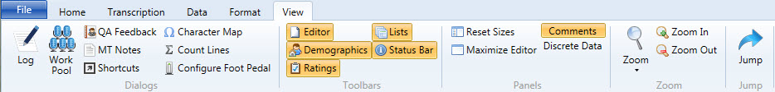

View Menu Functions
- Log: Display the log of completed transcriptions. The log is for informational use only. The actual line count may change based on transcriptions in QA, which will not be reflected in this log. (Hotkey: Ctrl+L)
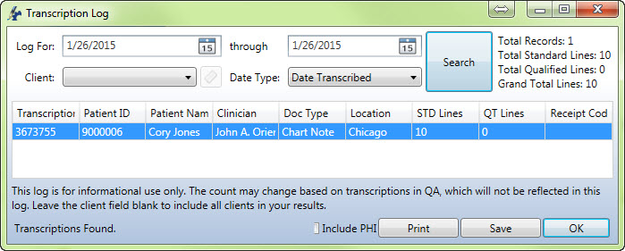
  - Log For: Define the date range to search completed transcriptions.
  - Client: Leave the client field blank to include all clients in the results or search for a specific client.
  - Date Type: Search by Date Transcribed or Date Delivered.
  - Search: Initiate the search using the selected parameters.
  - Include PHI: Include confidential Patient Health Information on the report.
  - Print: Print a copy of the Transcription Log.
  - Save: Save an electronic copy of the Transcription Log.
  - OK: Close the transcription log.
- Work Pool: Display a list of Transcriptions available for the MT currently logged into. (Hotkey: Ctrl+Shift+P)
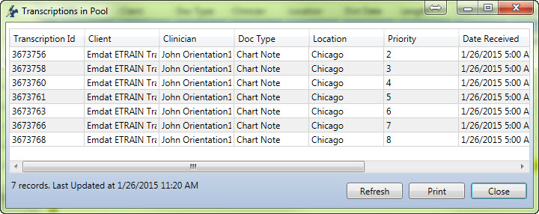
  - Transcription ID: The unique job identifying number.
  - Client: The hospital or facility where the Transcription originated.
  - Clinician: The author who dictated the job.
  - Doc Type: The work type the dictation was created with.
  - Location: The location the dictation was created with.
  - Priority: The priority level assigned to the dictation. Lower numbers indicate higher priority jobs. By default, standard priority dictations are assigned a priority of 4, and STAT dictations are assigned a priority of 2.
  - Date Received: The date the system received the dictation from the Author.
  - Refresh: Refresh the list to check for new arrivals.
  - Print: Generate a paper copy of the Pool contents.
  - Close: Close the Work Pool Window.
- QA Feedback: View Feedback for transcriptions reviewed in QA. (Hotkey: Ctrl+Alt+Q)
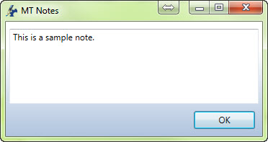
- MT Notes: View notes or instructions from the Transcription Company regarding the selected dictation. MT notes can include tips and information regarding the production of the transcriptions.

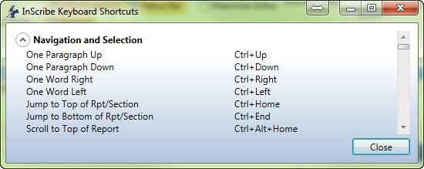
- Shortcuts: View a list of all hotkeys available in InScribe. (Hotkey: Ctrl+Shift+S)

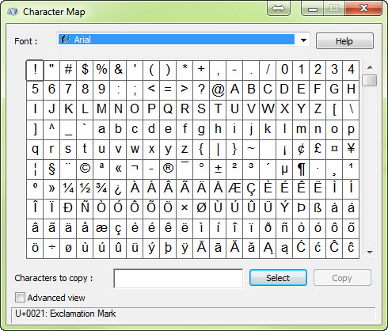
- Character Map: Open the character map for special characters.

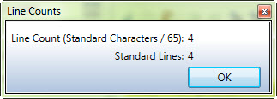
- Count Lines: Perform an ad hoc line count. (Hotkey: Ctrl+T)
- Configure Foot Pedal: Configure a three button USB foot pedal for use with InScribe. Note that not all foot pedals are supported.
- Show/Hide Toolbars: Tool bars lit up in Orange will be displayed in the InScribe production window. De-select the toolbars to hide them.
  - Editor: This toolbar contains the editing functions that are available in the Format Tab.
  - Demographics: This toolbar contains functions to search for patient demographics.
  - Ratings: This toolbar is used when creating QA feedback.
  - Lists: These toolbars control Associate, Additional Authenticators, Comment Tags, and Comment functions.
  - Status Bar: Displays MT Pool and Feedback counts and InScribe activity statuses.
- Reset Panel Widths: Resizes all panels to their default size and position in InScribe.
- Maximize Editor: Hide the Demographics, Associates, Additional Authenticator, and Comment panes to enlarge the viewable area of the Transcription Editor. (Hotkey: Ctrl+Tab)
- Comment: Toggle to display the comments list.
- Show Discrete Data: Toggle to display the Discrete Data list. Some document templates define fields that are specifically named by your transcription company. This allows the text used to replace that field to be referenced by a field later in the document, or by an interface. The Discrete Data window allows you to see what fields have been identified and named, and what values have been associated with each field. Please note that this feature is rarely used.

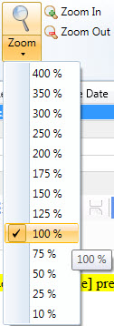
Zoom Settings
Zoom allows the apparent size of the text to be adjusted for visibility without altering the actual text size on the finished document. Select the desired zoom setting from the drop down menu, or use the Zoom In and Zoom Out buttons to select incrementally.
- Increase the apparent size of the text.
- Decrease the apparent size of the text.

Jump Functions
Use the Jump Functions to quickly navigate to different Panes in InScribe. (Hotkey: Alt+J) Once the Jump process is enabled, InScribe will prompt with letter keys until the cursor is in the desired position.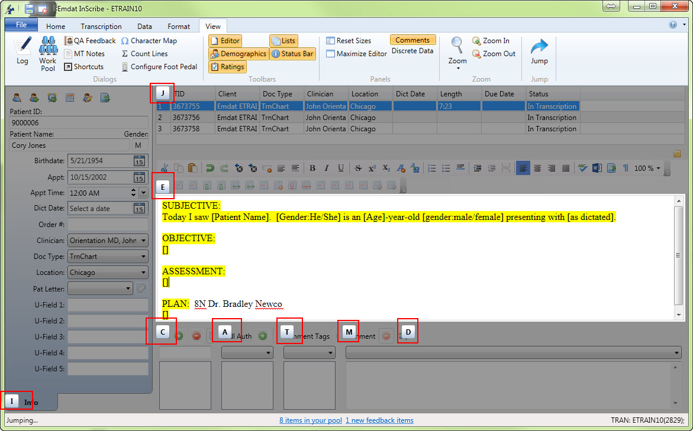

Advanced Table Functions
Advanced Table functions allow for control over the size and appearance of a table.

Table Properties
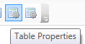
Table Properties affect the size and appearance of the entire table. To access the table properties, place the cursor in any cell belonging to the table and press the table properties button.
- Width: The percentage of the width of the page the table occupies.
- Rows: Number of Rows in the Table. This option is only available during table creation.
- Columns: Number of Columns in the Table. This option is only available during table creating.
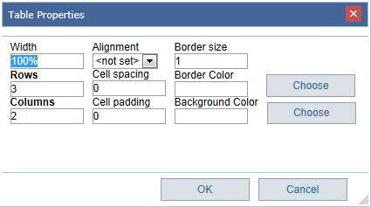
- Alignment: The alignment of the text in the table. Options are Left, Right, and Center.
- Cell Spacing: The amount of space between individual cells.
- Cell Padding: The amount of space between the text and the cell walls.
- Border Size: The thickness of the Cell Borders. Set width to “0” to hide Cell Borders.
- Border Color: The color of the Cell Borders.
- Background Color: The color of the Cell Background.

Cell Properties
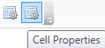
Cell Properties affect the size and appearance of individual cells. Some cell properties also affect the entire column or row. To access the cell properties, place the cursor in the cell and press the cell properties button.
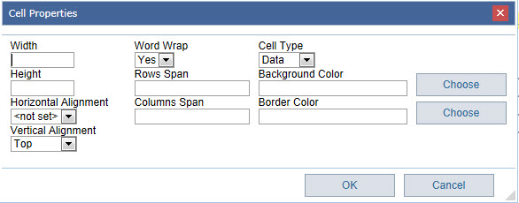
- Width: The percentage of the table width the selected column will consume.
- Height: The percentage of the table height the selected row will consume.
- Horizontal Alignment: The alignment of the text inside the cell. Options are Left, Right, Center, and Justify. “Not Set” takes the properties of the table.
- Vertical Alignment: The alignment of the text inside the Cell. Options are Top, Center, and Bottom. “Not Set” takes the properties of the table.
- Word Wrap: Set if text wider than the width of the cell can occupy additional lines.
- Rows Span: Indicates the number of rows the selected cell will take up.
- Columns Span: Indicates the number of columns the selected cell will take up.
- Cell Type: Options are Header and Data.
- Border Color: Color of the individual cell border.
- Background Color: Color of the individual cell background.

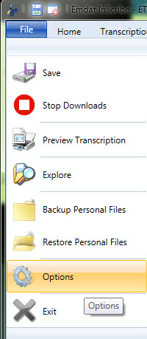
Options
Open the Options from the File Menu. The options change how InScribe behaves and allows the Transcriptionist to customize the workspace to optimize production.

General
- Startup Options
  - Download Dictations on Startup: Deselecting this option will prevent InScribe from automatically requesting a dictation upon login.
  - Hide Available Upgrades: InScribe will not prompt to update when an update is available.
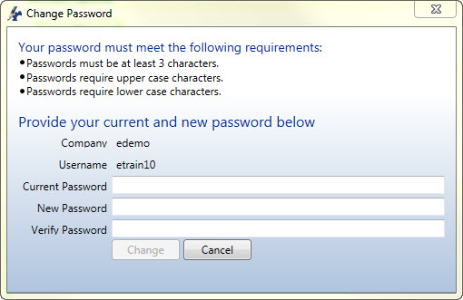
- Account Options
  - Change Password: Change the password used to log into the current InScribe account.
- Benchmark KB
  - User Name: The login ID assigned by Benchmark.
  - Password: The password for the Benchmark ID.
  - Register with Benchmark KB: A link for new Benchmark KB users.
- Language: Currently InScribe is supported in English and Swedish.

Prompts
- Job Completion
  - Prompt to Mark for QA: Options are Always, When In Question, When in Question and Unmarked, and Never.
  - Prompt to Mark for QA when Comments or Comment Tags Exist: Toggle to Mark for QA based upon Comments and Comment Tags.
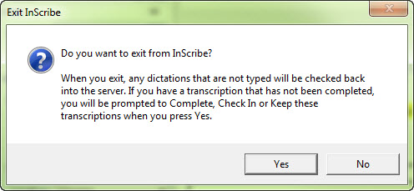
- Application Close
  - Show Shutdown Confirmation: Enables a Shutdown Confirmation popup to prevent accidental log off.
- Notifications
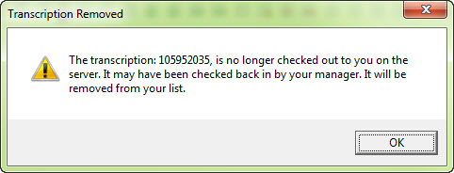
  - Prompt When High Priority Job Received: Display a notification if a higher priority (STAT) dictation is downloaded to the queue.
  - Prompt When Unselected Job is Removed From Your Pool: Display a notification if a dictation is removed from your downloaded queue by the Transcription Manager or automatic check-in.
  - Prompt When Queue is Empty and New Work is Available: Display a notification if no dictations are downloaded and work is added to the pool.
  - Prompt When Clinician Field Changes: Display a notification if the Author fields is updated.
  - Prompt When Appointment Date is After Dictation Date: Display a notification if the Appointment date is later than the Dictation Date.
  - Prompt When Dictation Has Not Been Played Within [ ] Seconds: Display a notification if the entire audio file has not been listened to.

Playback
Playback Options control how InScribe’s audio player performs.
- Control Functions
  - Continue Playback After Rewind or Fast Forward: Activate this option and the player will continue playback after performing Rewind and Fast Forward. Otherwise the player will pause.
  - Separate Play and Pause Functions: Enable for foot pedals that need to be held down to continue playback.
  - Remember Volume and Playback Rate by Clinician: Enable to allow InScribe to automatically adjust Volume and Playback rate to the last used settings per Author.
- Time Adjustments
  - Rewind [ ] Seconds: Control the increment that InScribe Rewinds per button press.
  - Fast Forward [ ] Seconds: Control the increment that InScribe Fast Forwards per button press.
  - Pause [ ] Seconds: Control the increment that InScribe automatically Rewinds when the dictation playback is paused then resumed.
- Shadow Scribe Playback
  - Attach Voice Cursor on Play: Attach the Voice Cursor to the Editing Cursor when the dictation is played.
  - Attach Voice Cursor on Rewind and Fast Forward: Attach the Voice Cursor to the Editing Cursor after Fast Forward and Rewind actions are performed.
  - Attach Voice Cursor on Jump to Index: Attach Voice Cursor to the Editing Cursor after Jump to Index action is performed.
  - Change Voice Cursor Color: Change the Color of the Voice Cursor to suit user preference.

Editing
- Auto Saving
  - Automatically Save Job Every [ ] minutes: Control the frequency that InScribe will create a save file for the selected transcription. Increase the time to increase computer performance. Decrease time to perform a greater number of backups.
- User Interface
  - Demographics Highlighter Color: Change the color of the label text in the Info Pane.
  - List Document Types by Description: Enable to list Document Types by their descriptions instead of their names.
  - Resize List Panels on Focus: Reset the size of List Panels to their default.
  - Hide Pool Count: Hide the number of Dictations in the Transcription Pool displayed in the status bar at the bottom of InScribe.
- Patient and Appointment Options
  - Search for Appointment When Dictation Loads at Transcription Level: Automatically search for an appointment if patient information is attached to the dictation when it is loaded at the standard transcription level.
  - Search for Appointment When Dictation Loads at QA levels: Automatically search for an appointment if patient information is attached to the dictation when it is loaded at any QA level.
  - Show Single Patient When Not an Exact Match: Show a patient listing when the result is a single patient, but is not an exact match. Otherwise, the patient information will automatically import.
  - Show Single Appointments: Show the Appointment Search window even if only one appointment option is available for the patient. Otherwise the appointment information will automatically import.
  - Automatically Load the First Appointment: Automatically load the most recent appointment, prior to or equal to today’s date, for the patient. Otherwise, the Appointment Search window will display all available appointments.
  - Automatically Select Single Patient From Clinician Listing: Automatically import patient information if only one patient is available for the Author for the selected appointment date.
- AutoText
  - Automatically Expand AutoText: Enable the use of the AutoText word expansion feature.
  - Jump to Next Bracket After AutoText: Enable and InScribe will automatically jump to the next [field] in the document. Otherwise use the Fields command to jump to the next field. (Hotkey: F1)
    - Set Cursor Position to Start of Document After AutoText With Brackets: InScribe will begin searching for [fields] at the start of the document after the last [field] has been populated.
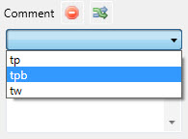
  - Show AutoText List in Comments: Add a dropdown list to select from AutoText entries marked for use as a Canned Comment in the Comments list.
    - Use All AutoText as Canned Comments: Enable to display all AutoText entries in the dropdown list in Comments.
  - Use Double Space After Sentence: InScribe will enforce two spaces after sentence punctuation.
- Navigation
  - Ctrl+Left Moves to the Beginning of the Prior Word: Enable this functionality. Ctrl+Left will move the cursor to the end of the prior word if this feature is not enabled.
  - Ctrl+Right Moves to the Beginning of the Next Word: Enable this functionality. Ctrl+Right will move the cursor to the end of the next word if this feature is not enabled.
- Templates
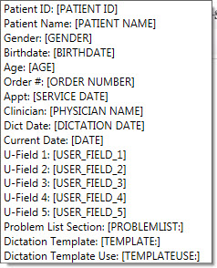
  - Get Document Template When the Location is Changed: InScribe will prompt to load a new Document Template upon Location change. Note that if the transcription contains text you will be prompted to choose to overwrite the existing text with the new template text, insert the new template text at the cursor, or keep the existing transcription text without loading the new template text.
  - Automatically Fill Template Fields: Allow InScribe to automatically populate any [field] entries that it has data for. For example, if Date of Birth is entered into the Info Pane, InScribe will automatically calculate the answer for the [Age] field or can populate the [Birthdate] data field within the transcription text.
    - Options are Always, Never, and Prompt.
    - On the right is a list of [Fields] the InScribe is capable of populating/calculating.

Foot Pedals
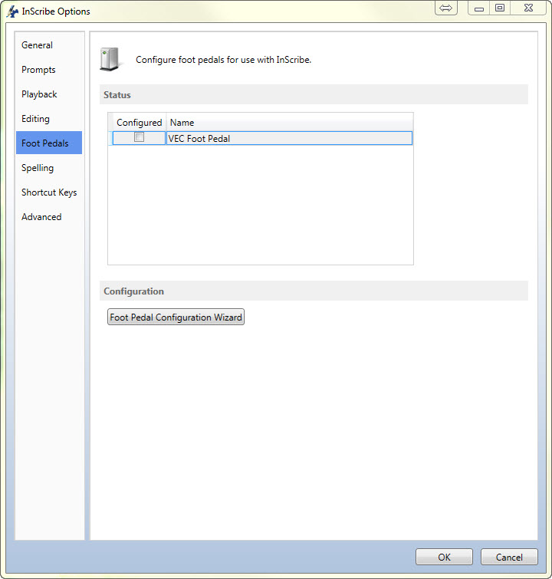
Foot Pedals are used by InScribe to control the Play, Pause, Fast Forward, and Rewind playback functions of the dictation, freeing up the typists’ hands from those tasks. If InScribe is open and a foot pedal is plugged in, InScribe will prompt the user to configure the foot pedal. The foot pedal configuration screen can also be opened via the File Menu, then Options, then Foot Pedals.
- Status: The status window displays a list of all connected foot pedals. A check in the box of the “configured” column indicates that the device has been configured and will work with InScribe.
- Foot pedals that are un-plugged from the computer will be remembered and will not have to be reconfigured.
- Foot Pedal Configuration Wizard: Press to launch the Foot Pedal Configuration Wizard.

Configuration Wizard
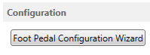
- Start the wizard by either plugging in a USB foot pedal, or by selecting the Configuration button.
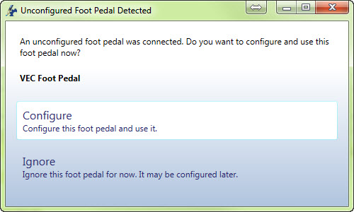

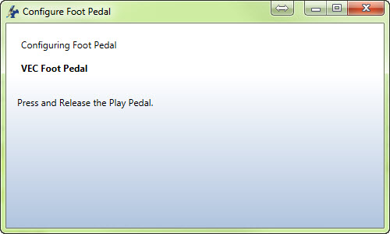
- Press and Release the Play Pedal

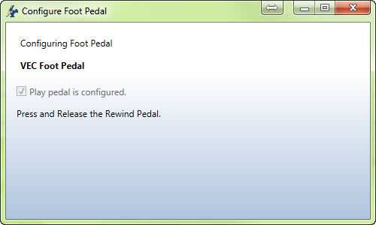
- Press and Release the Rewind Pedal

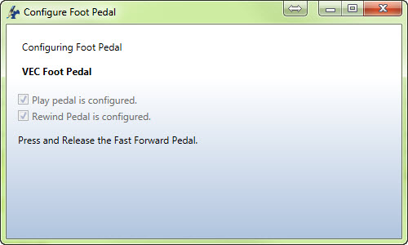
- Press and Release the Fast Forward Pedal

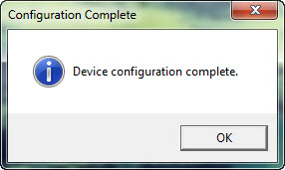
- Configuration Complete

Spelling
Control Spellcheck and Dictionary options.
- Configuration
  - Check Spelling as You Type: Allow InScribe to display the red line underneath misspelled words as you type.
- Correction Options
  - Ignore Words in ALL CAPS
  - Ignore Domain Names (Web Addresses, etc.)
  - Ignore mIxeD CaSE
  - Ignore Words with Digits (Hello1)
  - Ignore Numbers (12345)
  - Ignore Capitalized Words (First Letter Caps)
  - Split Hyphenated Words for Spelling (auto-text)
  - Split Contracted Words for Spelling (couldn’t)
  - Allow Accented Caps
  - Allow Possessives on Words (patient’s)
  - Report Uncapitalized Words (canada)
  - Report Doubled Words (the the)
  - Report mIxeD CaSE Words
  - Report Words with Digits (Hello2)
  - Suggest Phonetic Words
  - Suggest Typographical Words
  - Case Sensitive (Treat canada and Canada differently)
  - Check Word Parts (dumptruckdriver would be correct)
  - Capitalize First Letter of Sentence As You Type
  - Reset Options: Reset spelling options back to default.

- Dictionaries: Press the Custom Dictionaries button to choose which dictionaries will be used. Dictionaries on the right side of the Custom Dictionaries window are available for use. Dictionaries on the left side are currently active.
  - Compiled Dictionaries: Pre-made dictionaries that include Standard English and British dictionaries. InScribe does not include medical dictionaries, but Benchmark KB can be enabled to include Stedman’s Medical Dictionary. See section 3.1 for more information.
  - User Dictionaries: Dictionaries that contain words that are added by the user.

Shortcut Keys
- Action Keys: Customize the actions performed by the Action Keys F1 through F12.
  - Reset Actions: Reset the Action Keys to their default settings.
- Options
  - Disable Shortcuts for Re-Pool and Invalidate: Disable the Shortcuts.
  - Shortcuts: Choose the Shortcut configuration.
    - Use Modified Shortcuts: This is the default option and has been optimized for InScribe version 6. This is also the shortcut set used in this manual.
    - Use Classic Shortcuts: Use the original Shortcuts from prior versions of the software.
    - Use ASR Enhanced Shortcuts: Use a shortcut configuration optimized for use with ShadowScribe editing. (Voice Recognition QA)

Advanced
- Shortcuts
  - Use Global Function Keys: Allow the Action Keys (F1 through F12) and other (Hotkeys) to be active even when InScribe is not the primary active program in Microsoft Windows.
- Prompts
  - Automatically Check for New Dictations Every [ ] Minutes: Enable InScribe to check for available dictations at the specified interval.
  - Display JavaScript Errors: For troubleshooting purposes, display error message for InScribe.
- Playback
  - Audio Player
    - InScribe: Use the default InScribe player.
    - Other: Use an alternate media player currently installed on your machine.
  - Audio Player Path: The file path to an alternate media player; only enabled when Other is selected for the Audio Player.
  - InScribe Wave Player:
    - Automatic
    - WASAPI
    - WaveOut
- Data
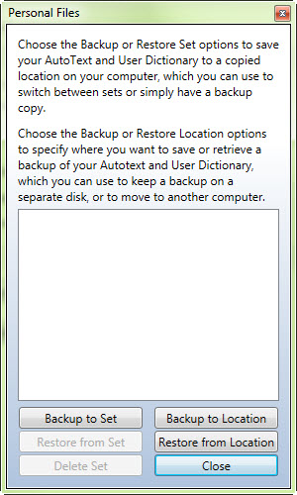
  - Remove Save Folders: This option will remove all prior “Save” folders under this username. By default, InScribe removes old folders each time you log in, but saves the last two weeks of transcription data. This option will clear all old data.
  - Backup and Restore Personal Files
    - Backup to Set: Choose the Backup options to save your AutoText and User Dictionary to a copied location on your computer, which you can use to switch between sets or simply have a backup copy.
    - Restore from Set: Restore a previous backup of your AutoText and User Dictionary files.
    - Backup to Location: Options to specify where you want to save a backup of your AutoText and User Dictionary, which you can use to keep a backup on a separate disk, or to move to another computer.
    - Restore from Location: Options to retrieve a prior backup of your AutoText and User Dictionary files.

AutoText
AutoText is InScribe’s built in Word Expander. Word expansion can be as simple as expanding a few characters into a longer word or phrase, or as much as entire templates complete with Tables and Ordered Lists. All of the formatting options that are available in the standard editing window are available in the AutoText editing window.

Adding and Removing Entries
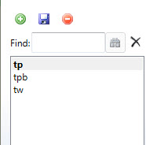
On the left side of the AutoText window is a list of all current expansions.
- The green button creates a new entry. The name entered here will be the short version of the expansion. Note that InScribe will gray out the “OK” button if the name entered has invalid characters or is already in use.
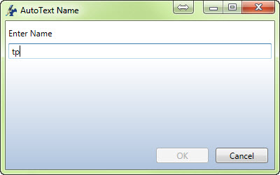
- The Save button stores changes made to the selected entry

- The Delete button removes the selected AutoText entry. Deleted entries can be recovered from backup files.

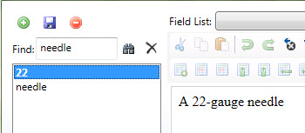
- The Find box is a keyword search, and will return results for both the short name and the expansion fields. The button initiates a search and the clears the contents of the search box.

Quick Add Feature
Use the Quick Add boxes to quickly add new AutoText entry. Enter the short form on the left, and the long form on the right. Press the button to add and save the entry. This feature is ideal for quickly adding short expansions, but is not suited for large amounts of text and advanced formatting like tables and lists.

AutoText Editing
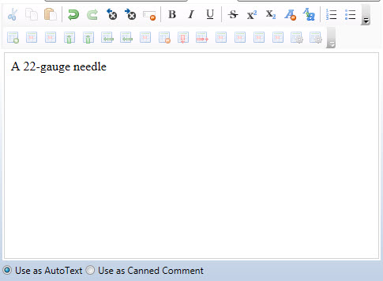
All of the formatting functions available in the standard editing window are available in the AutoText editing window. A detailed explanation of these functions is available in Section 2.13. In addition to the standard formatting options there are two new radial menu options.
- Use as AutoText: This entry is used in the main editing window.
- Use as Canned Comment: This entry is used in the comments pane, but can also be used in the editing window.
It is possible under the Options Editing screen to allow standard AutoText entries in the Comments section.

Fields and Functions
Fields and Functions found in your AutoText creator are advanced template creating functions. Using Fields and Functions are comprehensively covered in a document found here: https://www.emdat.com/software/inscribe.asp
How to use Template Fields and Functions

Rating a Transcription in InScribe
QA Ratings & Feedback allows the QA staff to record errors and leave feedback for the prior MT while editing the transcription. Each time a transcription passes through QA, the QA staff is able to rate the quality of the previous transcriptionist. The ratings and comments applied by a QA1 staff member will be visible to the original Transcriptionist; the ratings and comments applied by a QA2 staff member will be visible to the QA1 who worked on this document, and so on.
Your Transcription Company can determine if these ratings will affect your overall Quality Score, and thus your pay rate for this transcription. Your company might also choose to utilize this feature to simply provide feedback on the quality of your work, without influencing your pay rate.

Rating Process
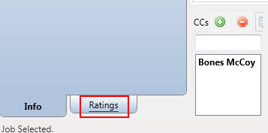
If the QA Ratings & Feedback feature has been configured and enabled by the transcription company, the QA staff will see the Ratings tab in InScribe.
The Ratings panel shares the same window as the Demographics panel. Click on the “Ratings” tab. (Hotkey: Ctrl+R)

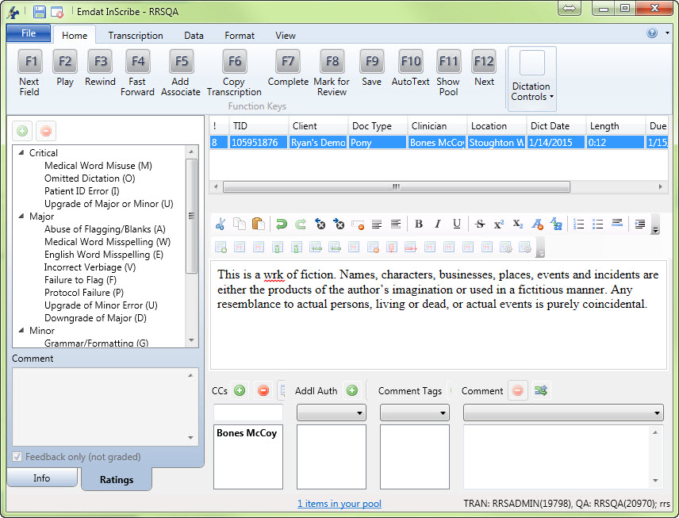
In the example, the word “work” is misspelled in the first sentence. The process to correct this and add an English Word Misspelling error is:
- In the Editor panel, delete “wrk” and type “work”. Jump to the Ratings Tab.
- Press E to select English Word Misspelling.
- Press Enter to add an Error Identification marker.
- Press Enter to jump to the Comment area.
- Type your comment and press Enter to jump to the Editor panel. The cursor returns the same location it was in before you added the error.

Notes:
- Shortcut keys are assigned by transcription company management when creating the Rating Program.
- The same shortcut key may be assigned to more than one Rating. In our example, W is the shortcut key for Medical Word Misuse in the Critical Category and for Medical Word Misuse in the Major Category.
- Pressing W once moves to the first Rating.
- Pressing W twice moves to the second Rating.
- If W is pressed a third time, it moves back to the first Rating.
- Comments are not required. After identifying a new error press Enter a second time to bypass the comment and return to the transcription body.
- To correct the misspelling place the cursor between “w” and “r” of “wrk” and type “o”.
- Return to the Demographic panel by clicking on the Info tab at the bottom. (Hotkey: Alt+I)
- A time index is created to mark the dictation at the time the error was created. This index will be available for playback to the person who receives your feedback.

Let QA Decide / Feedback Only
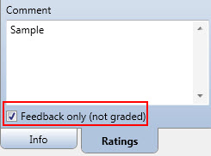
The transcription company will determine whether or not the Ratings feature will influence the Quality Score, and thus change the pay rate of its transcriptionists. QA staff can be given the ability to make this decision on a per-transcription basis. At the bottom of the Rating window is a checkbox for “Feedback only (not graded)” that is enabled depending on the company’s Ratings settings.
- If Ratings will not influence the Quality Score, this option is turned ON, and QA cannot change the setting. This option will simply provide feedback to the person whose work you are reviewing.
- If Ratings will influence the Quality Score, this option is turned OFF and QA cannot change the setting.
- The company can also decide to allow the QA staff to enable this option. Doing so causes this transcription to be ignored by the Quality Score, and will not affect the transcriptionist’s pay. By default, this checkbox is not selected when a document is sent to QA. Select “Feedback only (not graded)” for minor changes that should not affect transcription pay rate.

Reviewing Feedback
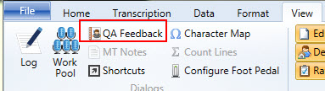
When new feedback is available, a link will appear at the bottom of InScribe upon login. Click the link to open the QA Feedback summary window. Feedback is also accessed via the View Menu and pressing the button to view QA feedback. (Hotkey: Ctrl+Alt+Q)

Navigating the Feedback List
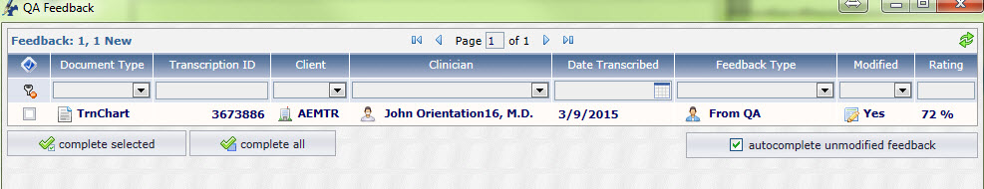
- Sort: Click on any column title to sort feedback items by that column. Click once to sort in ascending order, twice to sort in descending order.
- Filter: Use the drop-down menu boxes under any column header to filter feedback to show only transcriptions containing that value. Use this feature to view a particular client, document type, etc.
- Clear Fields Button: Reset any selected filters to display any feedback items that might be hidden.
- Complete Selected: Remove feedback items by selecting the boxes on the left and clicking Complete Selected.
- Complete All: Remove all feedback items.
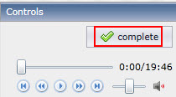
- Complete: Complete an individual feedback item using the “Complete” button in the Controls box.
- Auto Complete Unmodified Feedback: turn on to skip feedback for transcriptions where the body has not been modified by QA. (Such as those that only go to QA to add an associate.)
Records with Bold text have not been reviewed and are considered “New.” Records not in bold text have been previously opened.

Transcription Feedback
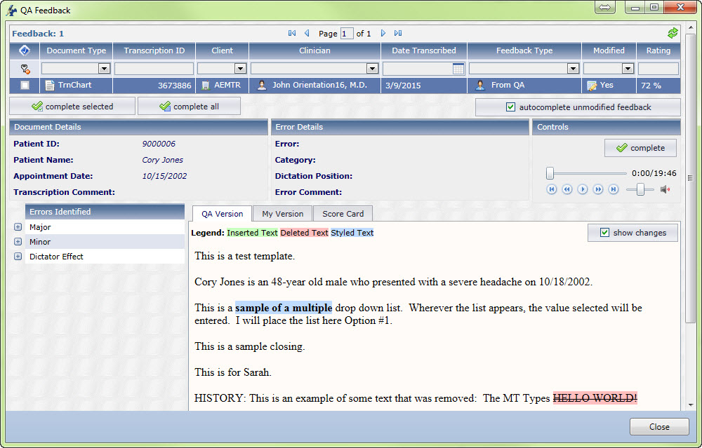
View a specific feedback item by clicking on the transcription record. Feedback will open in the bottom of the window. The transcription text section defaults to the “QA Version” Tab.
Identified errors are placed in categories to the left. Expand the error categories to see individual errors.
Click on the Dictation Position value in the Error Details to move the playback cursor to that time on the audio file. Addition playback controls allow for Play, Pause, Rewind, Fast Forward, Move to Beginning, and Move to End.
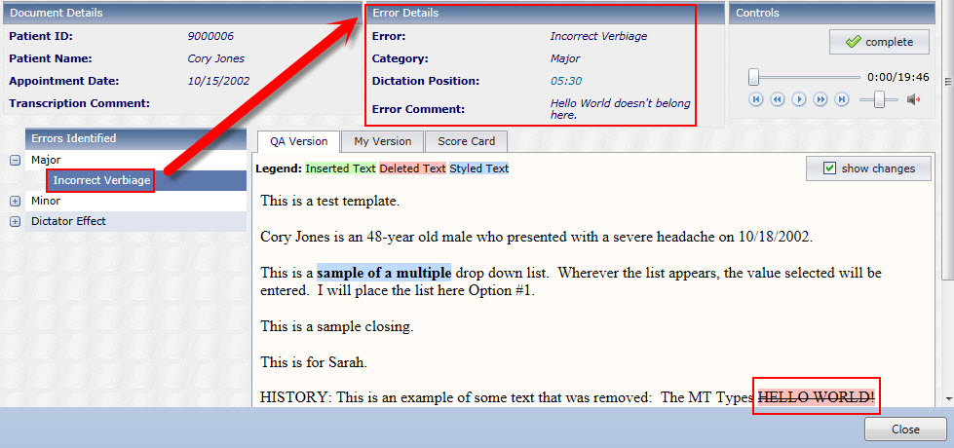
When a specific error code is selected, additional error details appear which include:
- The type of error code identified.
- The Category of the error code.
- The time in the audio file that the error was identified.
- Any additional comments about the error added by QA.

If “Show Changes” is unchecked in the QA version tab, clicking on an individual error will also highlight in blue any altered text. Toggle between the QA finalized version and the changes mark-up version with the “Show Changes” checkbox.
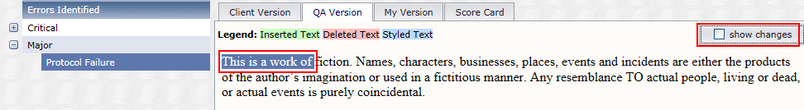
With “Show Changes” checked, the transcription is marked with QA alterations.
- Deleted items are highlighted in pink.
- New items are highlighted in green.
- Items with formatting changes are highlighted in blue.
The original transcription text is available under the “My Version” tab.
The “Client Version” tab displays edits made by the client.

Score Card
A summary of all errors and point deductions is available on the Score Card. The score card can be printed with the available print button.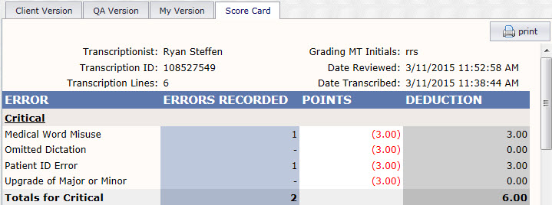
- Error: All Error Categories and Error Codes used by the QA Program.
- Errors Recorded: The number of occurrences for the Error in this transcription.
- Points: The number of points deducted for each occurrence of the error.
- Deduction: The number of points deducted for this error type in this transcription. This is calculated by multiplying “Errors Recorded” by “Points.”
The Final Score for the selected transcription is located at the bottom of the Score Card. This is calculated based upon the number of points deducted against the number of lines in the transcription.

The Quick Access Toolbar
The Quick Access Toolbar is located in the top left corner of the InScribe Window above the ribbon menus. By default it has buttons to Save the transcription, and to Stop Downloads. Toolbar options are found by right-clicking on any icon in the Ribbon Menu, or on the Quick Access Toolbar itself.
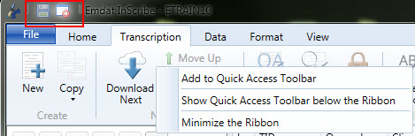

- Add to Quick Access Toolbar: This option is available when clicking on icons in the Ribbon menu. If the item is already present on the Toolbar, this option will be grayed out. This will add the selected action to the Toolbar.
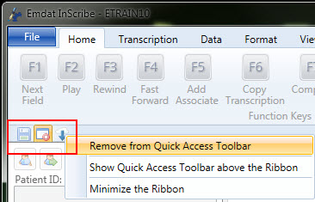
- Remove from Quick Access Toolbar: This option is available when clicking on icons in the Toolbar. This will remove the selected action from the Toolbar.
- Show Quick Access Toolbar above/below the Ribbon: Toggle where the Toolbar is displayed.
- Minimize the Ribbon: Hide the Ribbon Menu icons.

Help Menu
The help menu contains troubleshooting tools and links to articles that provide information to users experiencing difficulty, or learning to use the program.
- Press the button to open up the InScribe software page
To access the following features first press the next to the button and make a selection.
- InScribe website: Also opens the InScribe software page.
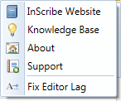
- Knowledge Base: Open the Nuance Knowledge base for frequently asked questions and troubleshooting assistance.
- About: Obtain statistics for InScribe and view the current transcription in HTML format. If instructed by a technician, press the “click here” link to upload additional diagnostic data in the form of a support ticket.
- Support: Contact information to receive technical support.
- Fix Editor Lag: Resolve Editor Lag problem. Note that this is not a permanent fix, but should “refresh” the editor to where it functions at a normal rate. (Hotkey: Alt+Shift+E)

Removing InScribe
(Note: Users on a network may need to contact their system administrators if they do not have the rights to install or uninstall software.)
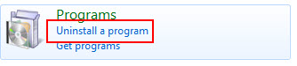
- Click on “Start” and select “Control Panel”.
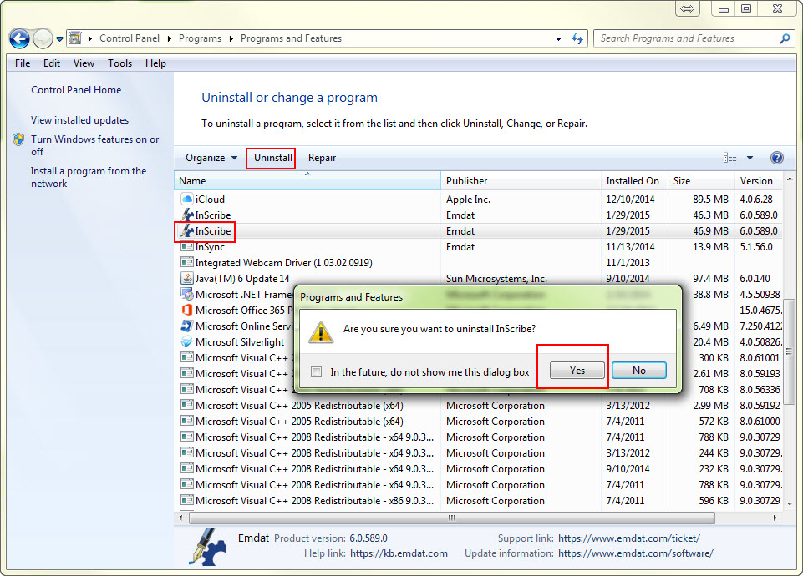
- Double click on “Programs and Features” or Choose to “Uninstall a Program.”
- Click on “InScribe”.
- Click on “Change/Remove”.
- Click on “Yes” to confirm uninstall.
- Once uninstallation is complete, click “OK”.

Support
We offer the following support options in the event that you need further assistance with InScribe:
- Emdat software page to download InScribe: www.emdat.com/software/inscribe.asp
- Emdat Knowledge Base Home: kb.emdat.com
- Emdat Knowledge Base: Foot Pedals: https://kb.emdat.com/wiki/Foot_Pedals
- Emdat Knowledge Base: AutoText: https://kb.emdat.com/w/index.php?search=autotext&title=Special%3ASearch
- More information about AutoText Field Lists and Functions: www.emdat.com/download/Template Fields.doc
- Information about BenchMark KB: www.emdat.com/interfix-partnership.html
- Help Desk Request: www.emdat.com/ticket
- Phone Support: (608) 270-6400 ext. 1 (Help Desk support is provided weekdays 7AM - 7PM CST)

A Note on Performance
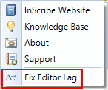
Currently there is a known issue where long reports can develop a degree of lag between keystrokes, and when the text will appear in the editor. This is a known issue that EMDAT is working with Microsoft to resolve.
As a workaround, Emdat has included in the help menu a button that will temporarily resolve editor lag.
(Hotkey: Ctrl+Alt+E)

