Emdat Mobile for iOS devices

Table of Contents
Table of Contents 2
Introduction 3
Requirements 3
IMPORTANT: RECEIVING CALLS WHILE DICTATING 3
1. Installing Emdat Mobile on All Apple Devices 4
2. Starting Emdat Mobile 5
3. Using Emdat Mobile on iPhones and iPods 6
3.1 The Patient Screen 7
3.2 The Dictation Screen 8
3.3 The Info Tab 8
3.4 The Templates Tab 9
3.5 The History Tab 9
3.6 Recording A Dictation 10
3.7 Creating a New Appointment 11
3.8 Creating Multiple Dictations on One Appointment 11
3.9 The Transcriptions Screen 11
3.10 The Folder View 12
3.11 Searching for Dictations 12
3.12 Transcription Viewer 13
3.13 The Edit Screen 14
3.14 The Settings Screen 15
3.15 The Account Screen 16
4. Emdat Mobile on the iPad 17
4.1 Logging into Emdat Mobile on iPad 17
4.2 Using Emdat Mobile on the iPad 17
4.3 Appointments on the iPad 18
4.4 Recording Dictation on the iPad 19
4.5 Viewing Pending and Completed Transcriptions on the iPad 20
4.6 The Search Function on the iPad 21
4.7 Editing Transcribed Dictations 22
4.8 The Settings Screen 22
4.9 Account Screen for iPad 23
5. Troubleshooting and FAQ 24
6. Inpatient 25
7. Removing Emdat Mobile 27
8. Support 28

Introduction
Emdat Mobile is available on iPhone, iPad, or iPod Touch. It is used to review appointments, create dictations and submit them for transcription, as well as edit and complete transcriptions.

The Emdat Mobile application is being constantly updated and improved. Some of the screen shots in this manual may not match the current version of the application.

Requirements
- Apple iPhone 3gs or later, iPad 2 or later, or iPod Touch 3rd generation or later.

- The iPod Touch requires a microphone if recording dictations.

- iOS 5.0 or greater is required and Emdat recommends the latest iOS version (currently 8) considering recent security vulnerabilities in unpatched version of iOS.

- Internet Access through a wireless Local Area Network (LAN) connection or through a phone service provider. It is strongly recommended to use a Wi-Fi LAN connection when uploading dictations.

- Emdat Mobile is not supported on iPhone models older than the iPhone 3GS.

IMPORTANT: RECEIVING CALLS WHILE DICTATING
The iPhone application cannot block incoming phone calls. Apple Inc. makes it impossible for Emdat Mobile, or any other application, to block phone calls. If you have concerns about receiving calls while making a dictation, switch your phone to “Do Not Disturb” or “Airplane Mode” while dictating. To continue using the application while in Airplane Mode, please enable the Wi-Fi.

If a phone call is received while dictating, Emdat Mobile will pause the recording. Dictation that was made prior to the incoming call will not be lost; to resume dictating after finishing the call, tap the record button again and continue to dictate.

Installing Emdat Mobile on All Apple Devices
To obtain Emdat Mobile go to the Apple App Store, search for “Emdat Mobile,” and download the Emdat Mobile application. The Emdat Mobile app can also be downloaded from the iTunes Store.

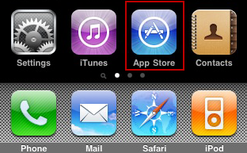
- Start the App Store application.
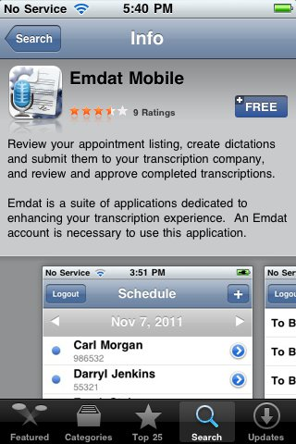
- Search for “Emdat Mobile.”

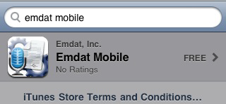
- Tap the “Free” button and the install option will display.
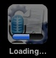
- The application will now install itself.

Starting Emdat Mobile
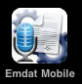
To get started, launch the Emdat Mobile application from the home screen after the installation has completed.

Once Emdat Mobile has started the login screen will appear. Enter your login credentials, which are the same as those used for InQuiry. Press the login button at the top right or the very bottom.

- Login – Enter your login name here.

- Password – Enter your password here.

- Client – The code that identifies the facility you work for.

- Save Login – The Emdat Mobile app will remember a user’s login when this option is switched to “ON”. The next time the application is opened, it will remember the login.

- Save Password – The application will remember a user’s password when this option is switched to “ON”, but it can only be used if the administrator of your facility’s account allows it. If this is set to “ON”, other people can gain unauthorized access to your account if they have your iPhone.
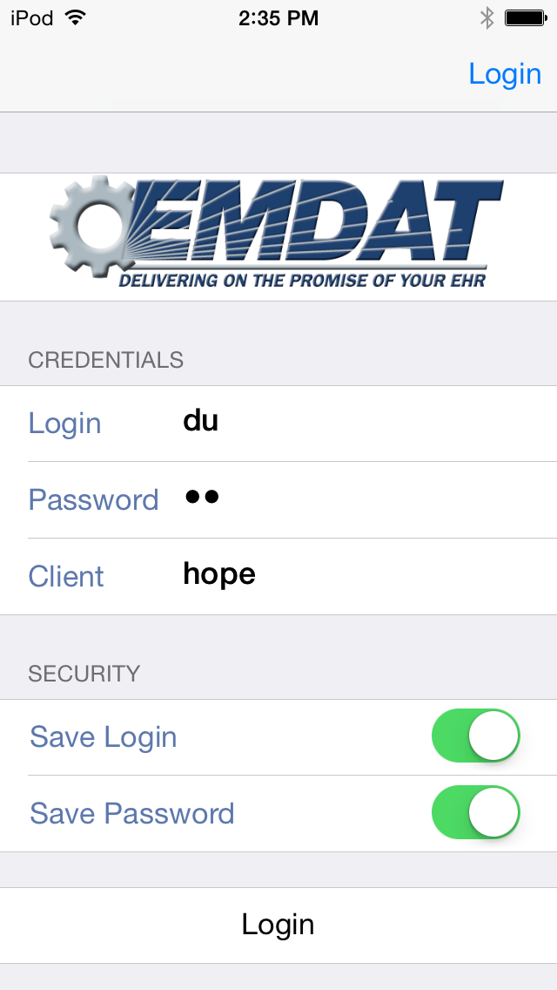

Using Emdat Mobile on iPhones and iPods
Once logged in, the Emdat Mobile application starts at the Account screen.

The iPhone and iPod application screens have four buttons at the bottom. These are for navigating to the four main screens of the iPhone app.

This button is highlighted in blue because the application is on the Patient Appointments screen. The other icons will highlight in blue when the application is on those screens.

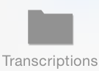
This button takes the application to the Transcriptions screen, where transcriptions can be viewed, approved, and edited.

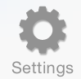
This button opens the Settings screen, where default settings for appointments, document types, locations, and other application features can be set. This is where the available document types and locations can be reduced to a smaller list of favorites.

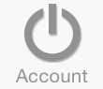
This button will access the Account Screen to facilitate switching between multiple Emdat Mobile logins.

The Patient Screen
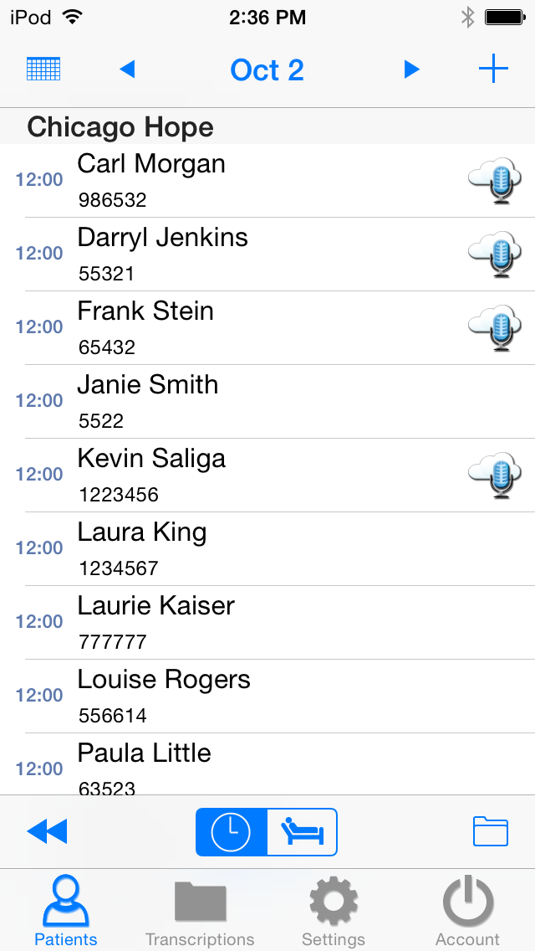
The Patient screen is used to review appointments and create new appointments and dictations. The calendar will open to the last viewed date in the previous session. If a dictation is over three days old, and has not been uploaded, Emdat Mobile will give a pop-up reminder.
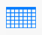
To choose a specific date tap the button in the upper left corner; the date selector will appear. The current day can be chosen from the date selector by tapping on the ‘Today’ button at the upper right of the screen.
Tap on the button at the upper right hand corner of the screen to create a new appointment. This will be covered in detail in the next section: The Dictation Screen.
Tap on the button at the lower right hand corner of the screen to filter which appointments will be visible. Filters can be used to hide appointments that:
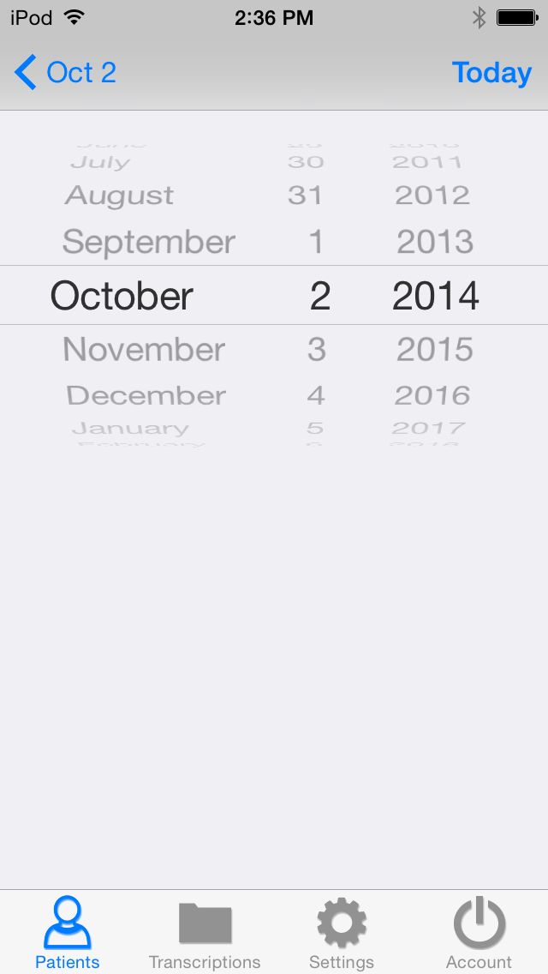
- Appointments dictated on other devices and already uploaded.
- Dictations that are currently uploading.
- Appointments that have dictation done and sent for transcription.

Appointments can also be filtered based on Schedule Resources. One or more Resource IDs can be assigned to a provider, and they can be filtered out as necessary.

Tap and hold down your finger while swiping down anywhere in the appointment listing to refresh the workflow folder listing. Note that this works when the view is already scrolled to the top.

Appointments that have a recorded dictation will show one of these icons:

- This icon represents an appointment that does have a recorded dictation, but has not been sent.

- This icon represents an appointment that has a recorded dictation and has been successfully sent to the transcription company.
- This icon represents an appointment that has been recorded and uploaded from another device.

The Dictation Screen
Select an appointment from the list in the Patient screen to view its details and record a dictation. New appointments are created by tapping on the button at the upper right side of the screen. The recording controls appear at the bottom of the screen.

The Info Tab
The Info Tab contains all the information about that specific appointment, such as the Document Type and Location. If a document type or location is not selected those fields will be highlighted in red. Additional appointment details can be found here.

Only the Document Type and Location can be edited for Dictations created from the appointment list. In addition for ad hoc dictations started with the button, Patient ID and Appointment Date and Time can also be edited.

Dictate any other appointment information that needs to be changed. The transcriptionist will make those changes during transcription.

The three screen shots below are from the Info tab. By default, the Info tab will appear when an appointment is opened. The default screen can be changed to Templates or History on the Settings screen.

By default, when new dictations are created, Emdat Mobile does not select a Document Type or Location for that dictation. When uploading a dictation with no Document Type or Location selected, Emdat Mobile will prompt the user to select one from a list of available Document Types and Locations. However, to stop Emdat Mobile from prompting for a Document Type and Location when uploading, select a default Document Type and Location from the Settings Screen.

The location for an appointment can be set by the facility scheduling software or EMR and it will appear by default. This location can still be changed by tapping on the location bar and selecting the new location.

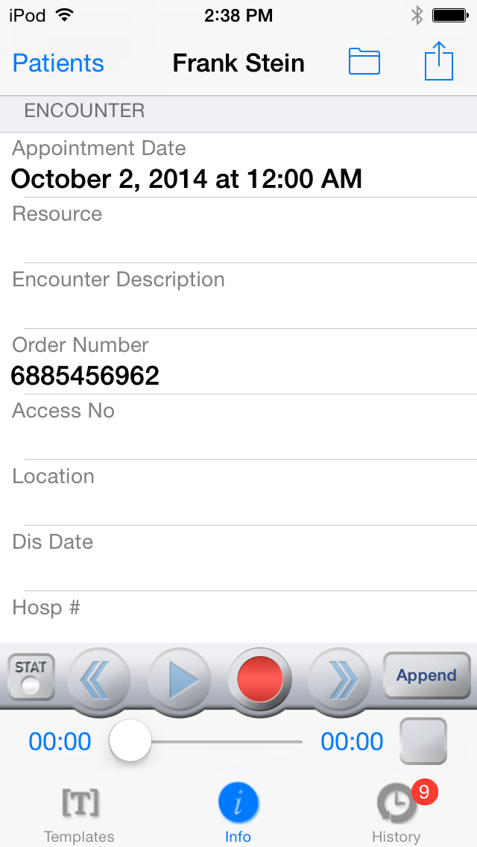
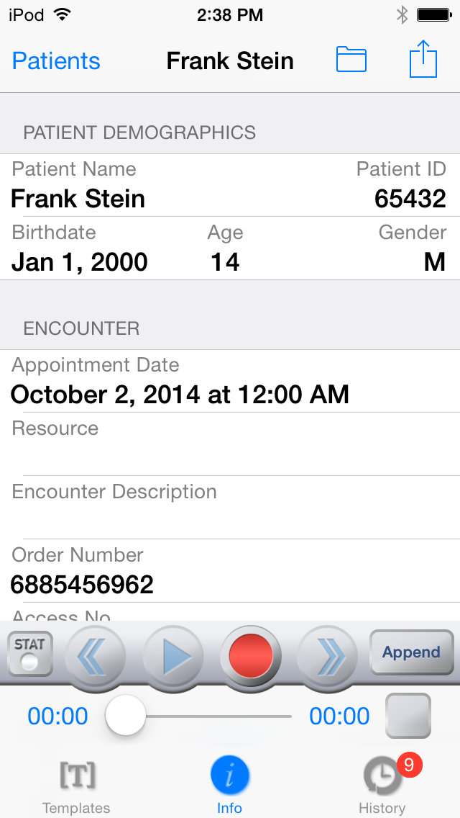
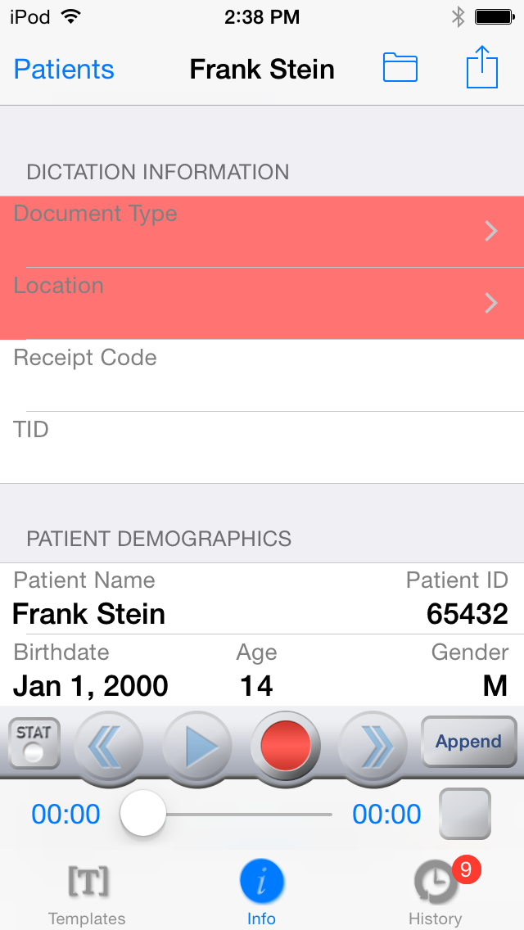

The Templates Tab
The templates tab shows the Document Template and Dictation Templates which can be used as a reference while dictating. The Document Type can be selected by tapping on the icon on the right side of the Document Template field. The template is displayed by tapping anywhere else in the field.
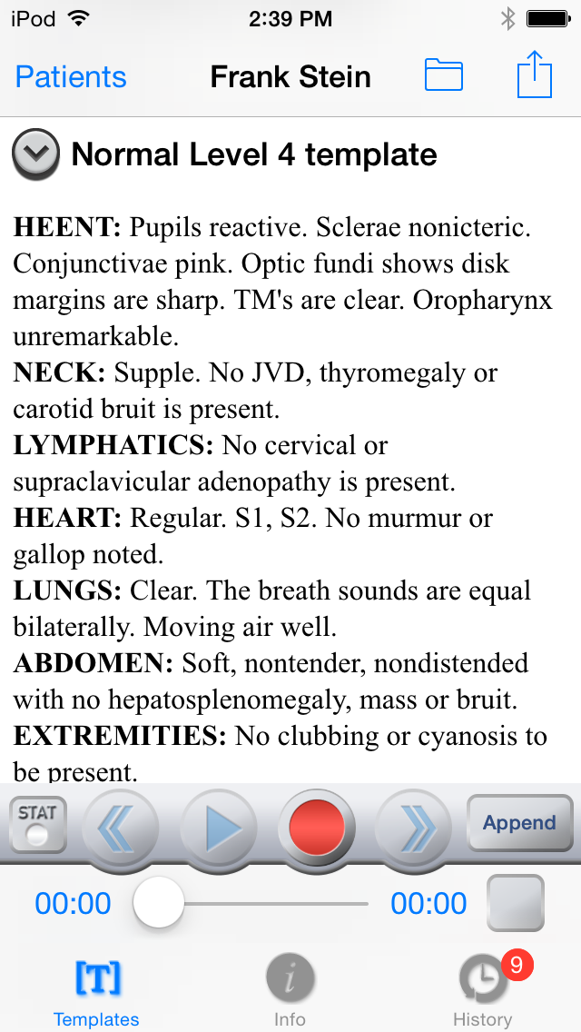
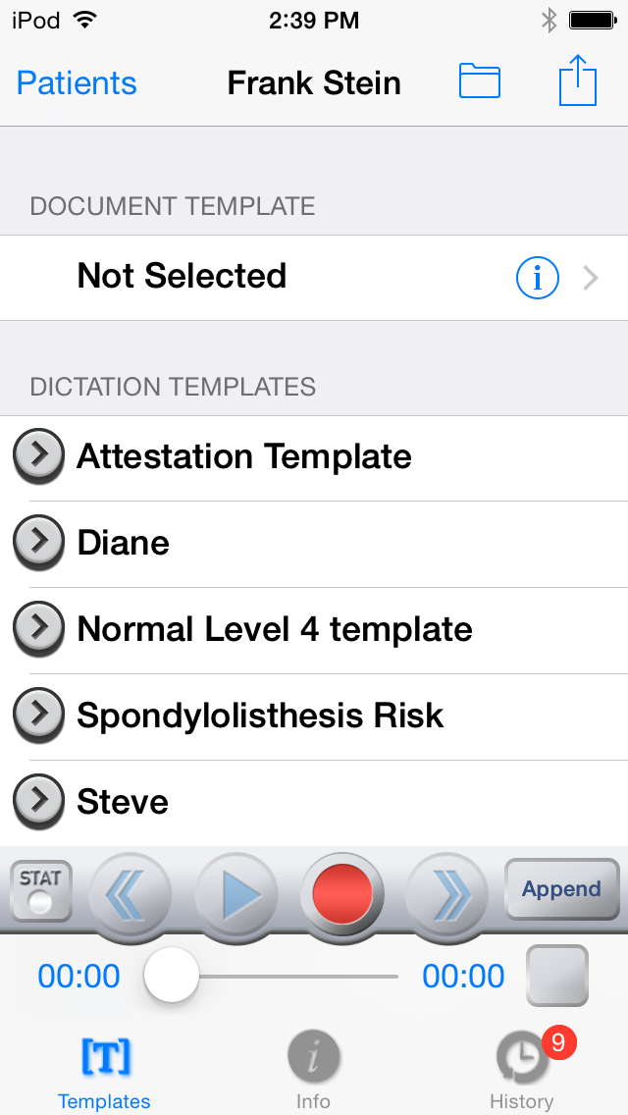

The History Tab
When Emdat Mobile recognizes the Patient ID for the current appointment, the history button will indicate the number of prior transcriptions for that patient that are available for review. Tap to show the list of prior transcriptions, which include document type, dictating clinician, and date for each transcription. Select an item to review its transcription and demographic details.

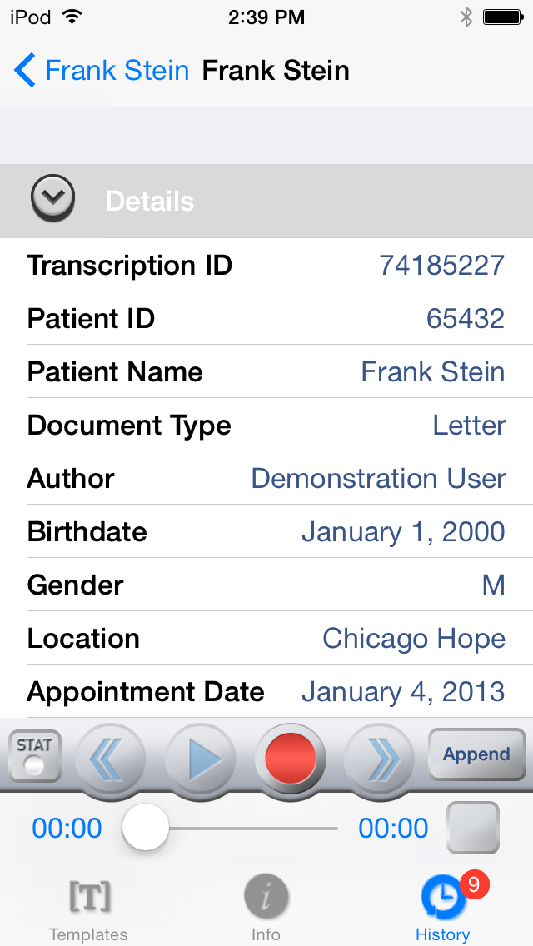
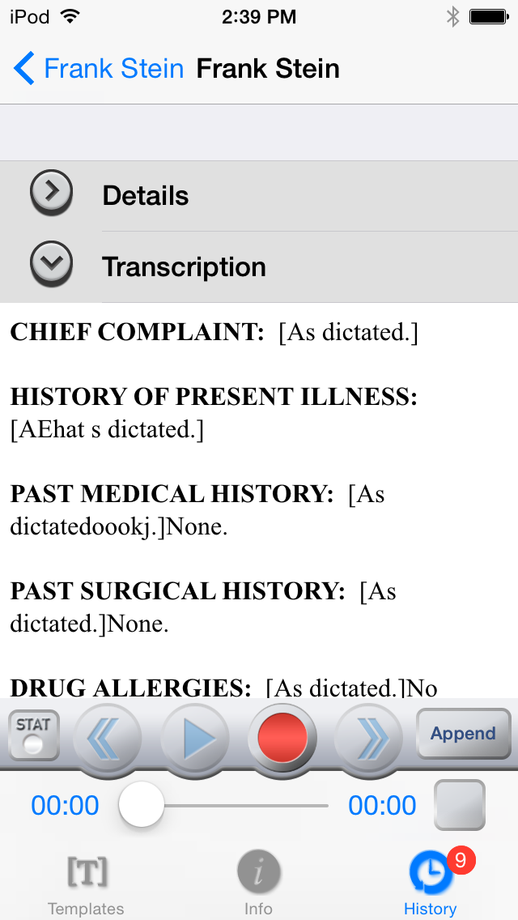
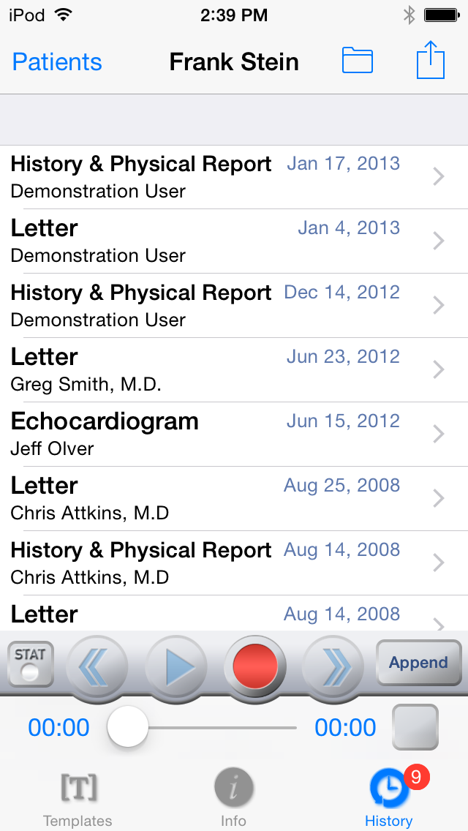

Recording A Dictation

iPhone and iPod
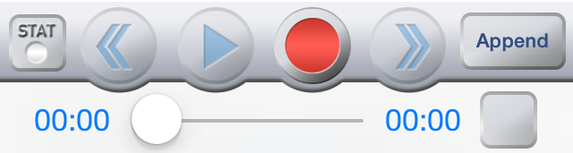
The recording mode can be modified by tapping on the button to the right side of the screen. The button at the far right indicates the current recording mode. Tap to switch between Append, Overwrite, and Insert modes. Underneath the recording buttons, the timer on the left side shows what part of the dictation is currently playing, or being recorded into, and the timer on the right shows the total length of the dictation. The slider can be dragged to play different parts of the dictation.
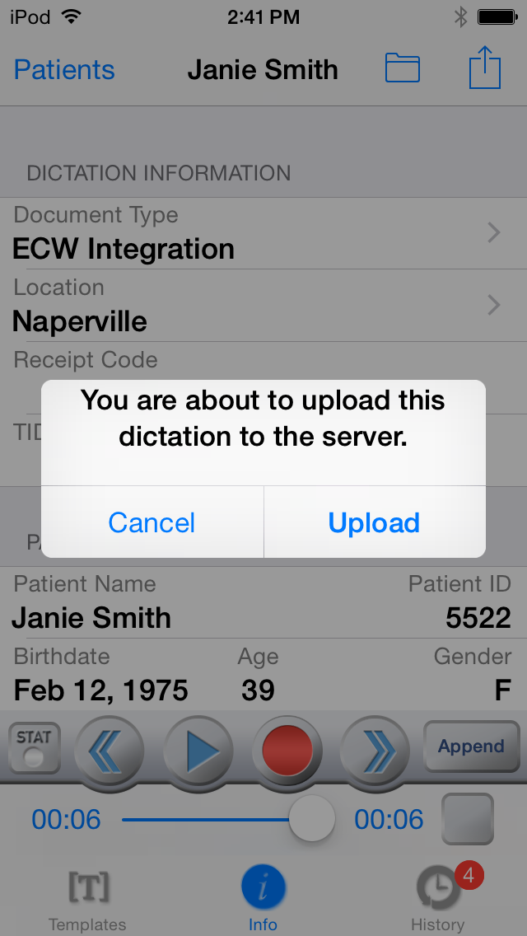
The box to the right of the recording timer is an equalizer that should flash green during dictation.

Note: Some older iPads and iPods must have a microphone attached to enable recording.

When the dictation is complete, tap the Upload button in the top right corner of the screen. The Emdat Mobile application will prompt to select a Document type and/or Location if one has not yet been chosen. Tapping the Upload button will send the dictation for transcription. Once a dictation is uploaded, no more changes can be made to it; it cannot be marked STAT for example.

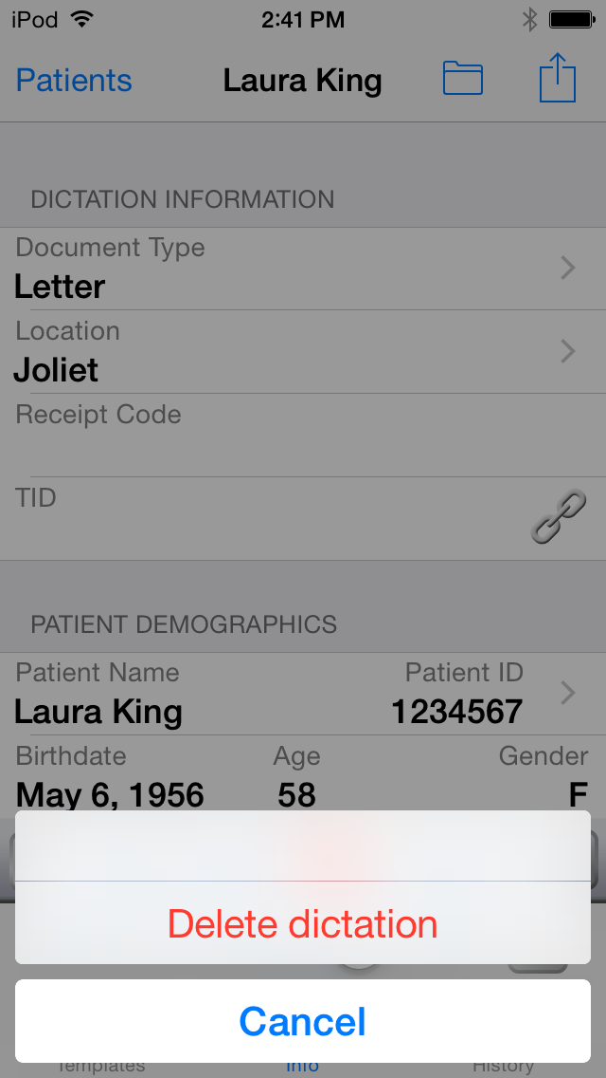
Tapping this will provide the option to delete the recorded dictation from the device. If the appointment was created new on the phone the appointment will be removed. If the appointment was downloaded from the Emdat servers, the appointment will not be removed from the Patient Appointments screen.

The Patients button on the top left corner can be tapped while recording or when recording is paused. Tapping on the Patients button will pause the dictation and return Emdat Mobile to the Patient Appointments screen.

Creating a New Appointment
Use the button at the top right corner of the Patient Appointments screen to create a new appointment, which can then be dictated. The appointment date will be populated with the date currently shown at the top of the Patient Appointment screen, but it can be changed.

There will be an arrow next to the Patient ID field; tap on this button to enter the patient ID for this appointment. The patient’s name and demographic data will be associated with the appointment when the dictation is uploaded to the transcription company.

Creating Multiple Dictations on One Appointment
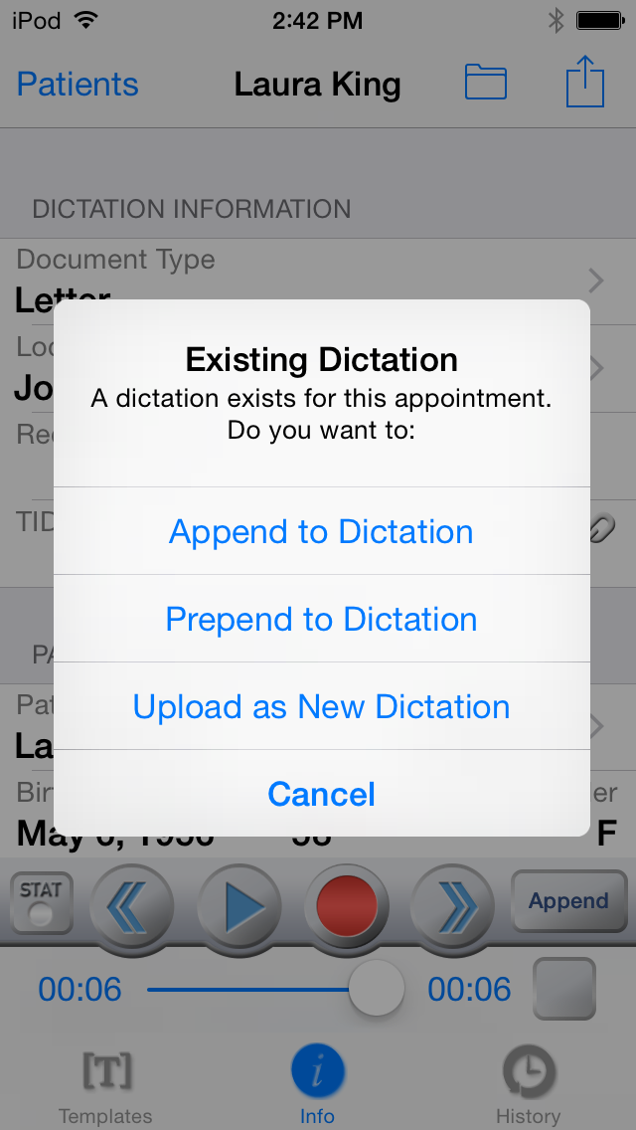
If it is necessary to create an additional Transcription for an Appointment return to the Patient Screen and locate the appointment.

Press the edit button and select the option for “New Dictation.” Select Document Type, Location, and record normally.

Press the upload button and Emdat Mobile will prompt for Append information.

- Append: Attach this transcription to the end of the prior transcription.

- Prepend: Attach the prior transcription to the end of the new transcription.

- Upload as New Dictation: Upload this dictation as a standalone Transcription. This Transcription will not be attached to any prior Transcriptions.

The Transcriptions Screen
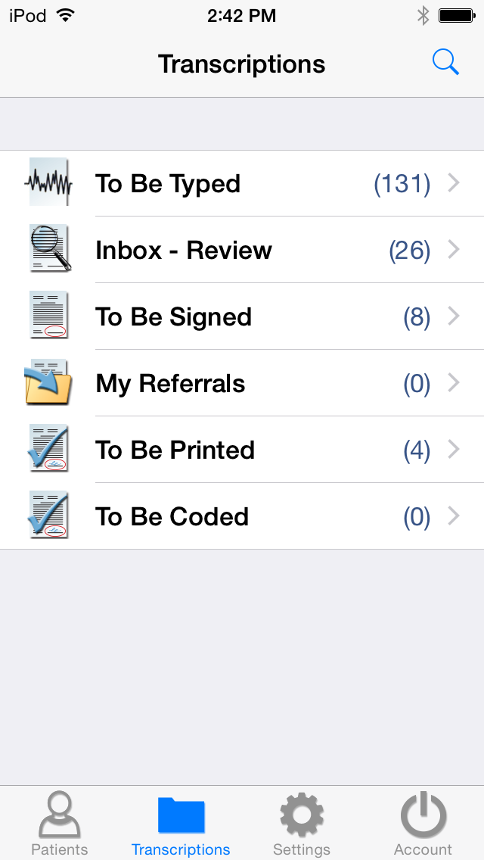
The workflow screen gives an overview of how many transcriptions appear in each folder of the workflow. The workflow folders will display the label name assigned by your medical facility.

Tapping on any of the folders will show a list of the transcriptions that are in that stage of the workflow. The first folder, here called “To Be Typed”, contains dictations that are at the transcription company, but have not yet been transcribed.

The Folder View
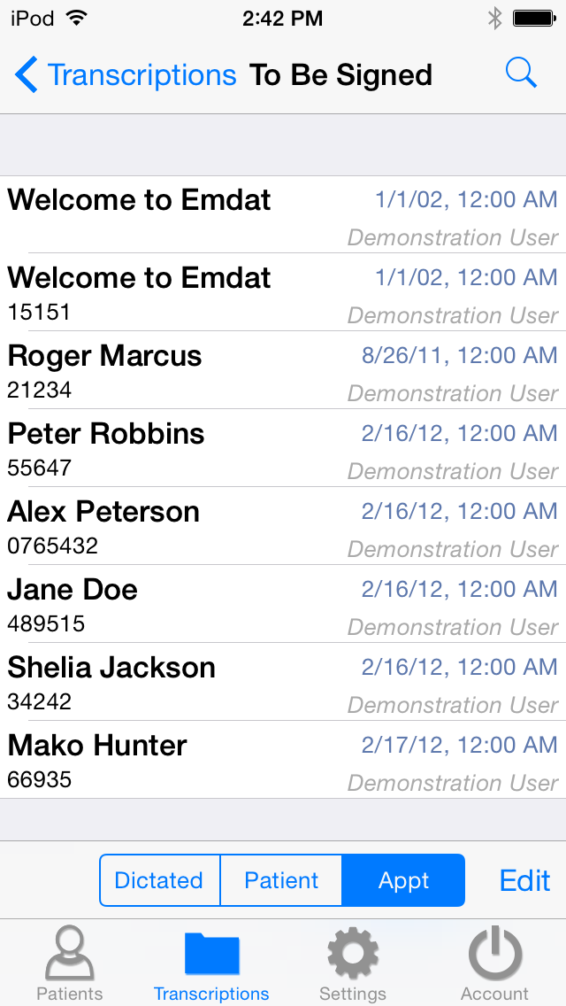
When a workflow folder is opened, Emdat Mobile will list all transcriptions that would be seen in that folder in InQuiry. The patient name, patient ID, appointment Date and Time, and dictating clinician’s name are shown for each transcription in that folder.

The Edit button at the lower right corner of the screen is used to complete all or selected transcriptions, and move them to the next folder in the work flow. Select or de-select transcriptions by tapping on them; a checkmark will appear next to the selected transcriptions. Then tap on the complete button to complete them, or the cancel button to cancel without completing the selected transcriptions.

The sort order of the folder view can be by Date Dictated, Patient Name, or Appointment Date. This sort order is changed by tapping on the Dictated, Patient, and Appt buttons at the bottom of the screen.

Tap and hold down your finger while swiping down anywhere in the transcription listing to refresh the workflow folder listing. Note that this works when the view is already scrolled to the top.

Searching for Transcriptions
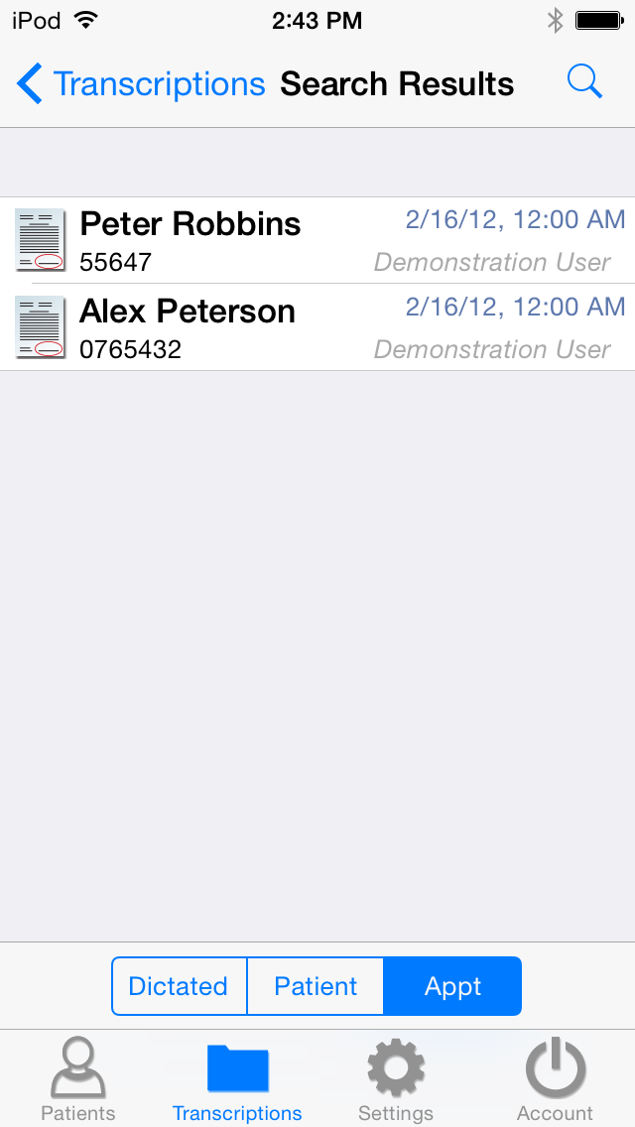
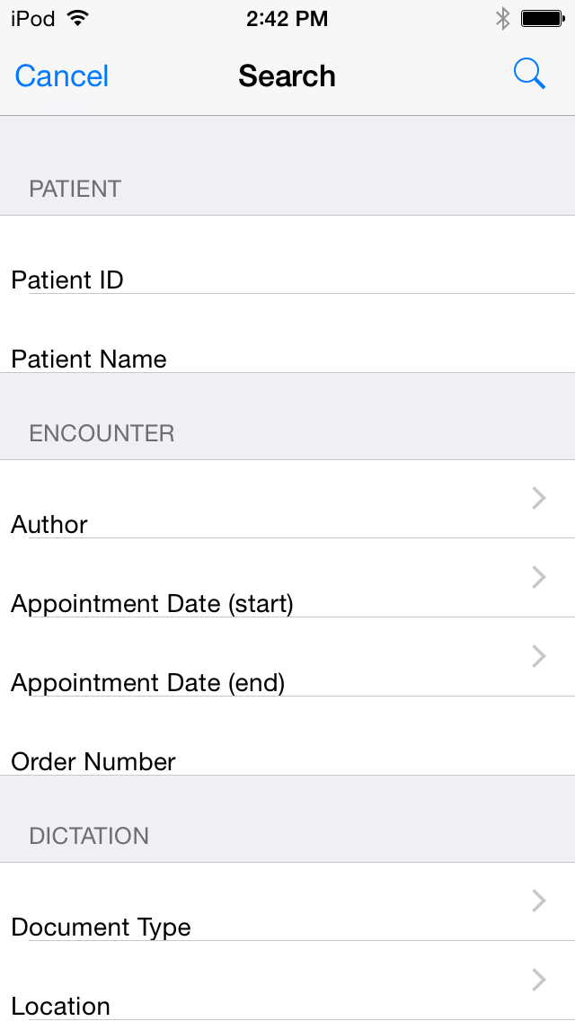
At the upper right corner of the Transcriptions Screens is the Search Button. This button appears in both the main Transcriptions screen, and the screens for each individual folder. When the Search Button is used from the main Transcriptions screen it will search in all folders of the workflow.

When the Search Button is used from within a folder in the workflow it will only search transcriptions in that folder.

The icons next to the Search Results will indicate which workflow folder that dictation is in. The icons are:

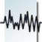
- Dictation – This is a dictation that is still being transcribed by a transcriptionist.
- Review – This is a transcription that is in the Review folder of the workflow.
- Preliminary – This is a transcription that is in the Preliminary folder of the workflow and can be electronically signed.
- Final – This transcription is in one of the Final/Print folders at the end of the workflow.
- Referral – This transcription is in the Referral folder; a folder for Emdat clients at other facilities to view dictations as associates.
- Archive – This transcription has been moved through the entire workflow and is now archived.

Transcription Viewer
A transcription is viewed by tapping on one of the entries in any workflow folder other than the Dictation Status folder; that folder contains dictations that have not yet been transcribed. The Patient Name will be displayed at the top between the Back arrow button at the left, and the Edit/Complete button to the right.

Create a New Dictation, Complete, or Edit a transcription by tapping the button on the upper right. After completing a transcription the application loads the next transcription immediately. The Edit screen is covered in the next section of this manual.

The template editor box appears when a dictation is completed if a signature requires an attestation. Emdat Mobile will prompt you to enter your attestation with you electronic signature. Choose from available attestation templates or complete without a template.

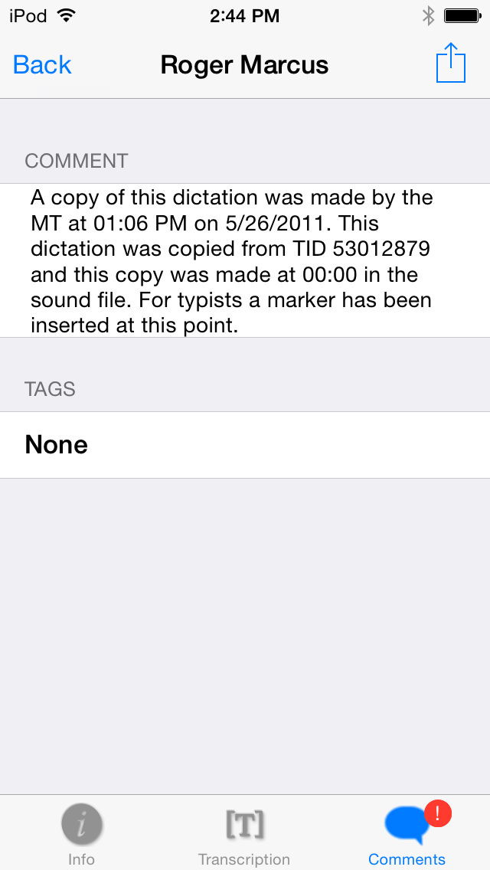
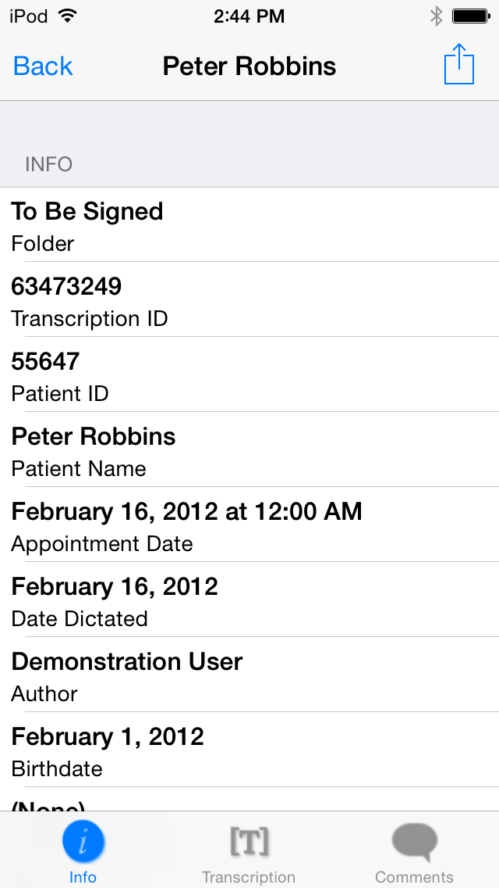
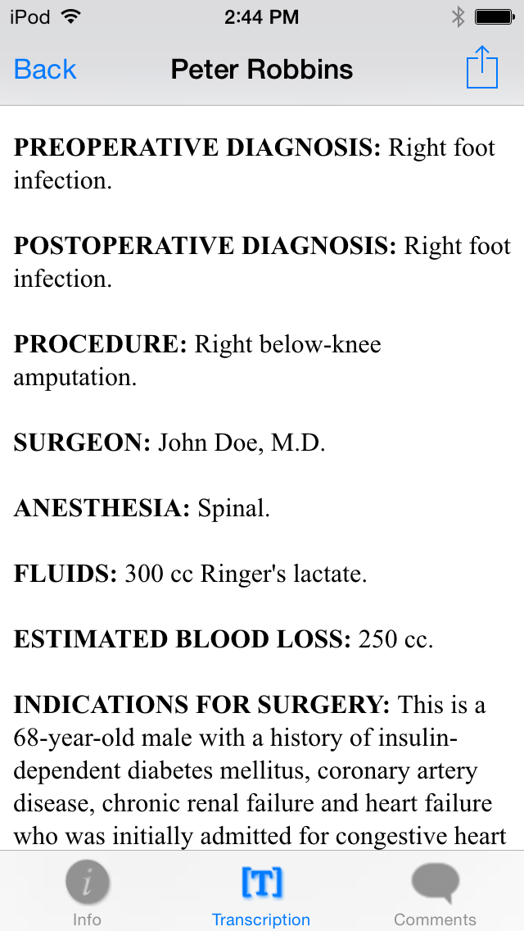
Recorded dictations are stored on the phone for two weeks after the dictated date, but they cannot be listened to from the transcription viewer. To listen to a recorded dictation that is still saved on the iPhone or iPod, go to its entry on the Schedule screen.

The Edit Screen
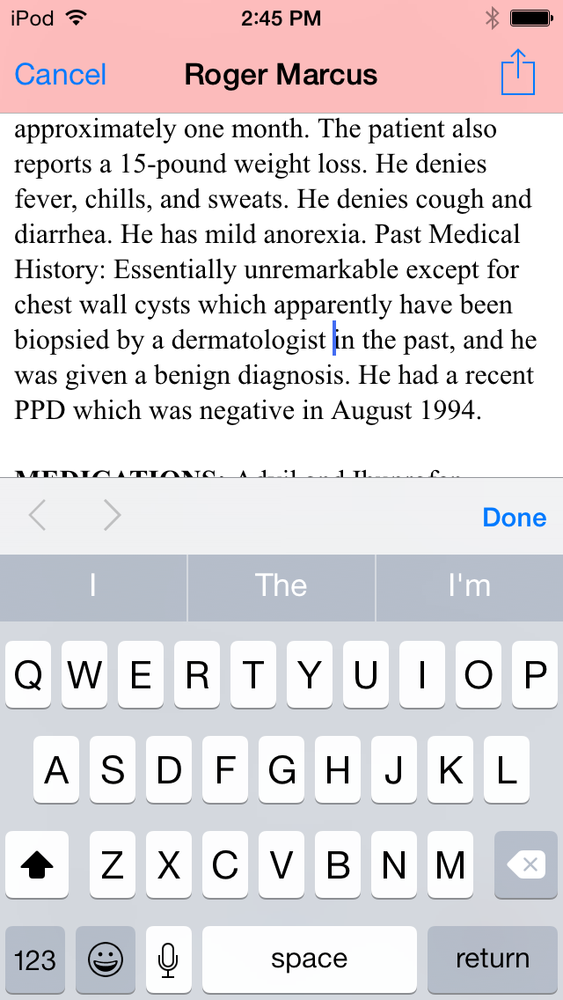
The Edit option is intended for small or minor edits. If more extensive editing and formatting is needed, consider using InQuiry on a desktop computer.

Access the Edit Screen by tapping the button at the top right corner of the transcription viewer. After tapping the button, Emdat Mobile will ask if the transcription is to be completed, edited, or to create a New Dictation. Tap on Edit to edit the transcription.

To edit a transcription’s demographic details, tap on the field to be changed. Depending on the type of field selected, the keyboard, date selector, or a list of options will appear. In text fields a button will appear. Tapping on this button will delete all of the text from that field.

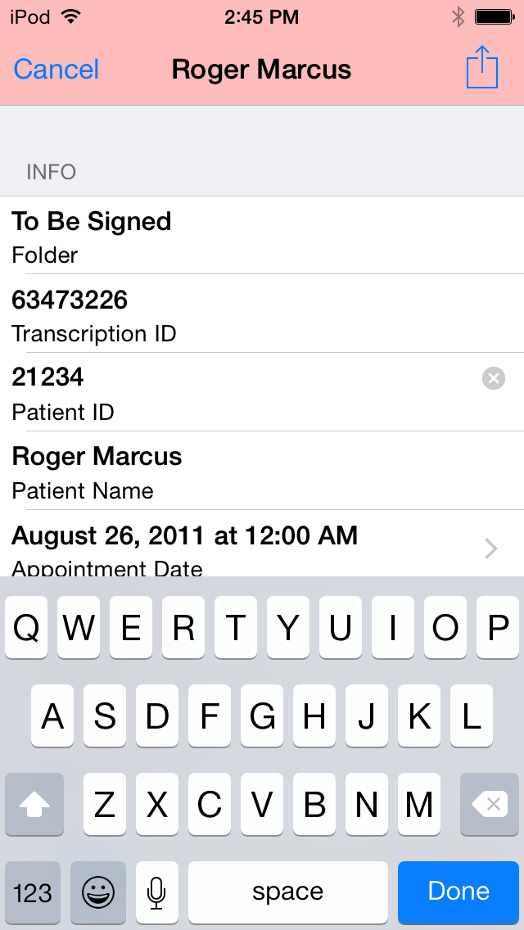
In date and text fields, tap the done button to keep the changes, and return to the Transcription Viewer. Tap the Cancel button to cancel the changes made, and return to the Edit screen. In selection list fields (Location, Document Type, or Author) tap on a selection or the back button on the upper left hand corner of the screen to return to the Edit screen.

Changes are not saved until the Complete button is tapped in the Edit screen.

- New Dictation: Save Changes and begin dictation for a new Transcription.

- Undo Changes: Undo any changes and return to the Transcription Viewer.

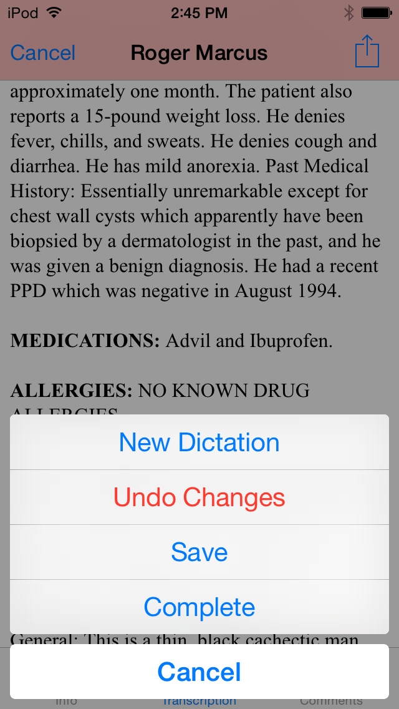
- Save: Save Changes and return to the transcription viewer.

- Complete: Save Changes and complete the Transcription from the workflow folder.

- Cancel: Return to the Editing screen.

The Settings Screen
The Settings Screen is used to set default screens and behavior for the Emdat Mobile application.

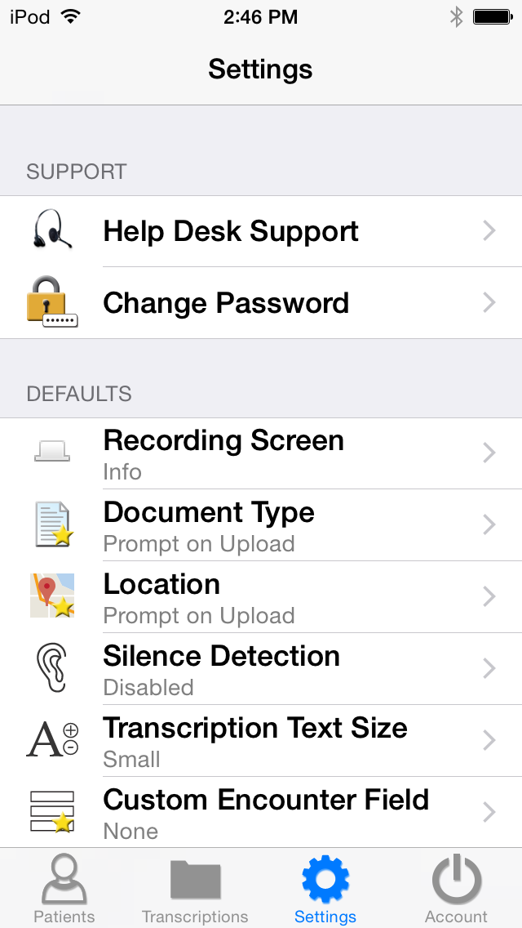
- Change Password: Change the password for Emdat Mobile. Remember that InQuiry, InSync, and Emdat Mobile passwords are all the same.

- Recording Screen is used to choose which tab is selected when opening a Patient Appointment; Templates, Info, or History. Info is selected by default.

- Document Type is used to select a default document type for dictations. The previous default document type setting will be set as default. If “None” was selected before, Prompt on Upload will be selected by default. Emdat Mobile will prompt to select a document type when uploading a dictation that does not have one selected. If this is the first time Emdat Mobile has been used, Prompt on Upload will be defaulted in.

- Location is used to select a default location for dictations. The previous location setting will be set as default. If None was selected before, Prompt on Upload is selected by default. Emdat Mobile will prompt to select a location when uploading a dictation that does not have a one selected. If this is the first time Emdat Mobile has been used, Prompt on Upload will be defaulted in.

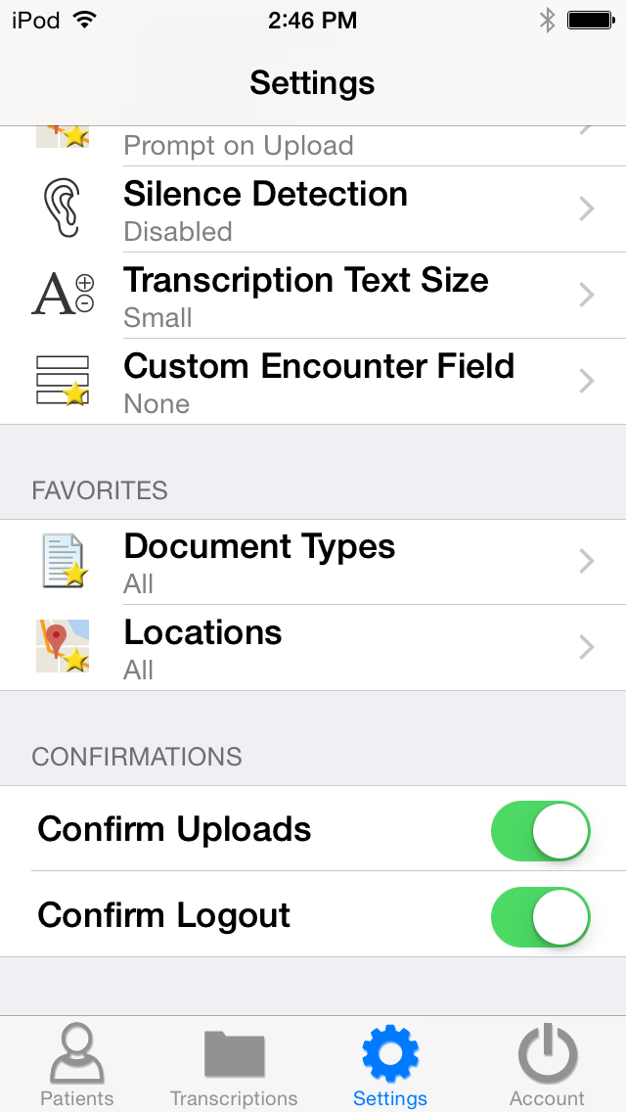
- Silence Detection selects how long Emdat Mobile will wait on silence before pausing a recording.

- Transcription text size selects how large text is when viewing a transcription.

- Custom Encounter field selects which custom field is displayed to the right of the patient name on the appointment listing.

- Document Types in the Favorites section is used to filter the document types that are available when choosing a document type for a dictation. If a facility has thirty document types, but a dictator only needs five of those document types, this setting is used to remove the other twenty-five from the list of possible document types.

- Locations are used to filter the locations that are available when choosing a location for a dictation. If a facility has fifteen locations, and a dictator only works at three of them, this setting is used to remove the other twelve from the list of possible locations.

- Confirm Uploads and Confirm Logout turns the confirmation pop-up for those actions on or off.

The Account Screen
Logout from the application by tapping the Account button located in the lower right hand corner of the application screen and pressing the logout button in the upper left corner.

Users who want to quickly switch between different logins can link additional accounts by pressing the button in the upper right corner of the Accounts screen. Then enter the login credentials and select login.

Unwanted accounts can be removed by swiping the account name from right to left and pressing the delete button that appears.

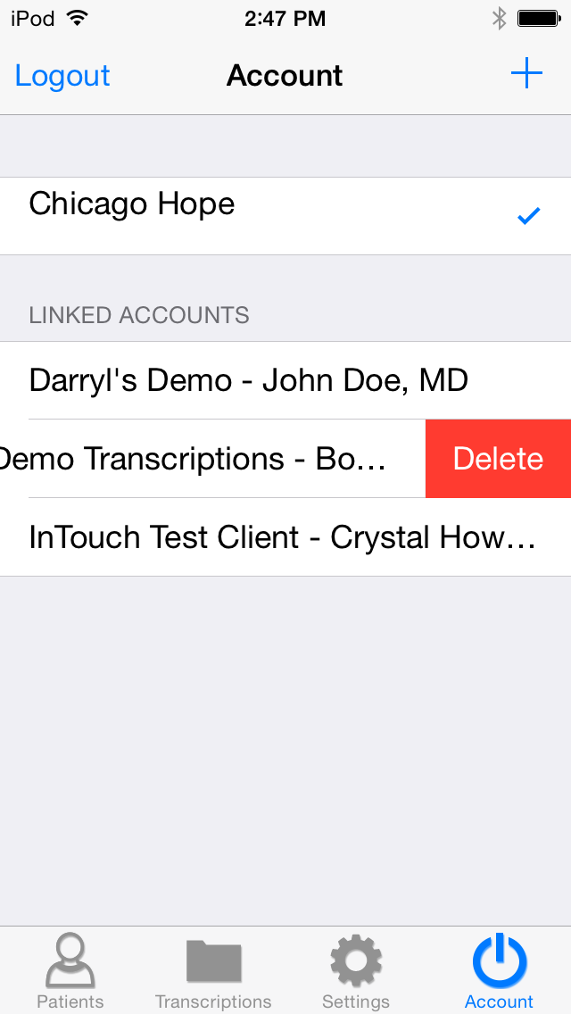
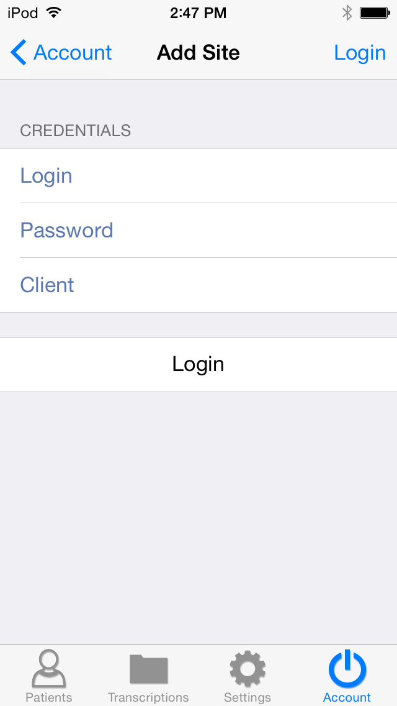
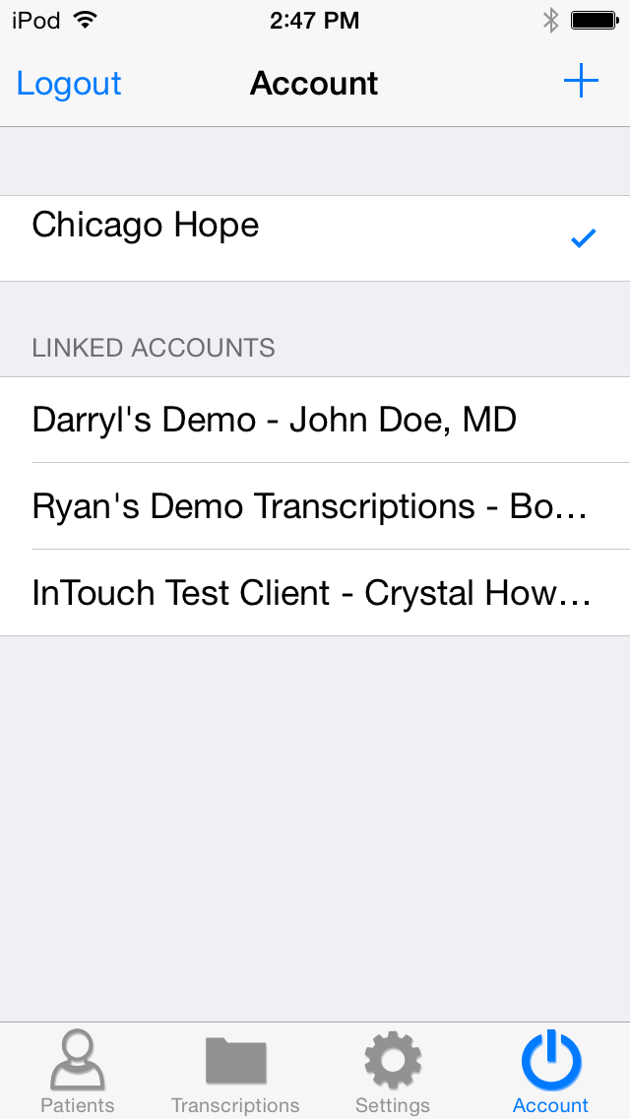

Emdat Mobile on the iPad

Logging into Emdat Mobile on iPad
To get started, launch the Emdat Mobile application from the home screen after the installation has completed.

Once Emdat Mobile has started the login screen will appear. Enter your login credentials, which are the same as what you use for InQuiry, and press the login button at the top right.

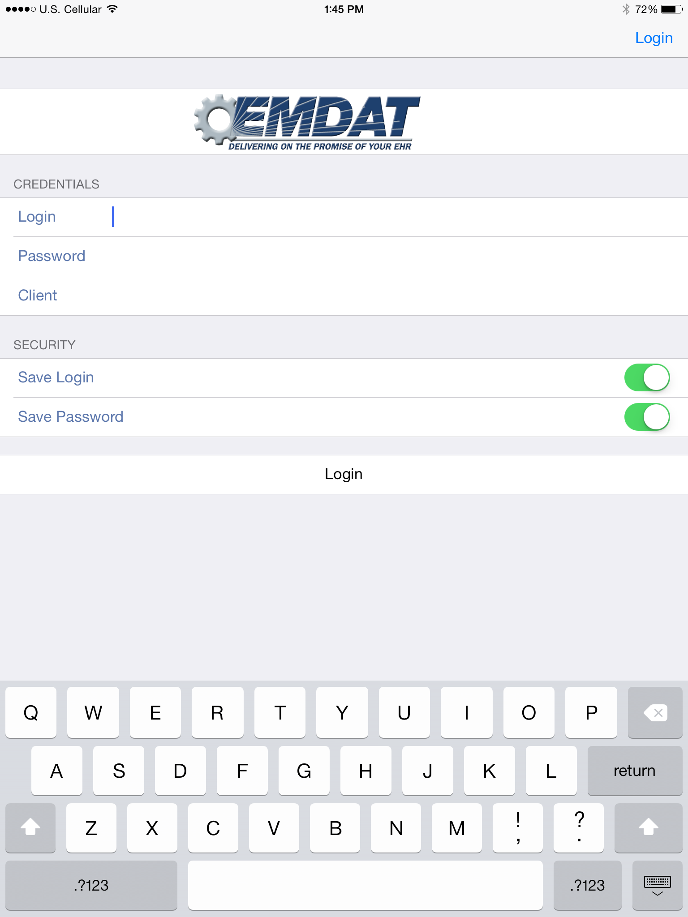
- Login – Enter your login name here.

- Password – Enter your password here.

- Client – The code that identifies the facility you work for.

- Save Login – The Emdat Mobile app will remember a user’s login when this option is switched to “ON”. The next time the application is opened, it will remember the login.

- Save Password – The application will remember a user’s password when this option is switched to “ON”, but it can only be used if the administrator of your facility’s account allows it. If this is set to “ON”, other people can gain unauthorized access to your account if they have your iPad.

Using Emdat Mobile on the iPad
The Schedule screen and buttons for Emdat Mobile on the iPad are different from the iPhone. These are the buttons that appear in the navigation bar on the left side of the screen when Emdat Mobile is used on the iPad:

The Patients screen displays a list of available patient appointments that have been assigned.
The Transcriptions button takes the application to the Transcriptions screen, where submitted dictations can be reviewed, edited, and passed through the workflow.
The Settings button takes the application to the Settings screen, where default behaviors of the application can be set; Silence Detection for example.
This button will access the Account Screen to facilitate switching between multiple Emdat Mobile logins.

Appointments on the iPad
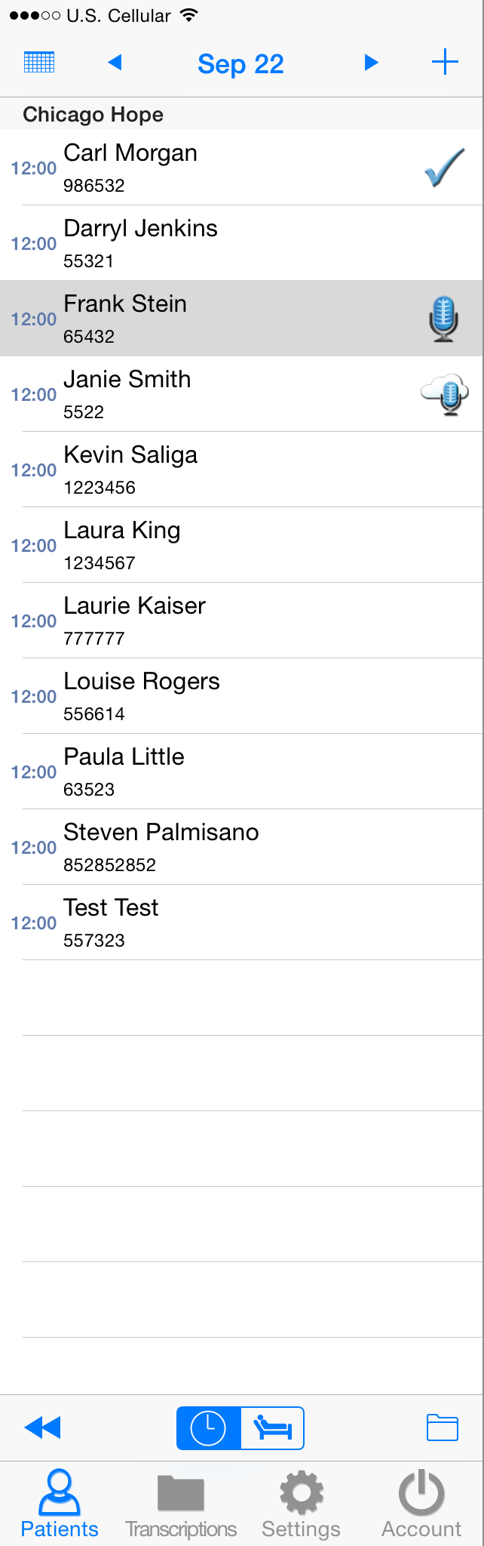
The navigation bar on the left side of the iPad application provides a list of patient appointments, and allows the application user to choose an appointment, or create a new appointment, dictate, and send the dictation in for transcription.
To create a new appointment, tap on the icon, this will create a new appointment. A patient’s medical record number can be entered to identify the patient when creating a new appointment on the iPad.

To dictate on an appointment, tap on the appointment to bring up the dictation screen and then tap on the red record button. From here, the history of this patient can be viewed, document type and location can be selected, and the dictation can be marked STAT.

Appointments that have a recorded dictation will show one of these icons:

- This icon is for appointments that have been dictated and uploaded from a different source, for example, called in by telephone with InTouch.

- This icon is for appointments that have a dictation on them, but have not yet been uploaded. Additional dictation can still be added to these appointments.

- This icon is for appointments that have been dictated on and sent in for transcription. Additional dictation cannot be appended to an appointment once it has been uploaded.

The iPad application stores dictations for two weeks after the appointment date. Dictations can be replayed from the appointments on the schedule screen.

Tap on the folder icon on the lower right of the Schedule screen, just above the Account button, to open the Filters screen. Filters are used to hide appointments that:

- Have been dictated on other devices.

- Dictations that are currently uploading.

- Dictations that have been completed.

Appointments can also be filtered based on Schedule Resources. One or more Resource IDs can be assigned to a provider, and they can be filtered out as necessary.

Tap and hold down your finger while swiping down anywhere in the appointment listing to refresh the workflow folder listing. Note that this works when the view is already scrolled to the top.

Below are screen shots of each of the three screens available when dictating in the iPad application. A screen is selected by tapping on the Templates, Info, or History buttons at the bottom of the screen. The button for the current screen turns blue to show which screen is selected.

The Templates screen previews document templates and dictation templates so they can be used as a reference while dictating. The document type can be selected by tapping on the blue icon at the right side of the Document Template field.

The Info screen is used to select document type and location for all dictations. When a new appointment is created on the iPad by tapping on the icon, the Info screen is where the patient MRN or name and the appointment date can be entered.

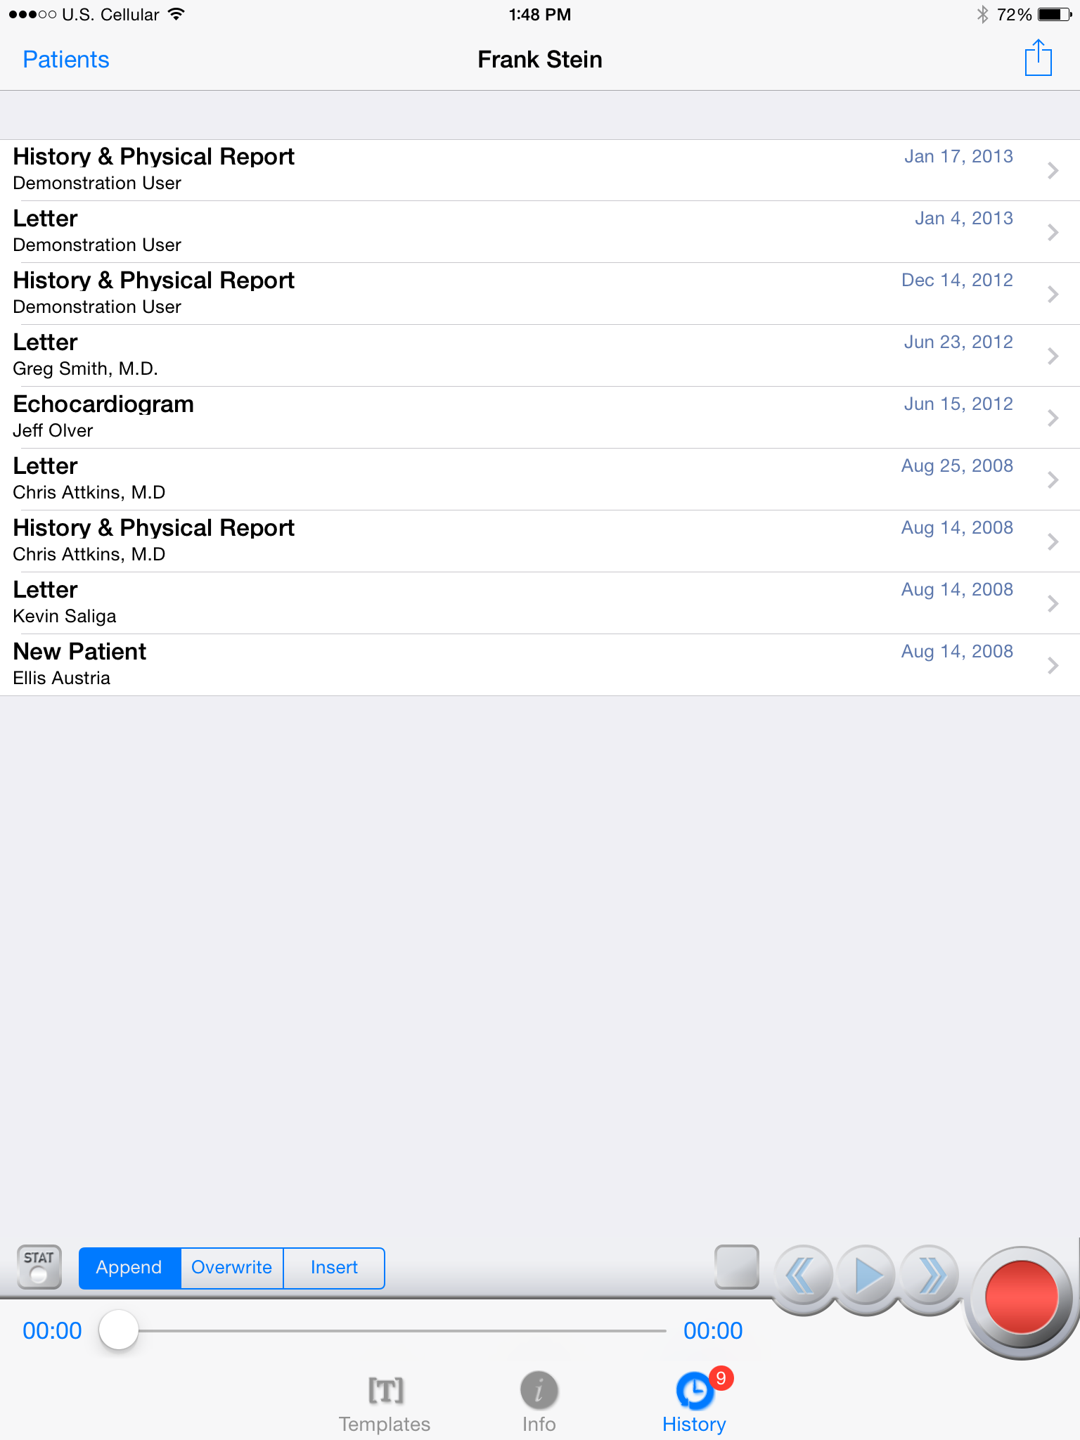
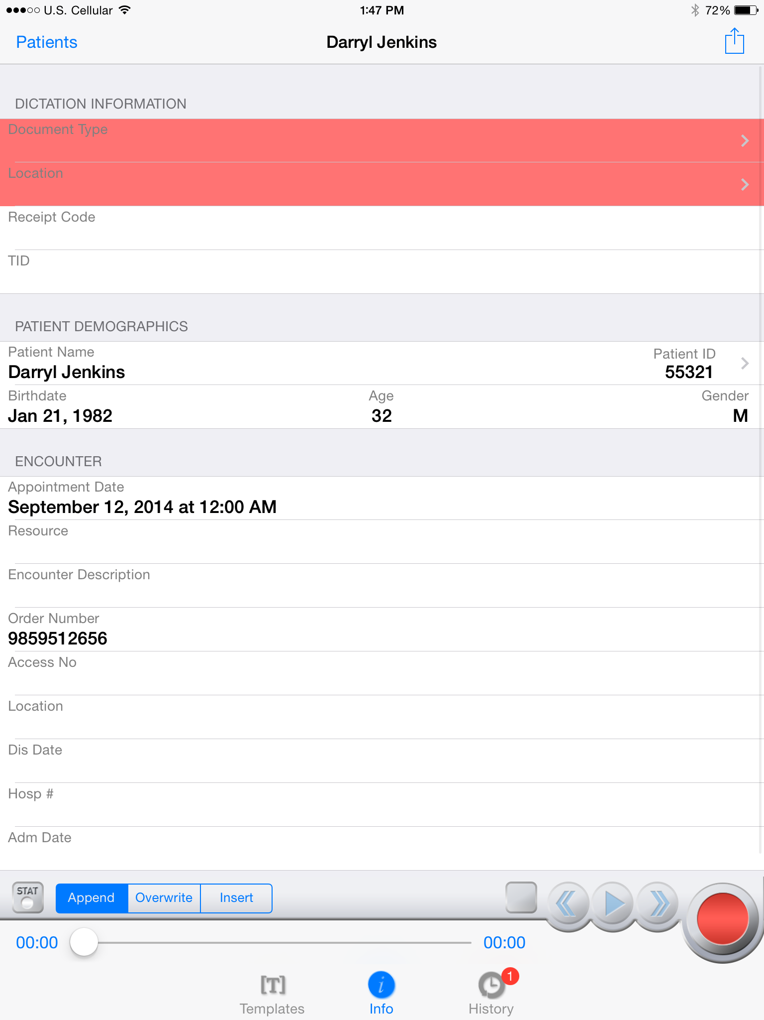
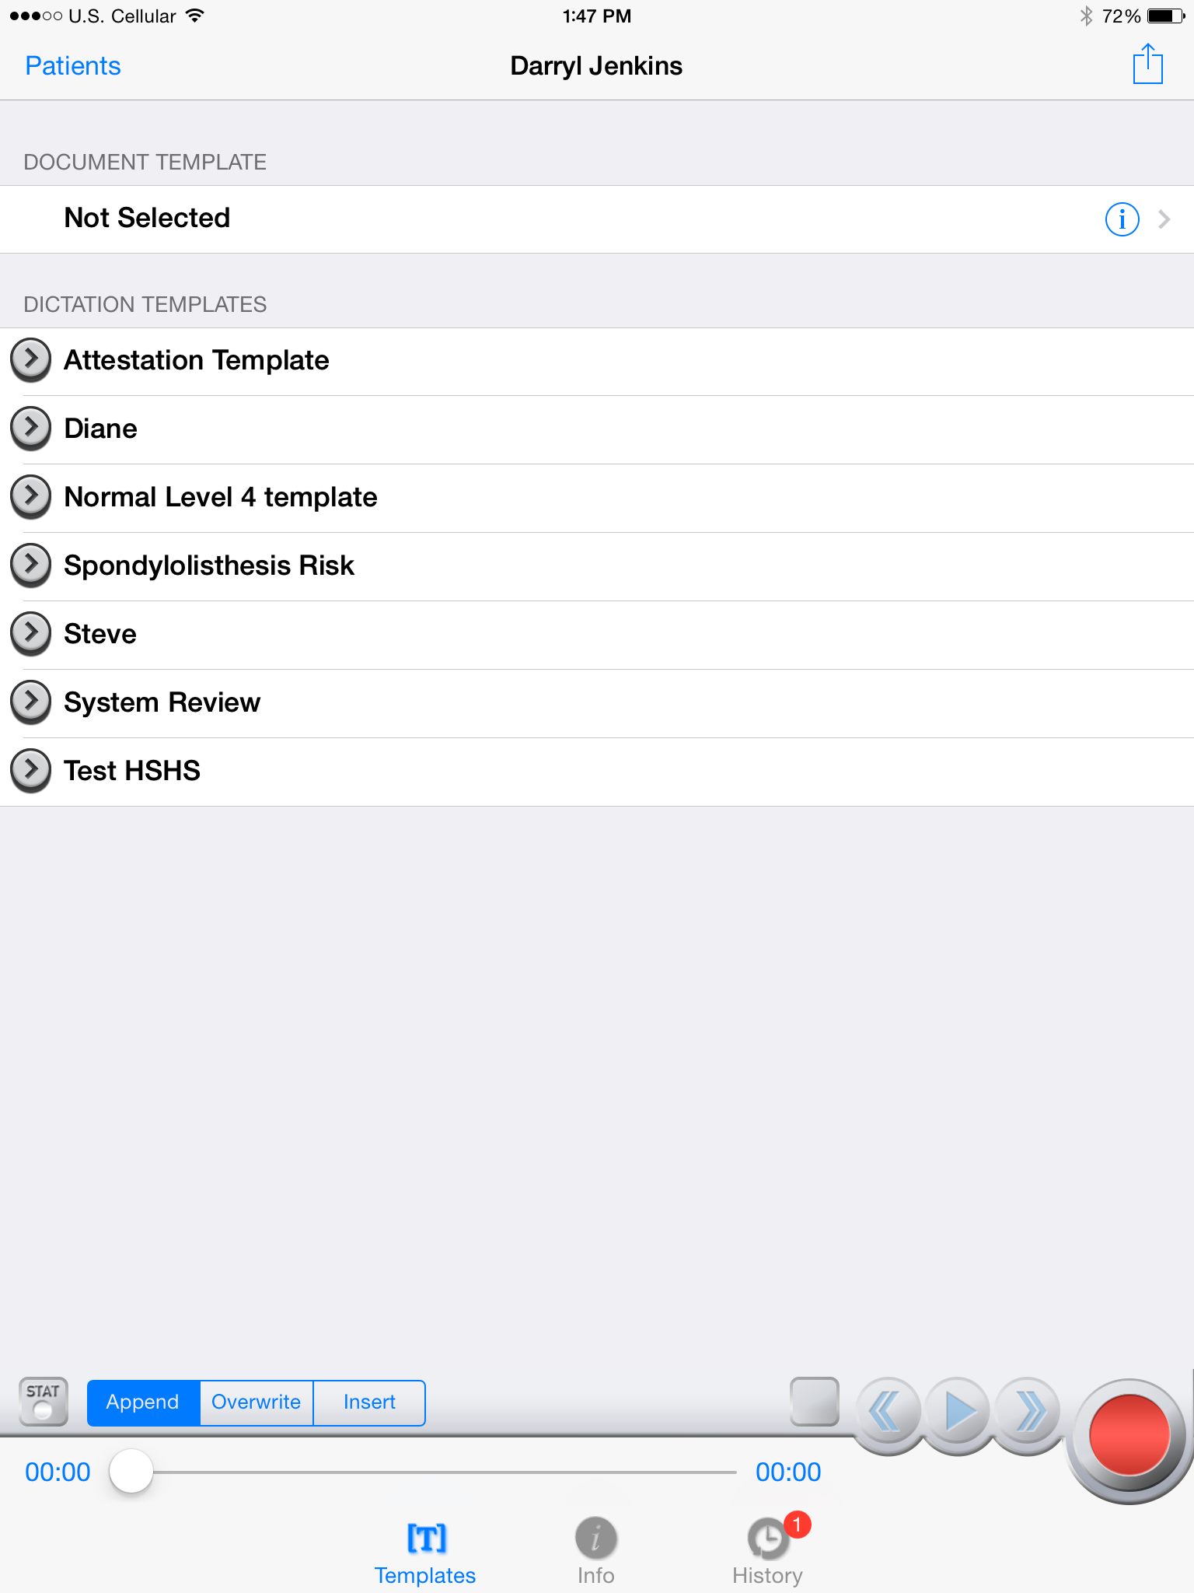
The History screen shows prior dictations done on the MRN or patient name that is entered for this dictation. Tapping on the items in this list will display the previous reports done on the patient.

Recording Dictation on the iPad
Recording a new dictation on the iPad is similar to recording dictations on the iPhone or iPod, but there are some minor differences. The History, Info, and Transcription screens do the same thing as the iPhone application’s screens. Dictations can also be marked STAT, recorded, and played back.

To change the recording mode from append to overwrite or insert, there are three buttons at the lower left of the screen. The size of the recording buttons cannot be changed. Tapping on the Patients button on the upper left corner of the screen will not close or pause recording; it will open the list of appointments to the left of the screen, and recording will continue.

By default, when new dictations are created, Emdat Mobile does not select a Document Type or Location for that dictation. When uploading a dictation with no Document Type or Location selected, Emdat Mobile will prompt the user to select one from a list of available Document Types and Locations. However, to stop Emdat Mobile from prompting for a Document Type and Location when uploading, select a default Document Type and Location from the Settings Screen.
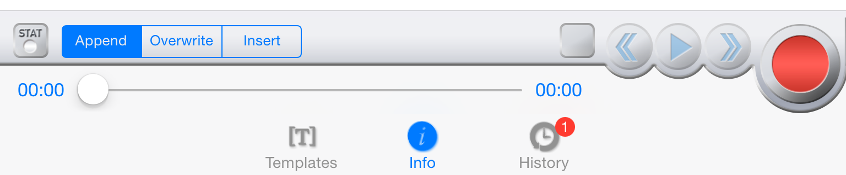

Viewing Pending and Completed Transcriptions on the iPad
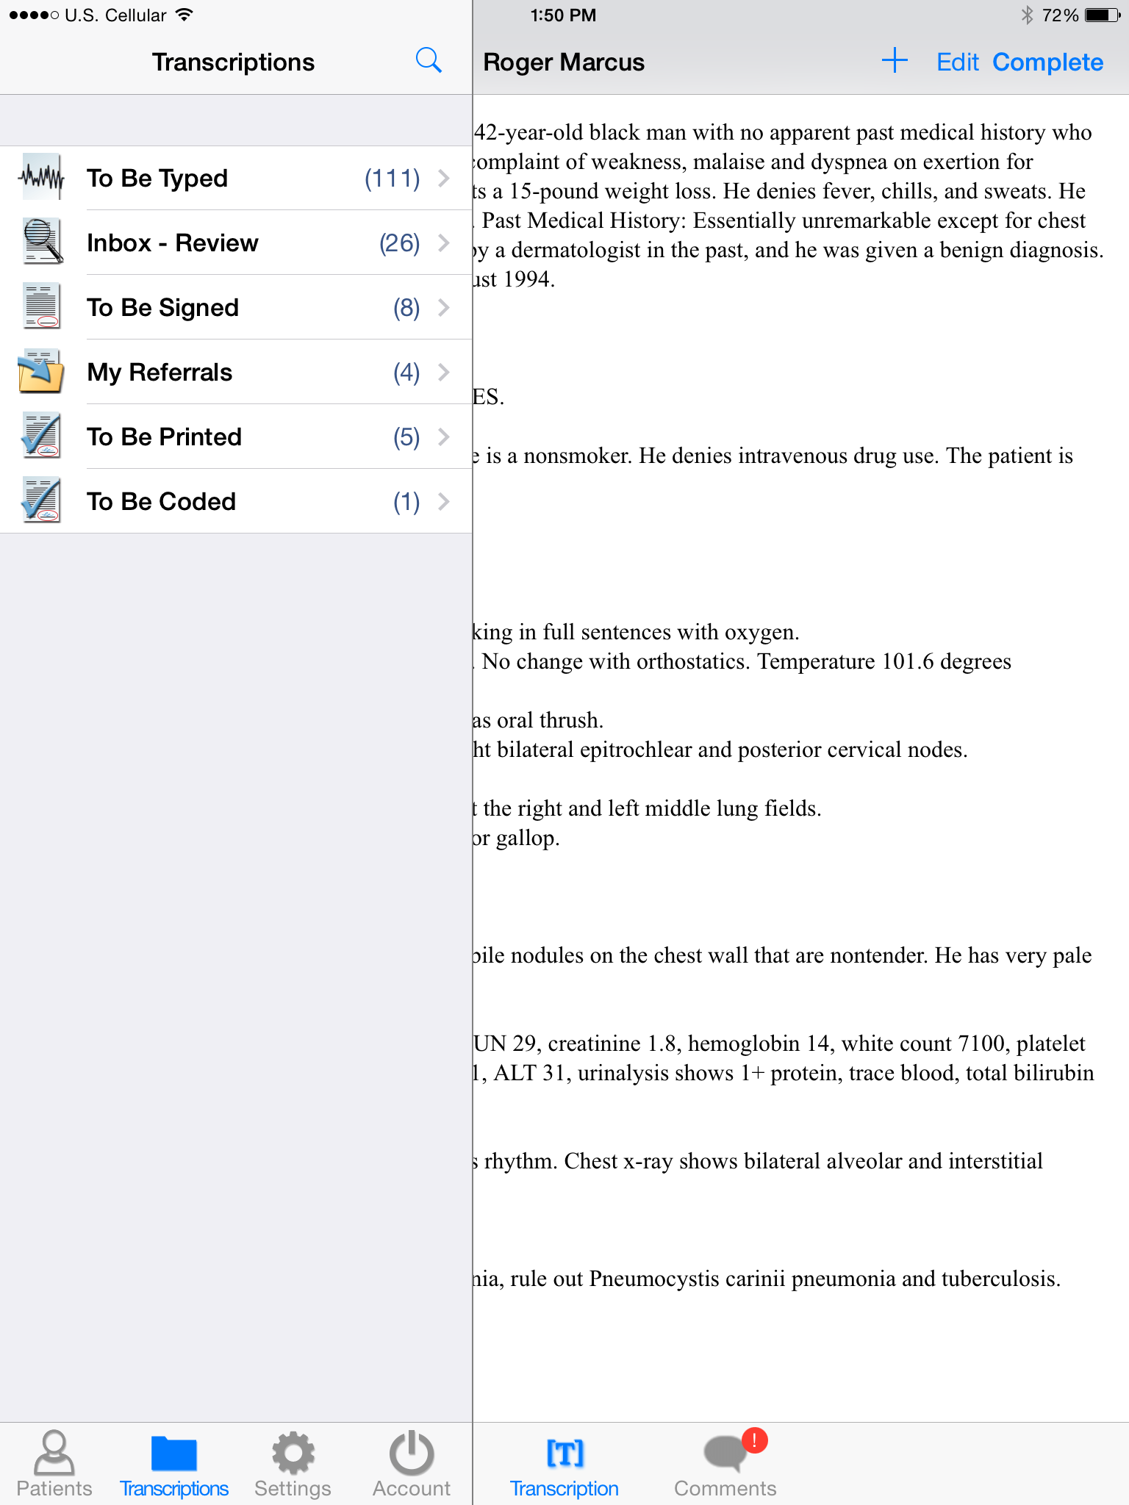
The workflow on the iPad will appear as a bar on the left side of the screen when the transcriptions button is tapped.

Tapping on one of the folders in the bar will bring up a list of all the reports that are in that folder. Tap on an item from this list to view and edit it.

When a transcription from the list is tapped on, the transcription viewer will come up. At the bottom of the transcription viewer are three buttons.

Tapping the Info button will bring up a screen showing the demographic data: MRN, Dates, Document Type, Location, etc. This data can be edited after tapping the edit button on the upper right side of the screen.

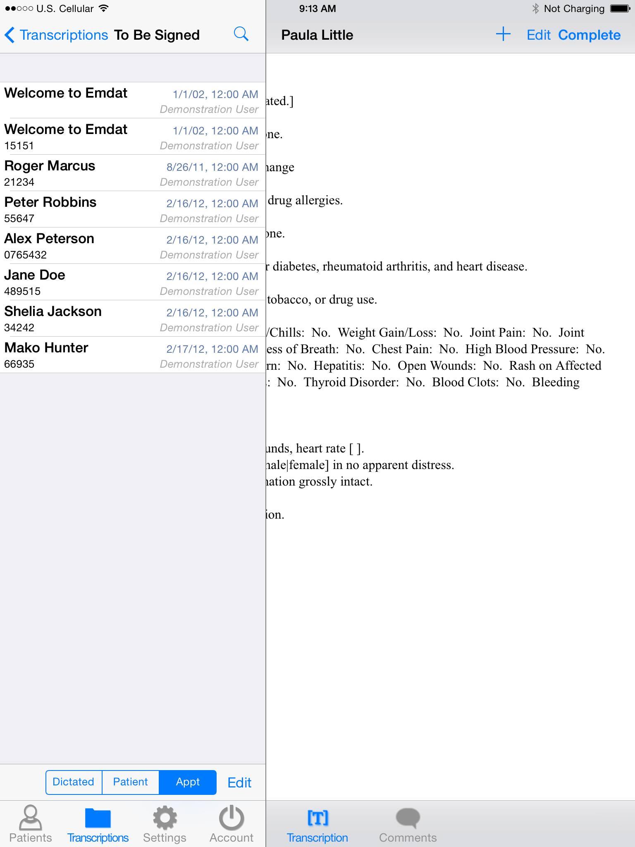
The Transcription button will show the text of the dictation. This can also be edited by tapping on the edit button on the upper right side of the screen.

The Comments button will show comments and comment tags on the transcription. These are usually comments from the transcriptionist about the dictation. Comments and comment tags cannot be edited in this application.

Tap on the Edit button on the lower right of the navigation bar to complete all documents in a folder, or select a set of documents in a folder for completion. This button is not used to edit the text of a transcription.

Tap and hold down your finger while swiping down anywhere in the transcription listing to refresh the workflow folder listing. Note that this works when the view is already scrolled to the top.

The Search Function on the iPad
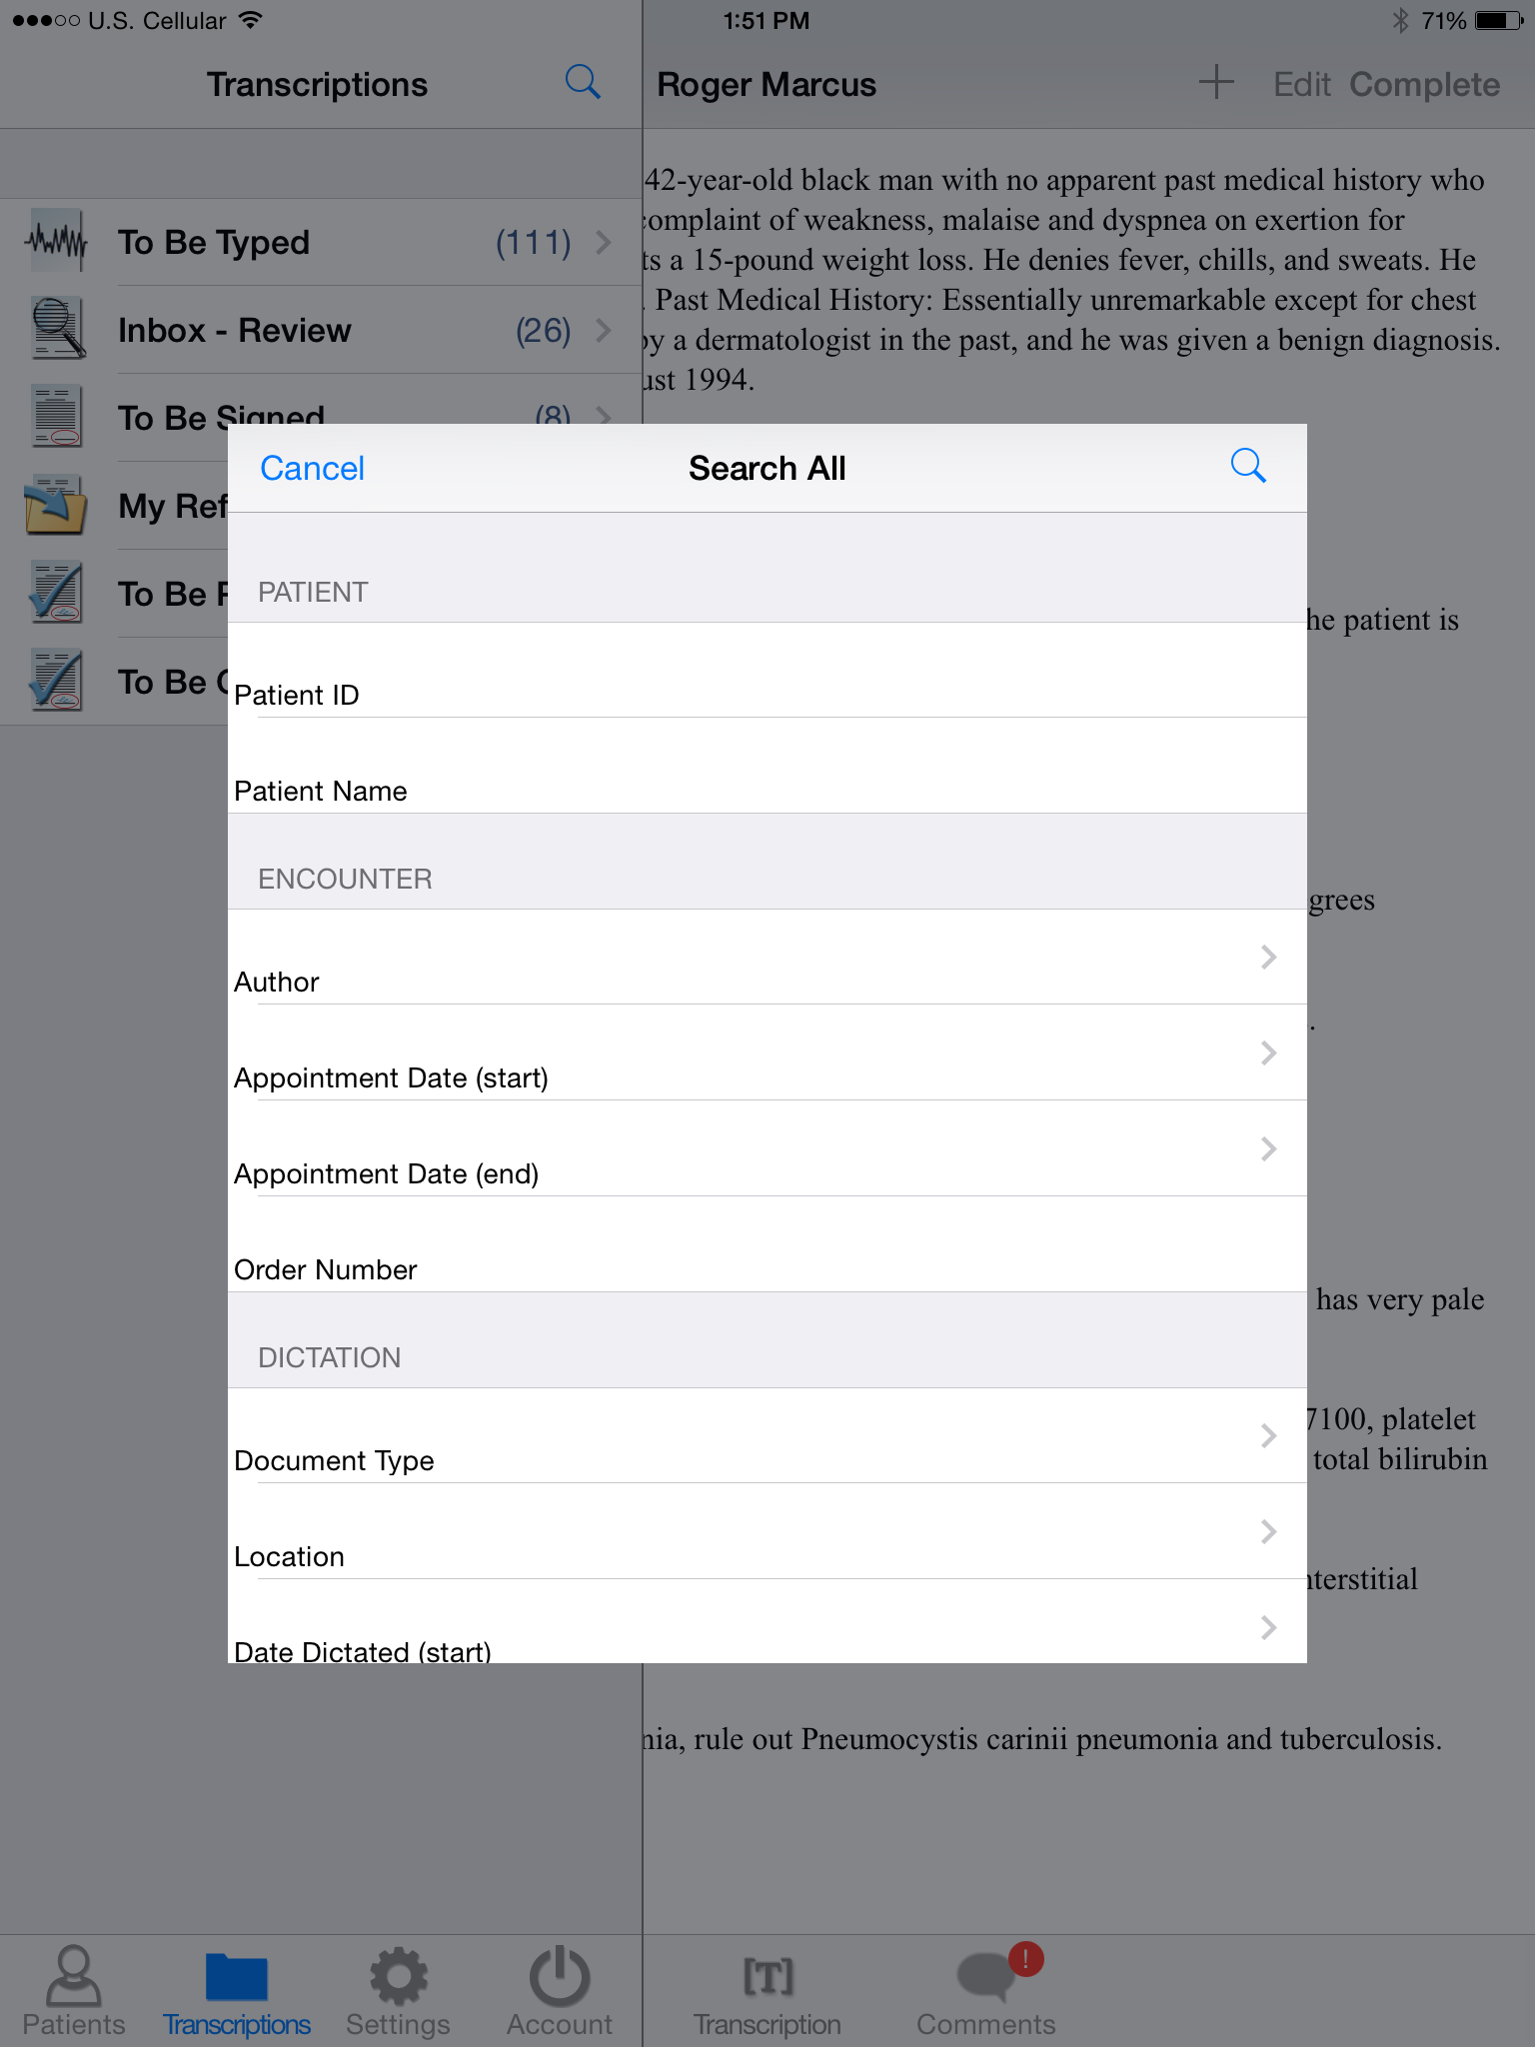
Tap the search button on the upper right of the navigation bar to search for transcriptions. This will bring up a search window. If done from Transcriptions, it will search all transcriptions. If done from a folder, like the Preliminary Folder, it will search in that folder. The title at the top of the search window will say “Search All” if searching from the Transcriptions screen and “Search” if done from a specific folder.

Search criteria can be entered into one or more of the fields shown. The labels for these fields can be different from those shown to the right, and should match terms used at your facility.

Tap on the icon at the upper right of the search window to execute the search. The search results will then be displayed in a navigation bar to the left of the iPad screen.

The icons next to the Search Results will indicate which workflow folder that dictation is in. The icons are:

- Dictation – This is a dictation that is still being transcribed by a transcriptionist.

- Review – This is a transcription that is in the Review folder of the workflow.

- Preliminary – This is a transcription that is in the Preliminary folder of the workflow, and can be electronically signed.

- Final – This transcription is in one of the Final/Print folders at the end of the workflow.

- Referral – This transcription is in the Referral folder; a folder for Emdat clients at other facilities to view dictations as associates.

- Archive – This transcription has been moved through the entire workflow, and is now archived.

Editing Transcribed Dictations
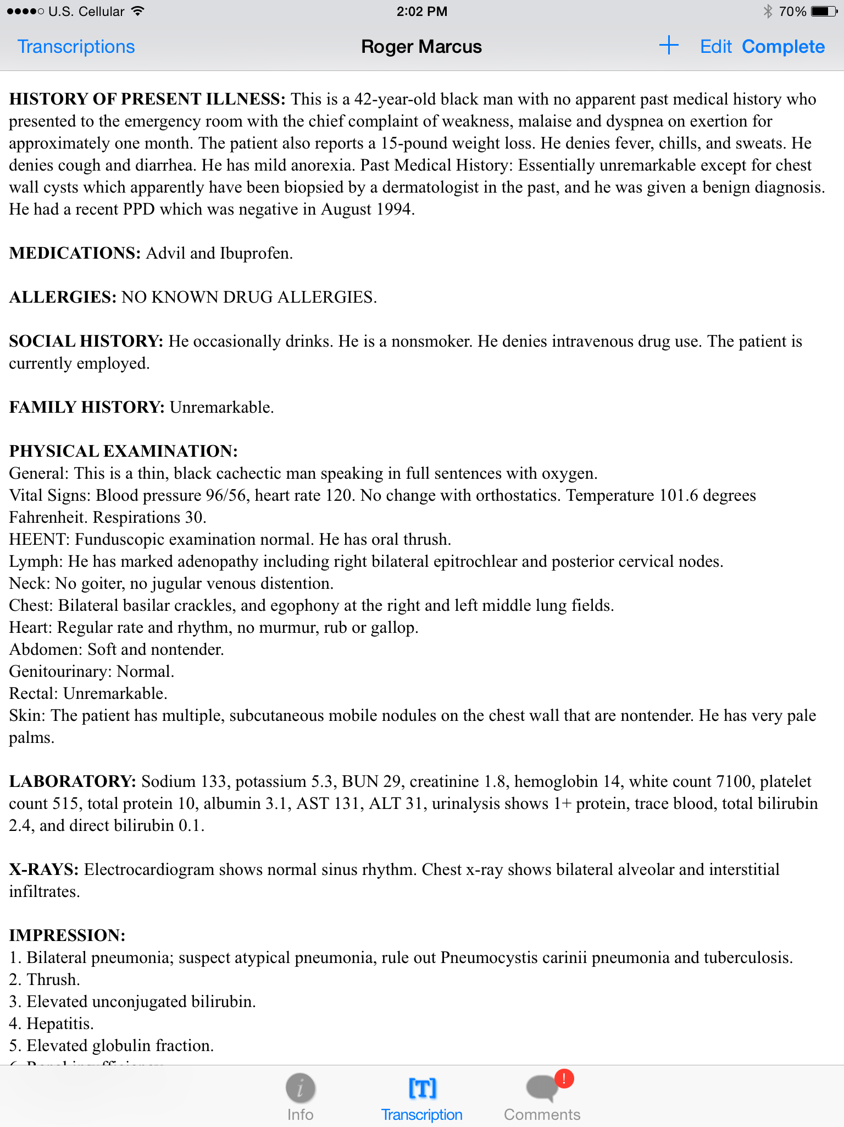
Once a dictation has been transcribed, it can be viewed, edited, and moved through the workflow from the Transcriptions part of the navigation bar. To open an item, tap on the dictation and the transcription viewer will open.

From this viewer, the transcription can be completed to the next step in the work flow, the text of the transcription can be edited, and comments and demographic information can be viewed. Comments cannot be edited.

When in edit mode, the bar at the top of the screen will turn red.

The Settings Screen
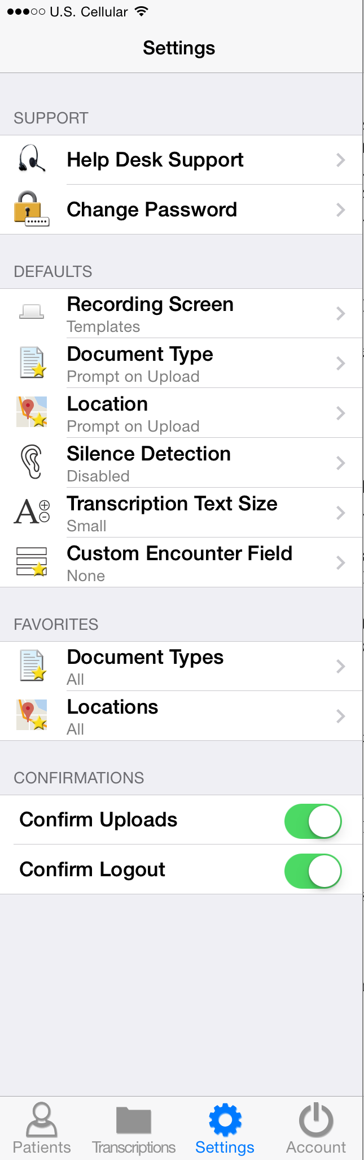
The settings screen is where the default settings for the Emdat Mobile Application can be changed. When new documents are created, the application can be set to start them with a default document type and location. Silence Detection when dictating is set under options, as is which screen loads when dictating.

The Recording Screen setting determines which screen (Templates, Info, or History) appears first when opening an appointment to dictate. The default is Info.

The Document Type and Location settings will set one document type or location as default for all new dictations. If the previous default setting was “None” or this is the first time using Emdat Mobile, the default setting is to prompt the user to choose a document type or location every time a dictation without one chosen is completed and uploaded.

Silence Detection will stop recording a dictation after a certain period of silence from the dictator. The default setting for is for silence detection is “disabled”.

Transcription Text Size adjusts the size of text when viewing and editing transcribed dictations.

Custom Encounter field selects which custom field is displayed to the right of the patient name on the appointment listing.

The Favorites setting for Document Types and Locations will allow a user to limit the list of items to choose from. If, for example, a user’s facility has fifty locations, but the user only goes to three of them, the Favorites – Locations setting can be used to show only those three locations when choosing an appointment’s location.

Confirm Uploads and Confirm Logout will turn on or off a confirmation prompt when uploading dictations, or logging out of the application.

Account Screen for iPad
Logout from the application by tapping the Account button located in the lower right hand corner of the application screen and pressing the logout button in the upper left corner, or by pressing the Home button at any time.

Users who want to quickly switch between different logins can add linked accounts by pressing the button in the upper right corner of the Accounts screen. Then enter the login credentials and select login.

Unwanted accounts can be removed by swiping the account name from right to left and pressing the delete button that appears.
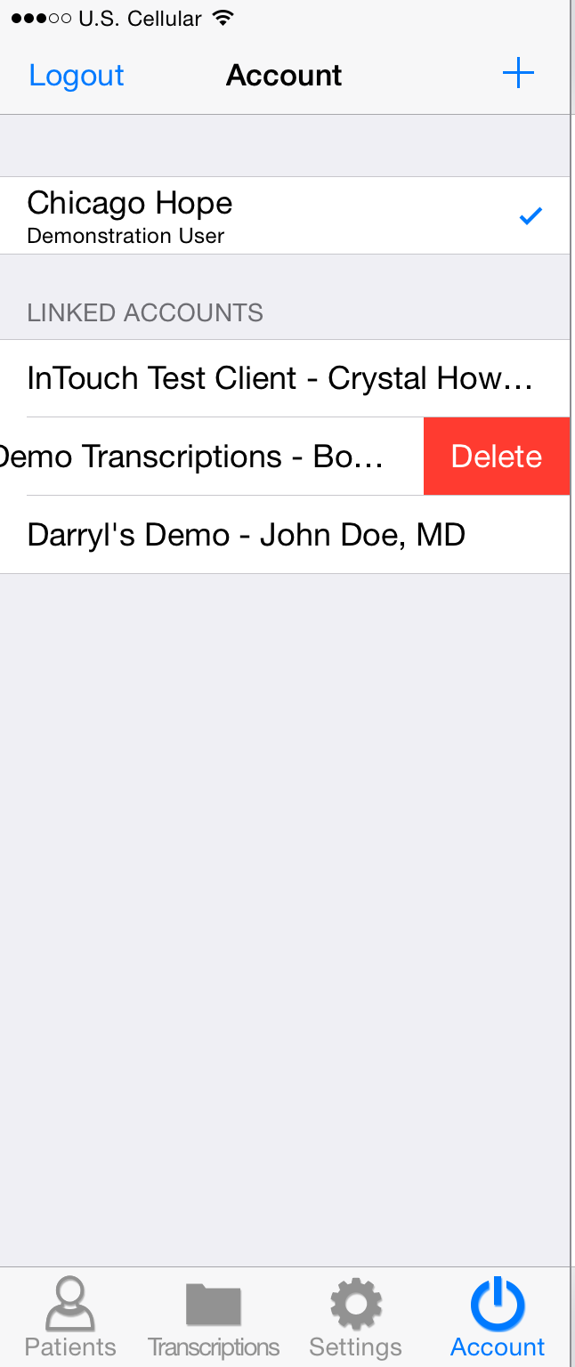
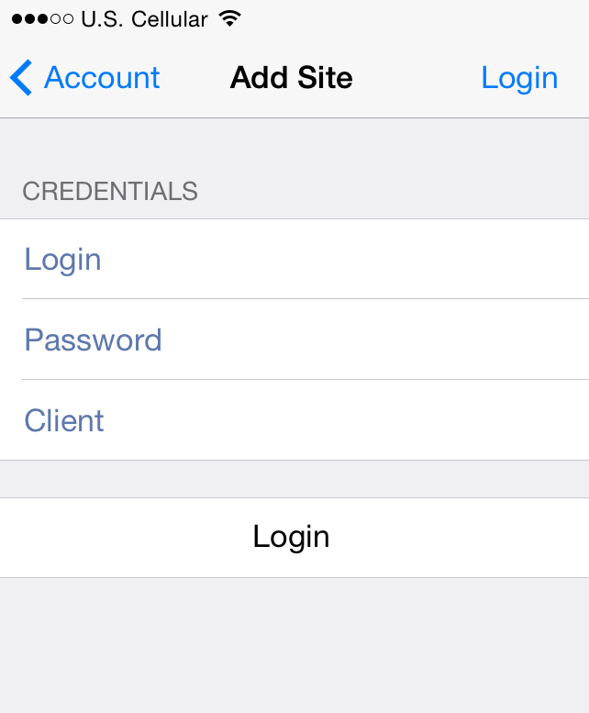

Troubleshooting and FAQ
Q: My dictations get interrupted when I receive a phone call on my iPhone, how do I stop this from happening?

A: By design, Apple does not allow our application to block incoming phone calls while you are dictating. You will not lose any work if a phone call comes in while dictating. When the Accept/Message/Reject screen pops up, recording will pause. You will be returned to the record screen upon ending or rejecting the phone call. You can then resume dictating by pressing the Record button.
If you have concerns about incoming phone calls while dictating, you can switch you phone to “Airplane Mode” or “Do Not Disturb.” This can be done by going back to the home screen, tapping on the Settings icon, and switching modes; it is the first option in the list when you go into phone settings.
Q: My appointments are gone, or are not appearing as they should.

A: There are two common causes of this problem. The most frequent is that the filter view has been changed. Please see page 5 for filtering information. There could also be an issue with the way appointments have been uploaded to our system from your facility’s scheduling software or EHR. Please call our Help Desk at 608-270-6400 x 1 to help resolve this issue.
Q: My application has not been updated. How do I update Emdat Mobile?

A: Apple devices do not support automatic updates. To update apps on an Apple device go to the Apple Store. If there are updates available it will open to the Updates tab, and updates can be manually applied there.
Q: How is my data protected in the app?

A: All data that is stored on the device is protected by Apple’s AES 256-bit crypto engine. Additionally, all of the data that is transferred over the Internet is encrypted by a TLS connection, the same protection that banks use to give you safe and secure access to your accounts. Both of these mechanisms ensure that data-at-rest and data-in-motion are always secure when you use Emdat Mobile.
The encryption keys are derived from the passcode that you set to lock your device, therefore using an alpha-numeric password is much more secure than a four digit PIN.

Inpatient
This optional feature is active only if requested by the Client, and is not available for all users.

The inpatient workflow is an alternative scheduling method where, instead of listing patients based upon appointment, patients are listed based upon inpatient encounters.

For example a physician is working on the Critical Care ward of his hospital and is required to make regular rounds to all of the patients that are admitted to Critical Care. The inpatient workflow allows the physician to easily track which patients are on his ward and if he has dictated on them today, or he still needs to visit them. Inpatient also allows the physician to clear his schedule manually when he needs to see patients more frequently.

To switch between the standard appointment screen and the inpatient feature use the toggle at the bottom of the patient tab.

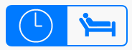
- Highlight the clock for appointment mode.

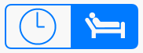
- Highlight the bed for Inpatient mode.

Inpatient encounters can be sorted by Author Groups and by Location. To change views between Author Groups and Location select the Filter button.
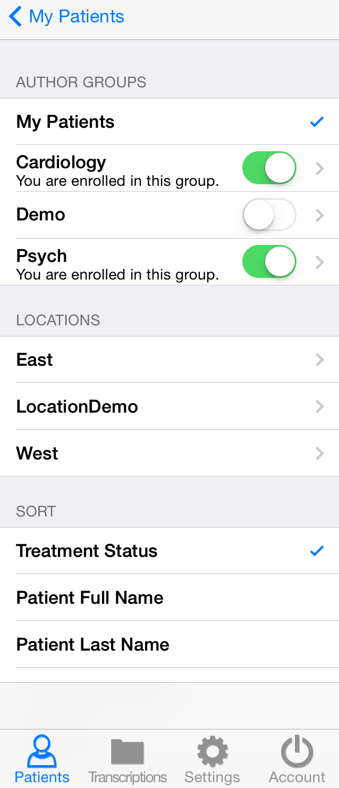
- My Patients will display all patient encounters linked to the default schedule resource of the logged-in user. This is the default view in inpatient mode.

- Author Groups are used to group patients based on the schedule resource. Users can be enrolled in multiple Author Groups. Select an Author group to view all patients for all users enrolled in this group. You do not have be enrolled a group to view the patients. To view an Author Group tap on the group name. Enrolling in a group will allow other users to view your patients. To enroll in a group tap the toggle button and it will appear green; to disenroll tap the toggle button again and it will appear white.

- Use Locations to show all inpatient encounters based on the location resource regardless of the associated schedule resource.

- The Sort filter will order the patient encounters by Treatment Status (marked as Treated or not), Patient Full Name, Patient First Name, Patient Last Name, or Admit Date.

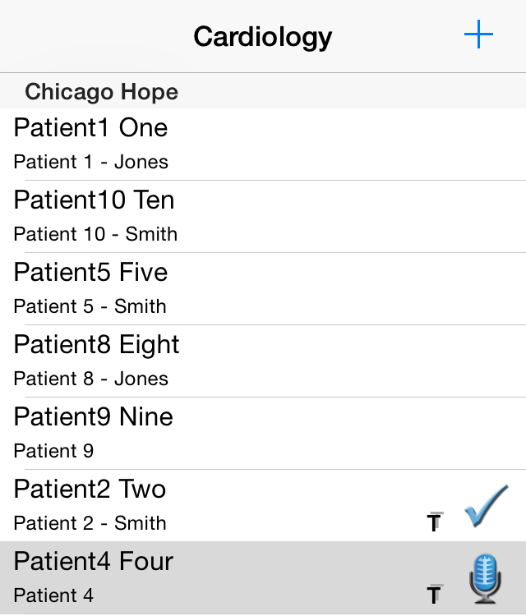
Patients who have received treatment are marked with this icon . This indicates that a dictation has been started for this patient or the patient has been marked as Treated. The checkmark still indicates a completed dictation, the microphone indicates a dictation on hold.

Patients can be marked as Treated without dictating by selecting the Set Treatment Status option within the options menu in the patient encounter details. Patients can also be removed from a work list by choosing Remove from my work list.

Patients can be added to a work list by pressing the Add button and searching for a patient with an existing inpatient encounter record.

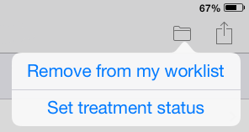

Note: The Cloud Icon is not used with inpatient encounters.

To remove the Treatment Status icon from all patients press this button.

Treatment Status can be removed from a single patient by selecting the appointment, selecting the options button in the top right and Clear Treatment Status
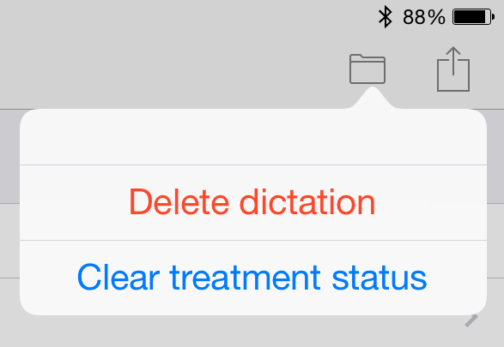

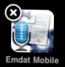
Removing Emdat Mobile
To uninstall Emdat Mobile, simple exit the application and press and hold the Emdat Mobile icon. The icon should display an “X” on the top left corner. Click the “X” icon to be prompted to uninstall the application.

Support
We offer the following support options in the event that you need further assistance with our applications:

- Help Desk Request: http://www.emdat.com/ticket

- Phone Support - (608) 270-6400 ext. 1 (Help Desk support is provided weekdays 7AM - 7PM CST)

