Emdat Mobile For Android Devices

Version 2.4.0



Table of Contents

[Introduction 3](#_Toc404339095)

[System Requirements 3](#_Toc404339096)

[1. Installing Emdat Mobile for Android Devices 4](#_Toc404339097)

[2. Starting Emdat Mobile for Android 4](#_Toc404339098)

[3. Using Emdat Mobile for Android 4](#_Toc404339099)

[4. The Patients Tab 5](#_Toc404339100)

[5. Dictating with Emdat Mobile for Android 7](#_Toc404339101)

[5.1 Dictations from Uploaded Appointments 7](#_Toc404339102)

[5.2 Creating a New Dictation 7](#_Toc404339103)

[5.3 The Templates Tab 8](#_Toc404339104)

[5.4 The Info Tab 8](#_Toc404339105)

[5.5 The History Tab 9](#_Toc404339106)

[5.6 The Recording Controls 10](#_Toc404339107)

[6. The Transcriptions Tab 11](#_Toc404339108)

[6.1 The Folder View 11](#_Toc404339109)

[6.2 Transcription Viewer 12](#_Toc404339110)

[6.3 Transcription Editor 13](#_Toc404339111)

[7. The Settings Tab 14](#_Toc404339112)

[8. Accounts 14](#_Toc404339113)

[9. Inpatient 15](#_Toc404339114)

[10. Updating Emdat Mobile 16](#_Toc404339115)

[11. Removing Emdat Mobile 16](#_Toc404339116)

[12. Frequently Asked Questions 18](#_Toc404339117)

[13. Additional Support 18](#_Toc404339118)

# Introduction

This is a reference for the Emdat Mobile for Android application. It describes the application, explains how to use it to record and upload dictations, and how to view and edit completed transcriptions.

This manual refers to using the application on mobile devices, which means any device running the Android operating system, such as tablets or phones.

# System Requirements

The Emdat Mobile for Android application requires version 2.1 or higher of the Android operating system. Tap on the Menu button when on the Home Screen, and then tap on the “Settings” item from that menu. Find and tap on the “About Phone” or “About Device” to confirm that the “Android Version” or “Firmware Version” listed is 2.1 or higher.

The device will need a connection to the Internet and a microphone. For best results, use a Wi-Fi connection to the Internet, and not a cellular service Internet connection.

## C:\Users\gmurie\Desktop\Android Screen Shots\Screenshot_2014-10-29-17-52-02.pngInstalling Emdat Mobile for Android Devices

Start the Play Store to install the Emdat Mobile for Android Application.



From the Play Store, search for “Emdat Mobile”.

Choose the Emdat Mobile application, and then tap on the Install button. Select the Accept and Download button to download and install the application.

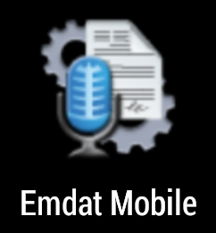

The Emdat Mobile icon will appear in the Application drawer when installation is complete.

## Starting Emdat Mobile for Android

***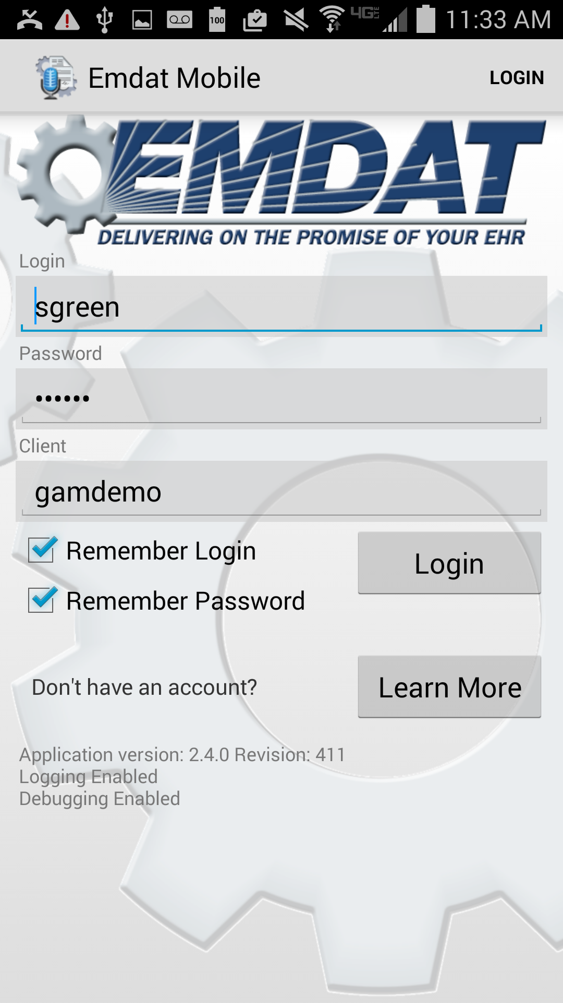***Start Emdat Mobile by tapping on the application’s icon, which will bring up the login screen. Use your InQuiry login credentials to log into Emdat Mobile. Both dictating users, and non-dictating staff, can log into Emdat Mobile.

**Login:** This is the same as the InQuiry user name.

**Password:** This is the same as the InQuiry password.

**Client:** The code used to identify your facility.

**Remember Login:** The Emdat Mobile application will remember the username, so it does not need to be re-entered.

**Remember Password:** When started, Emdat Mobile will remember the password. The medical facility must approve the use of this feature. Please note that with this option enabled, anyone with access to your device can access your Emdat account, and the confidential medical records in it.

## Using Emdat Mobile for Android

After logging in, the Emdat Mobile application will show the Patients tab. At the top of the screen, there will be three tabs: Patients, Transcriptions, and Settings. Uploaded patient appointments will appear here.

Tap the Menu button to access additional options on this or any other screen. If the device does not have a built-in menu button, the Menu icon will be found in the upper or lower right corner of the screen. The menu includes items such as Accounts and ways to change the appearance of the current tab. Tap on the Accounts menu item to log out of the application, or switch to a different account. Close the application by pressing the device’s home key. Emdat Mobile may not log out when the home key is pressed; the medical facility can approve the use of resuming sessions. This allows users to switch between applications without logging back in each time.

## C:\Users\gmurie\Desktop\Android Screen Shots\Screenshot_2014-10-30-12-27-08.pngThe Patients Tab

By default, this tab is “Patients”. The account administrator can change this label to something more appropriate to the client.

Use the Patients Tab to view a list of patient appointments and create dictations.

To create a dictation from an existing appointment, tap on the appointment to open the Recording screen.

To refresh the appointment listing, swipe the screen down, or tap the Refresh icon. refresh

To create a new appointment, tap on the New Dictation icon. plus

Tap the Earliest Started Dictation icon clockicon to open the calendar to the earliest date with a started dictation that has not yet uploaded.

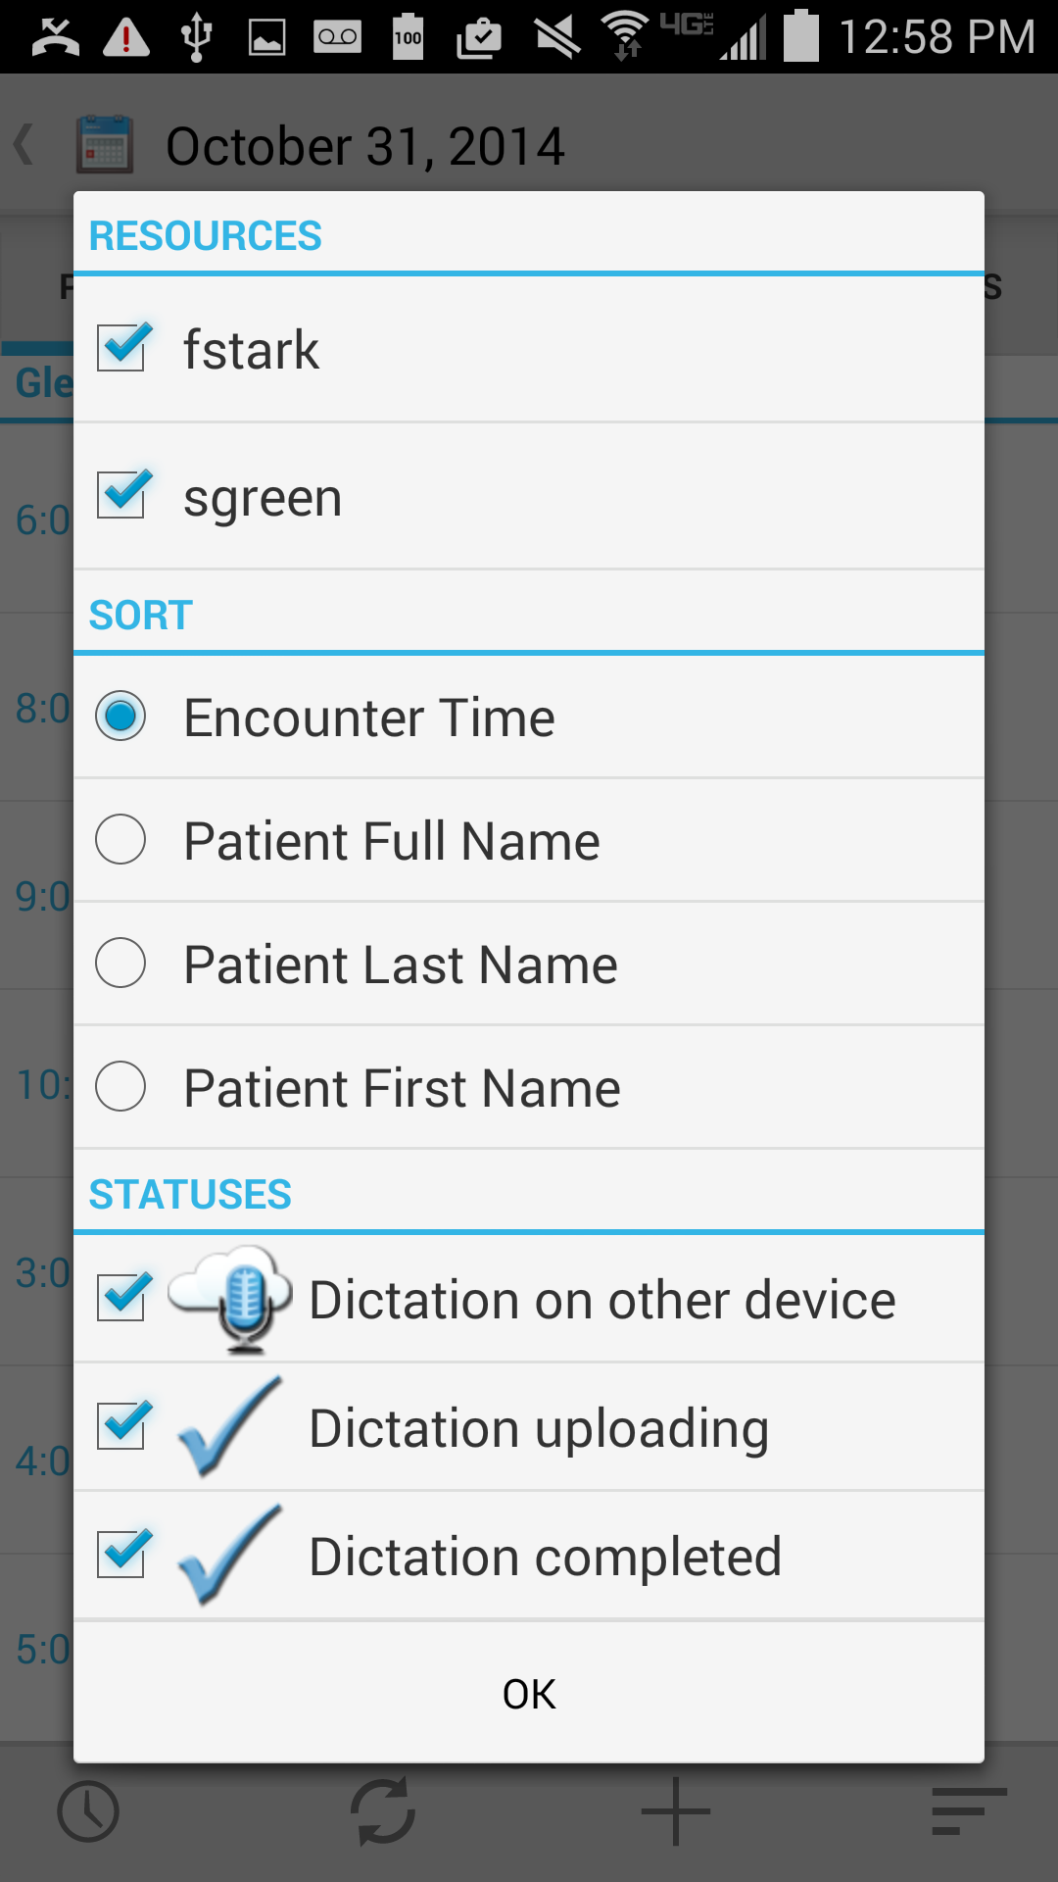Tap the Sort  icon to change the way the appointment list appears. Use this feature to change which appointments will appear by selecting resources or statuses, change how the app sorts appointments, or filter three statuses:

* Appointments with a dictation uploaded from a different device
* Appointments with an uploading dictation from this device
* Appointments with a completed dictation from this device

Tap the date in the upper left of the screen, or swipe the screen left or right, to change the current date.

Switch the appointment list between Day view and Agenda view by tapping on the Menu button while on the Patients tab, and then tap on either Day View or Agenda View. Day View will only list appointments for one day; Agenda View will list all appointments in chronological order.

An appointment without a dictation file will have no icon to its right. There are three icons:

 A different device created and uploaded the dictation, such as InTouch or InSync, another mobile device, or this android device created the dictation, and removed it to make room for new dictations.

The Emdat servers have received the dictation, and the audio file is still on the Android device. No changes can be made to a dictation after is has been uploaded.

The device has a recorded dictation for this appointment, but the Emdat servers have not received it. Emdat Mobile can make changes to a dictation until is it uploaded.

## Dictating with Emdat Mobile for Android

### Dictations from Uploaded Appointments

A list of appointments will appear on the Patients screen 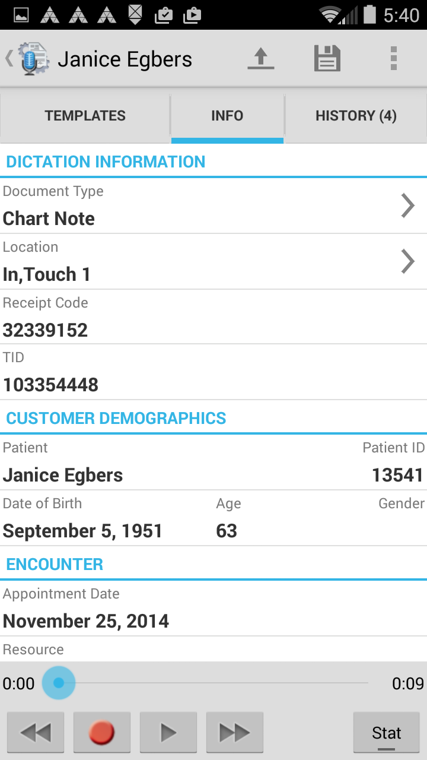if the facility sends patient appointment information to Emdat. Selecting one of these appointments will bring up the Recording screen.

This screen has three tabs: Templates, Info and History. See sections 5.3 – 5.5 below for more information about these tabs.

Use the Settings screen to set default document type and location, and to set a list of favorite document types and locations. Section 7 of this manual explains this.

### Creating a New Dictation

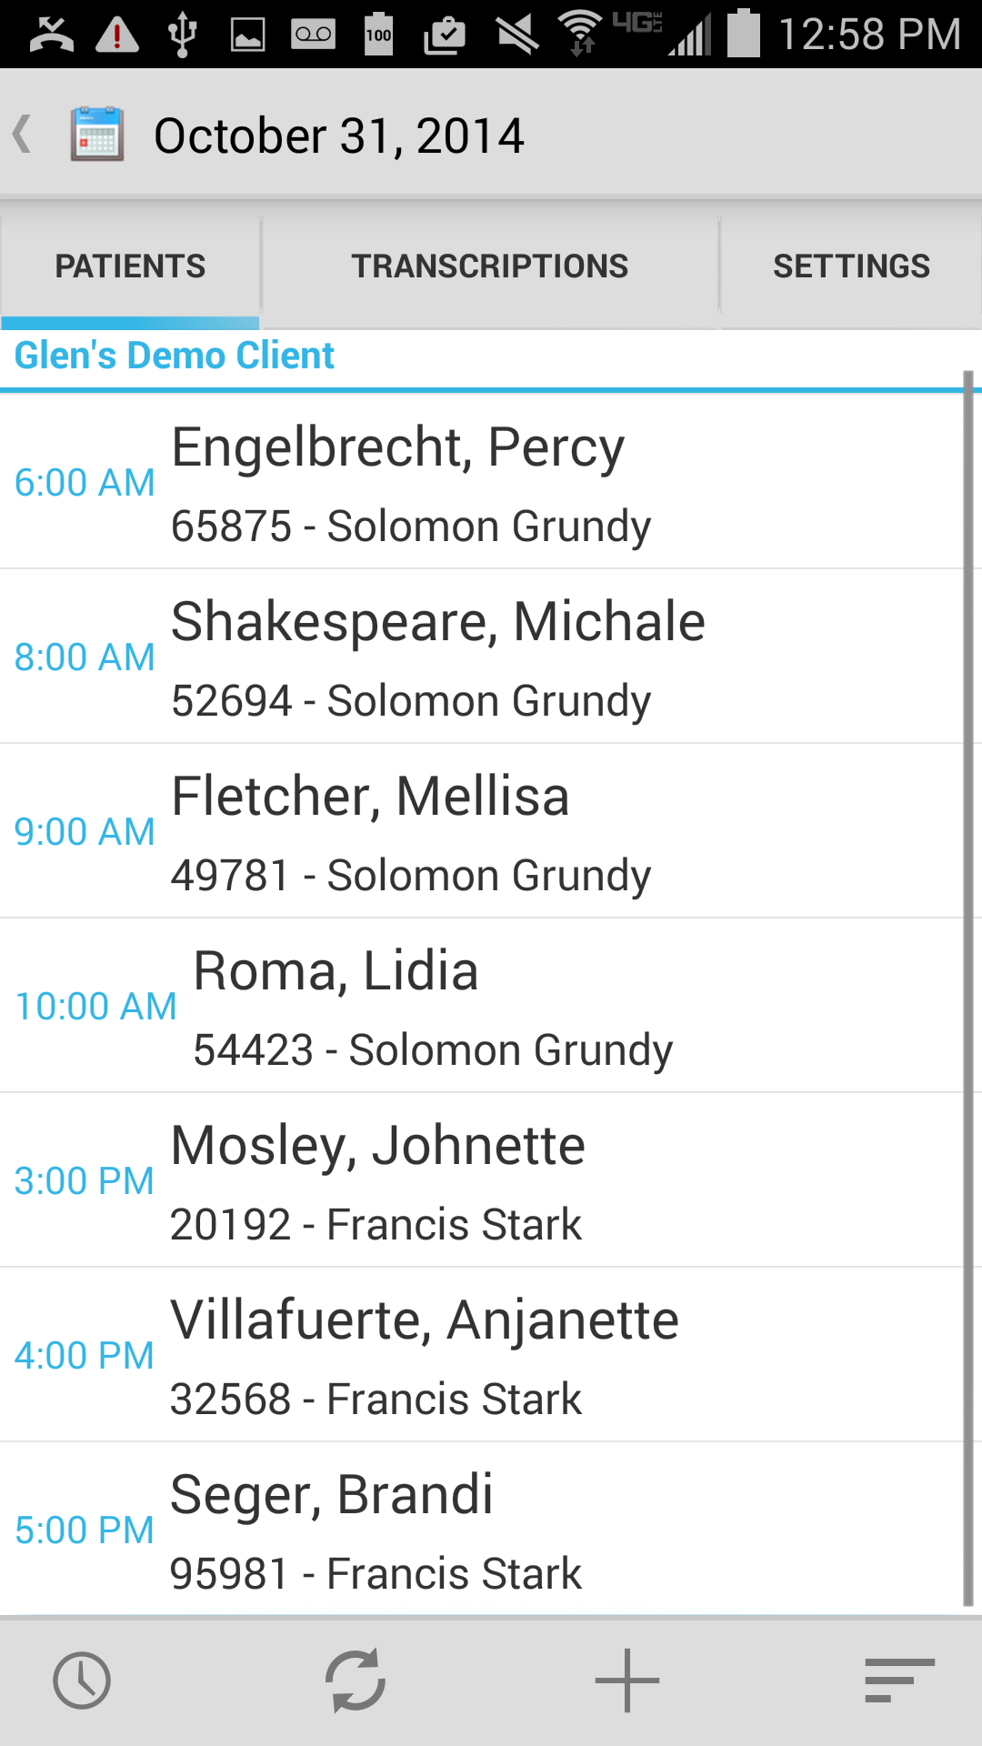Tap on the New Dictation button plus from the Patients tab to create a new dictation without an appointment. Tap on the Patient ID field to enter an MRN for the subject of this dictation. The History tab will populate with any prior transcriptions related to that patient. The Document Type and Location fields are also editable, and the Templates tab is available for reference.

### The Templates Tab

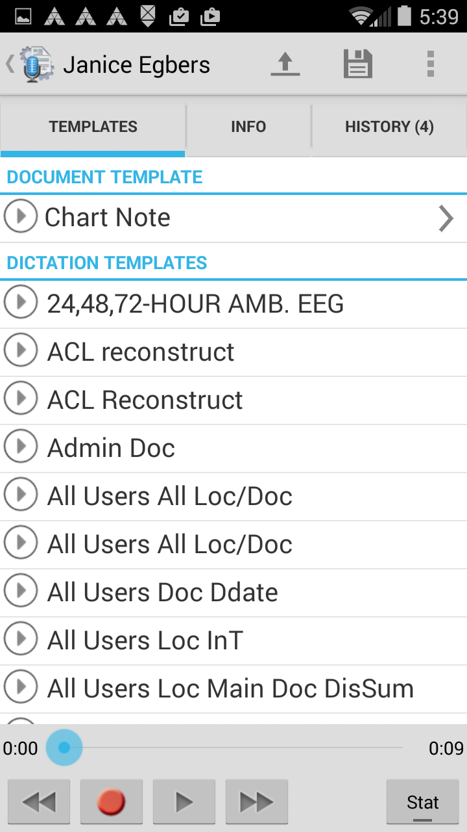The Templates tab displays Document and Dictation templates. To view the full text of a template, tap on the template name in the list. Select a document type to view its document template.

### The Info Tab

The Info tab contains information about this patient and appointment.

* Under DICTATION INFORMATION, the Document Type and Location fields are editable. Tap on the field and make a selection from the provided list to add or change the document type or location. Emdat Mobile highlights these fields in red when they are empty. Emdat Mobile fills in the Receipt Code and TID fields after uploading the dictation. The user cannot change the Receipt Code and TID fields.
* The PATIENT DEMOGRAPHICS section displays patient information. The user cannot edit these fields for an existing appointment, but the user can add a Patient ID to a New Dictation.
* The ENCOUNTER section displays any additional information about this appointment. The user can make changes to Appointment Date and Time for New dictations, but not for uploaded appointments.

### The History Tab

The History tab displays any existing transcriptions for this patient. These transcriptions are available for reference while dictating, but the user cannot edit transcriptions from this screen. The History tab will populate when the user adds a Patient ID to a new dictation.

### The Recording Controls

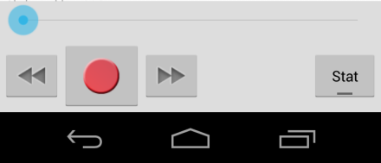The recording controls appear at the bottom of the screen for all three tabs: Templates, Info and History. There is a progress bar and three buttons for Rewind, Record and Fast Forward. After recording some dictation, Emdat Mobile shows a record button.

To the right of those controls is a button for marking this dictation STAT.

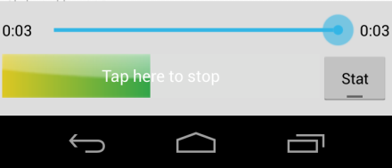The voice detection bar will appear while recording, showing the level of sound detected. Tap anywhere within the detection bar to stop recording. The STAT indicator can be turned on or off at any time prior to uploading the dictation.

The Upload button  sends a dictation in for transcription. Emdat Mobile cannot make changes to an uploaded dictation.

The Save button  is used to save a dictation; a saved dictation can be reopened and changed. Leaving dictations on the device for longer than three days without uploading will cause Emdat Mobile to display a reminder.

Tapping on the menu button will open a menu that provides three choices:

* **Cancel:** This will delete the dictation file. Emdat Mobile will give a warning screen to confirm removal of the dictation. An appointment from an uploaded schedule will remain on the Patients tab. Canceling a new dictation will remove the appointment.
* **Toggle Button Size:** This increases or decreases the size of the recording control buttons.
* 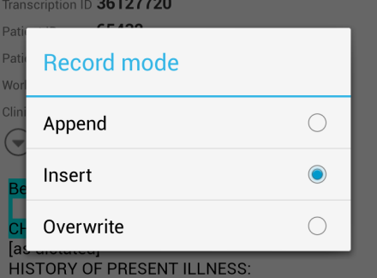**Record Mode:** Change the record mode from Append (the default) to Insert or Overwrite. Changing the record mode will cause the Record button to change to indicate the selected mode. Emdat Mobile will use the same record mode on all future dictations after this is changed.
  + Append Mode 
  + Insert Mode 
  + Overwrite Mode 

## The Transcriptions Tab

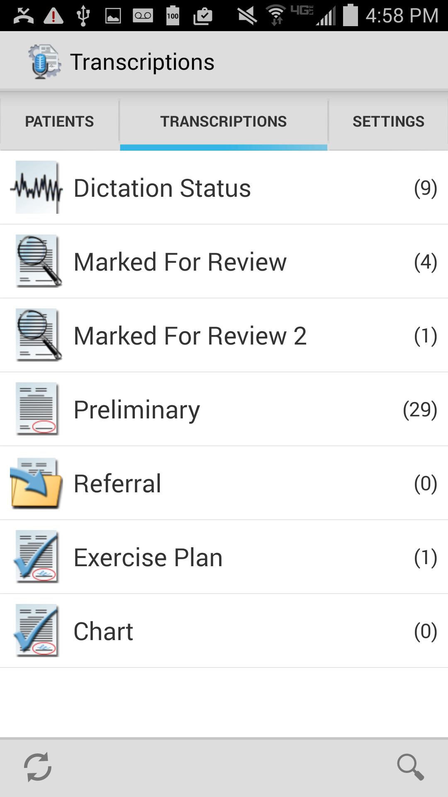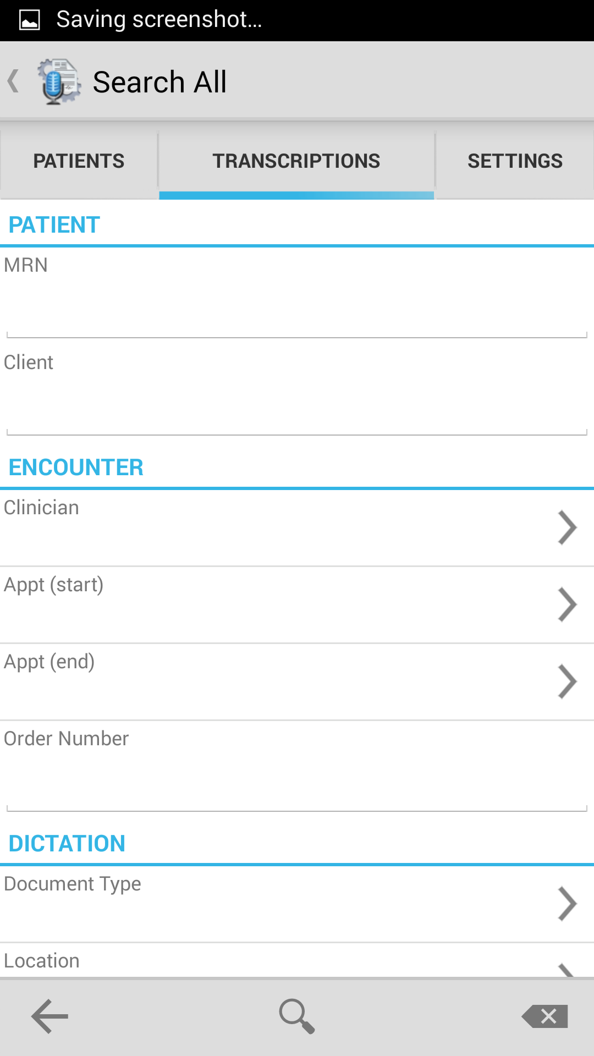This tab provides a view similar to the workflow summary in InQuiry. Use this tab to review, complete, or edit transcriptions.

Tap on a folder name to bring up a list of the dictations/transcriptions in that stage of the workflow. The “To Be Typed” folder contains dictations that are at the transcription company, but not transcribed.

Use the Search All  button on the lower right hand side of the Transcriptions to search for any dictation. In the Search All screen, select or type in the desired search parameters, and tap the Search  button at the bottom of the screen.

This will provide a list of results. Tap on an item from the list to view it.

### The Folder View

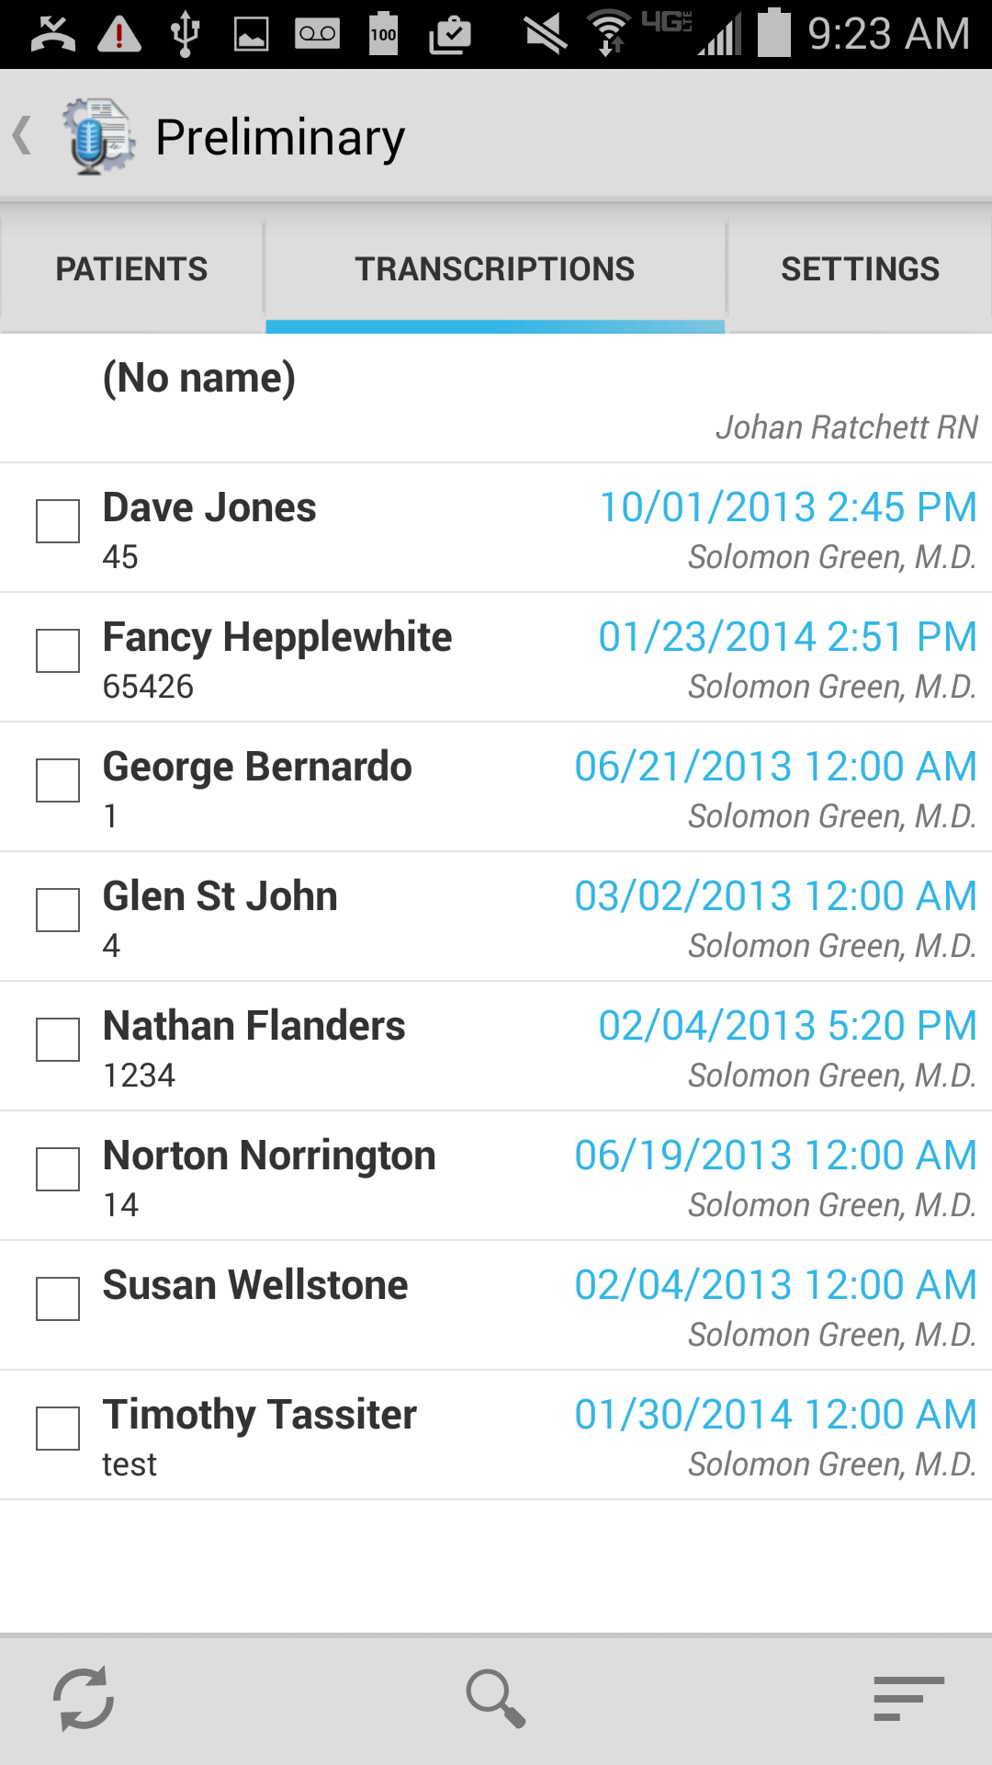Tap on a workflow folder to display the transcriptions in that stage of the InQuiry workflow. Emdat Mobile will show the Patient Name, Patient ID, Appointment Date and Time, and Dictating Clinician’s Name in the list of transcriptions. Use the Settings tab to add an additional data field (see Section 7). The app will display the workflow folder name at the top of the screen. To return to the summary list of all workflow folders tap on the name of the workflow folder.

The sort icon  opens a dialog to change the ordering of the transcriptions. The options are to sort by Patient Name, Appointment Date or Date Dictated.

The Menu button has options to Complete All and Complete Selected. To Complete Selected transcriptions, select one or more of them by tapping the checkbox to the left of the Patient Name.

The completion of a transcription cannot be undone. The Complete All option will be available to you based on settings for your user account. Emdat Mobile can give an additional prompt before completing the transcriptions, based on the user’s settings. See section 7 for more details.

Tap on the Transcription details line (not the checkbox) to open the transcription viewer.

### Transcription Viewer

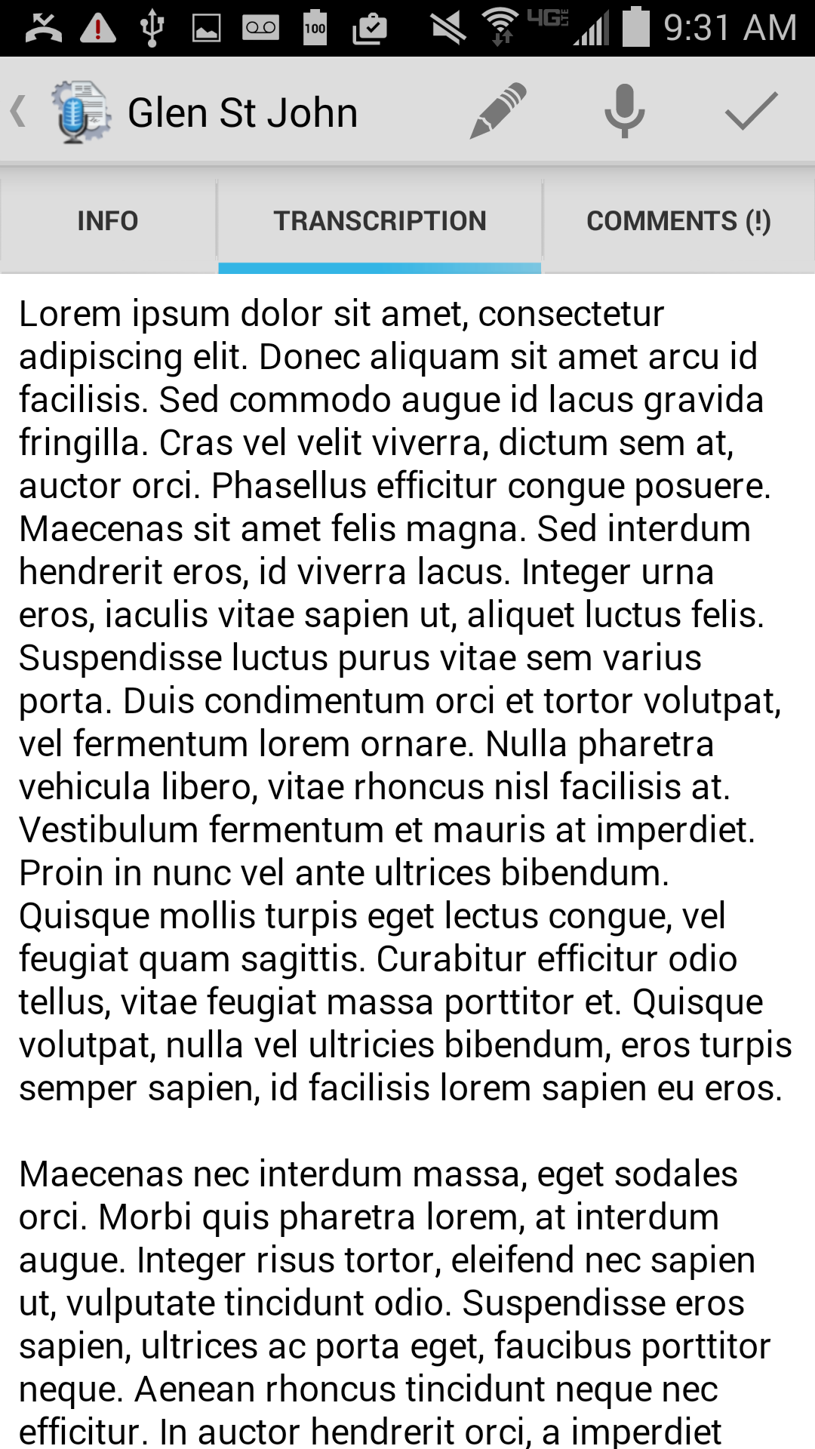Tap on a specific transcription to open the transcription viewer screen and review the transcription information and text. Emdat Mobile displays the Patient Name at the top of the screen; tap the Back arrow next to the name to return to the full folder listing.

The View screen has three tabs: Info, Transcription and Comments. The Info tab contains header information about the transcription; including Patient Demographics, Order Number, Document Type and Location, as well as Associates and any Signatures already on the file (signing the transcription causes the date signed to appear). The Transcription tab displays the text of the document. Emdat Mobile displays comments or comment tags that have been added to the transcription under the Comments tab.

Tap on the complete icon to complete the transcription. Unlike completion from the Workflow folder, Emdat Mobile may **not** provide a prompt asking the user to verify this action, depending on the user’s settings within the mobile app (see section 7). Completing a document cannot be undone.

Tap on the Edit icon to open the Transcription Editor from any of the three tabs in the Transcription Viewer.

Tap on the New Dictation icon to start a new dictation with the same demographic information as the original document. When Emdat Mobile uploads the new dictation, it will ask if it should append or prepended to the original dictation, or if it should create a new unlinked dictation.

### Transcription Editor

The title bar turns red when the editor is active. Use the Save button  to save changes to the document and close the editor. Tapping the Complete  button while editing a transcription will save changes and complete the job from the workflow older. Tapping the Back button  while editing will allow the user to cancel changes made.

Edit the body of the transcription from the Transcription tab by tapping on the section of the transcription text. Emdat Mobile will provide an additional menu at the bottom of the editing pane with four buttons. The arrows  will jump the editor to the prior or next section of text to continue editing. The Undo  button will undo the last change, and the Done  button will change the view back to the full text of the transcription.

Use the Info tab to change demographic information about this transcription. All fields with a bracket are editable.

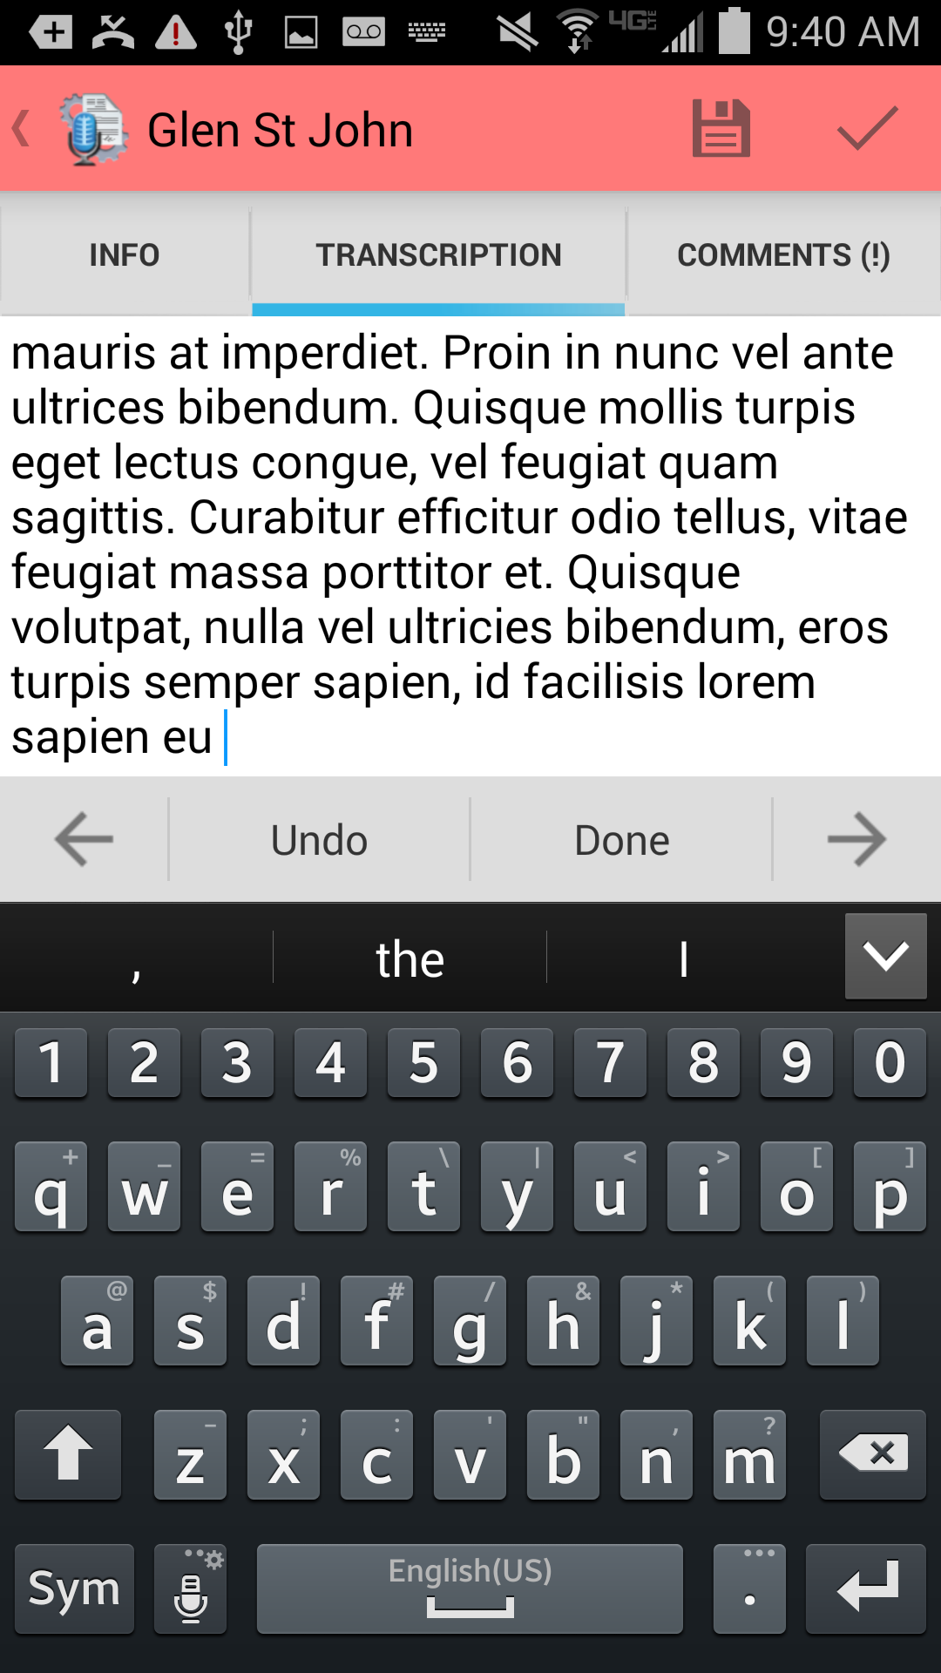 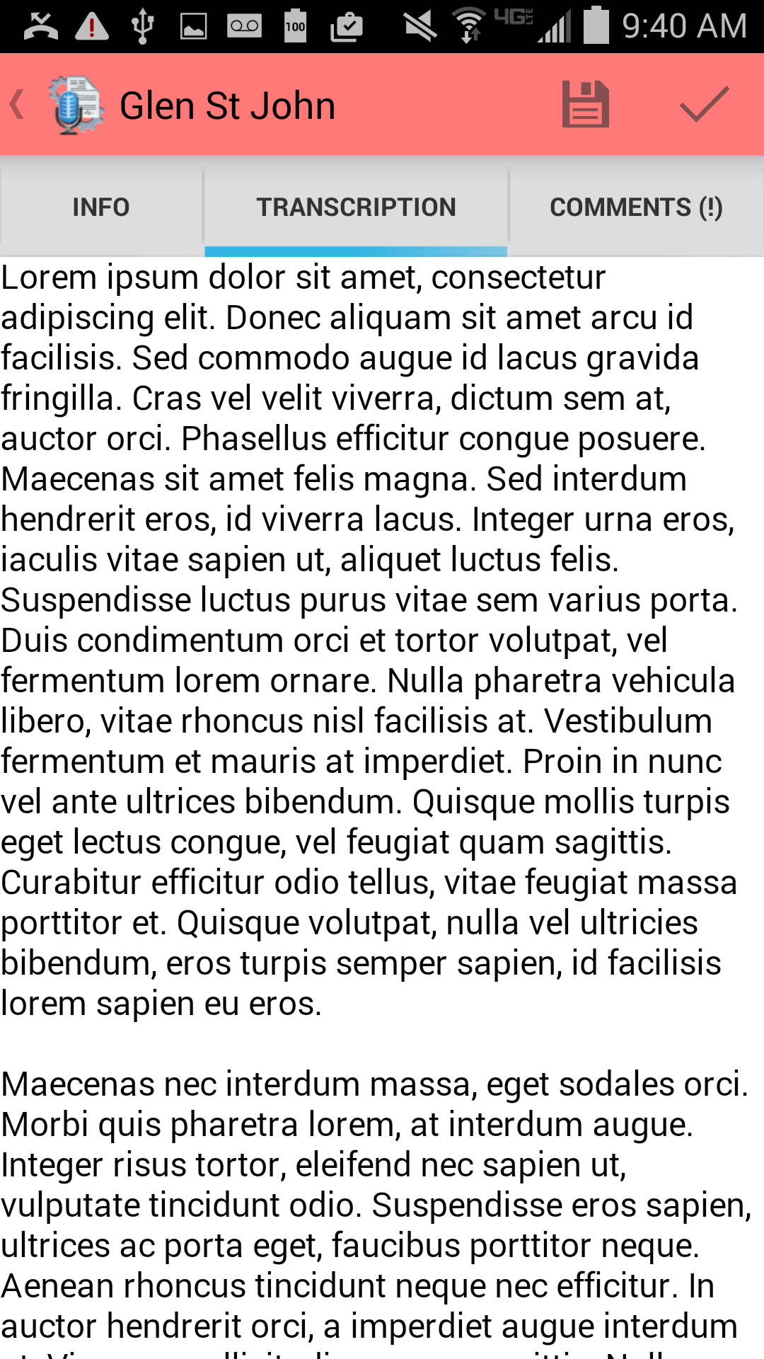Emdat Mobile cannot edit items in the Comments tab.

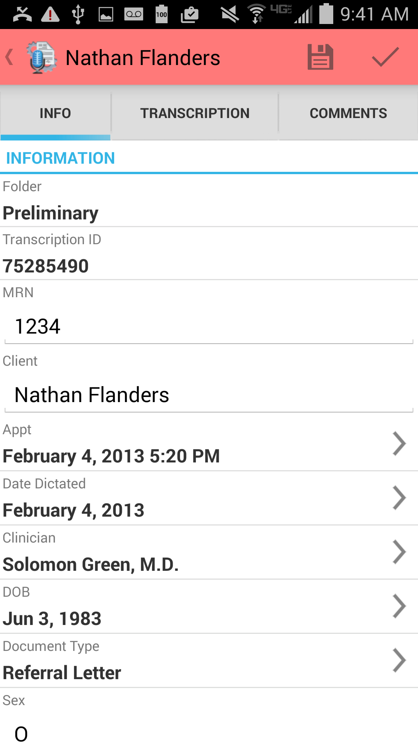

## The Settings Tab

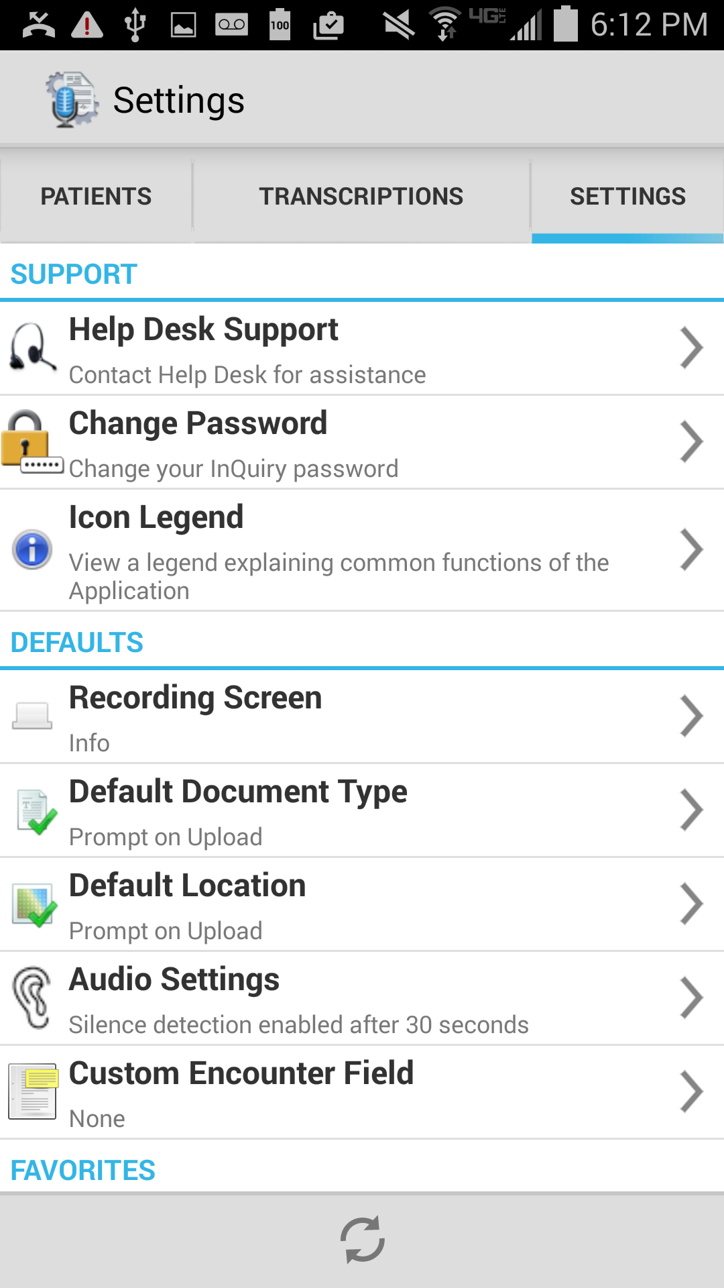Use the Settings tab to set default screens and behavior for the Emdat Mobile application, and access the Help pages for the application.

* **SUPPORT:** Contains a shortcut to the Help screen.
  + **Help Desk Support:** Includes instructions for accessing Emdat support staff by phone or email, and a feature to upload information to Emdat.
  + **Change Password**: Change the account password.
  + **Icon Legend:** View a legend explaining common functions of the application.
* **DEFAULTS:** Set default behavior for various aspects of the Emdat Mobile application.
  + **Recording Screen:** Select which tab opens by default when recording a dictation: Templates, Info, or History.
  + **Default Document Type:** Select a document type to set as default for all new dictations. This setting will not override Document Type information already attached to the appointment record.
  + **Default Location:** Select a location to set as default for all new dictations. This setting will not override Location information already attached to the appointment record.
  + **Audio Settings:** Opens the Silence and Sound Detection settings. Follow the on-screen instructions to set these levels for your device, as well as customize the length of time Emdat Mobile will continue to record silence.
  + **Custom Encounter Field:** Use to set a custom field to show next to appointments in the Patients tab.
* **FAVORITES:** This section allows you to set up Favorites lists for Document Types and Locations. If your facility has several documents types and locations and you typically dictate for only a small number of them, you can select which document types and locations will initially display in your Locations list.
* **CONFIRMATIONS:** Enable or disable prompts to confirm Upload and Logout actions.

## Accounts

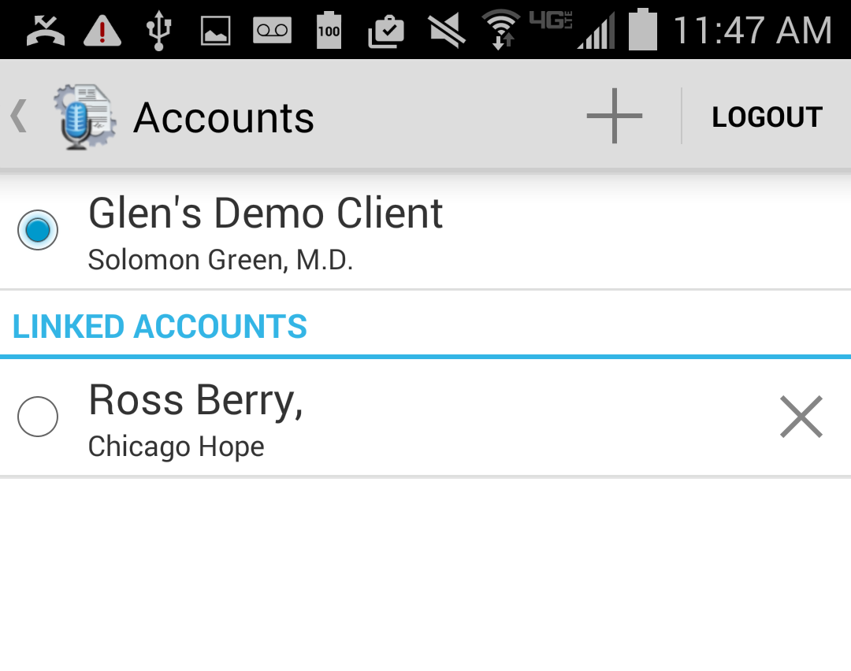Emdat Mobile can access accounts with multiple medical facilities at once with. To log in and out of these accounts tap on the Android device’s menu button and tap on Accounts to go to the Accounts screen. This screen will list all Linked accounts and allows the user to log out.

Tap on the + button to add an account. Emdat Mobile will be prompt for login information. Tap on the linked account to login as that user; login credentials are not required to switch to a linked account. The blue circle indicates the current logged-in account. Tap the X to the right of the linked account to remove that linked account.

Tap on Logout to log out of the Emdat app entirely.

## Inpatient

This optional feature is active only if requested by the Client, and is not available for all users.

The inpatient workflow is an alternative scheduling method that lists patients based on inpatient encounters, instead of listing patients by appointment.

For example, a physician is required to make regular rounds to all patients admitted to Critical Care. The inpatient workflow allows the physician to easily track which patients are on his ward, and if he has dictated on them today, or he still needs to visit them. Inpatient also allows the physician to clear his schedule manually when he needs to see patients more frequently.

To switch between the standard appointment screen and the inpatient feature tap on the menu icon  on the lower right hand side of the patients screen and then tap on “Inpatient View.” To change back to the Appointments View tap on the menu icon on the lower right hand side of the screen and then tap on “Appointments View.”

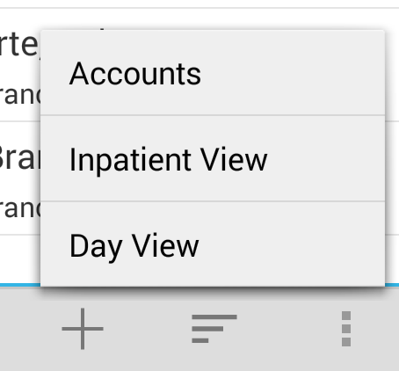 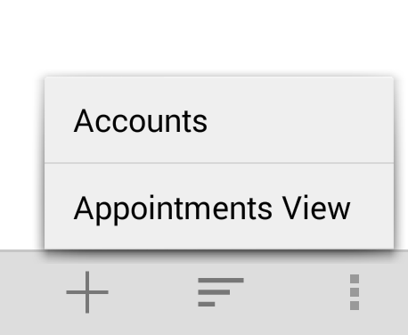

Emdat Mobile can list Inpatient encounters by Author Groups or by Location. To change views between Author Groups and Location tap on the Filter button. 

* 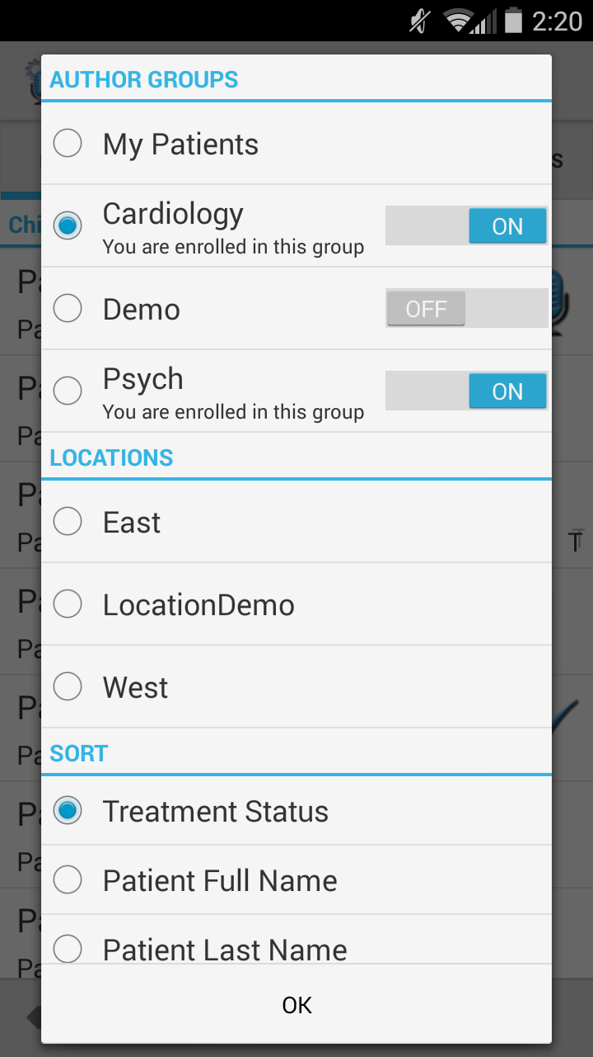My Patients will display all patient encounters linked to the default schedule resource of the logged-in user. This is the default view in inpatient mode.
* Use Author Groups to group patients based on the schedule resource. The account administrators can enroll users in multiple Author Groups. Select an Author group to view all patients for all users enrolled in this group. You do not have be enrolled in a group to view the patients. To view an Author Group tap on the group name. Enrolling in a group will allow other users to view your patients. Tap on the toggle button to enroll and disenroll.
* Use Locations to show all inpatient encounters based on the location resource regardless of the associated schedule resource.

The Sort filter will order the patient encounters by Treatment Status (marked as Treated or not), Patient Full Name, Patient First Name, Patient Last Name, or Admit Date.

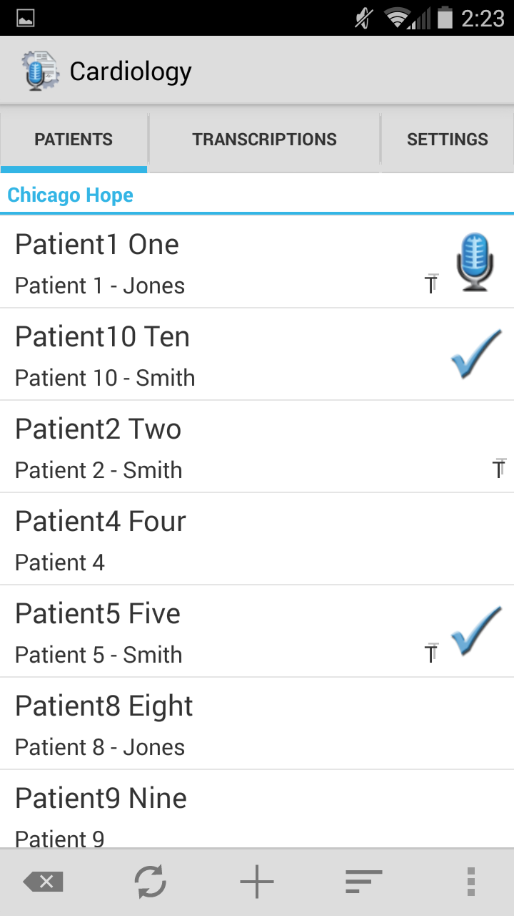Patients who have received treatment are marked with this icon. The checkmark still indicates a completed dictation; the microphone indicates a dictation on hold.

Add a patient to a work list by pressing the Add button plus and searching for a patient with an existing inpatient encounter record.

Patients are automatically marked as treated when a dictation has been started. Patients can also be manually marked as treated or not treated by using the Set Treatment Status option in the options menu. Remove patients from a work list by choosing Remove from my work list.

Patients can be added to a work list by pressing the Add button.

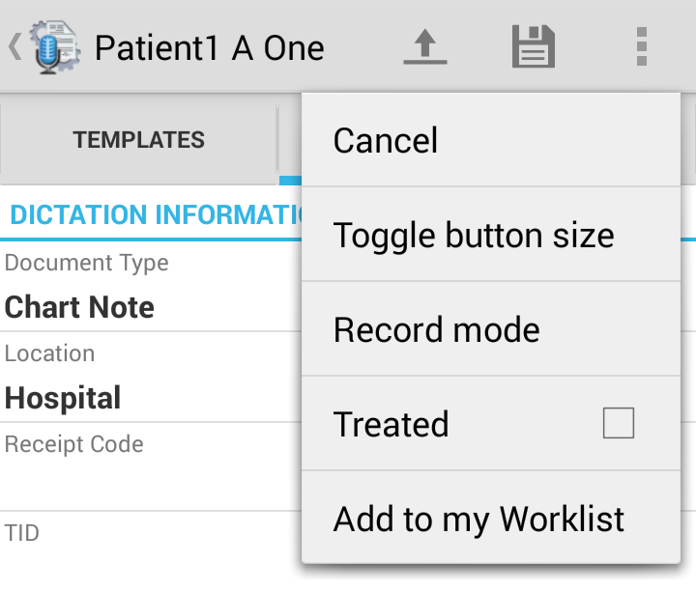 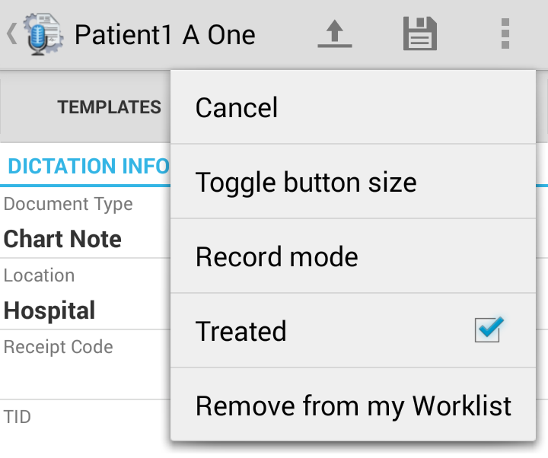

Note: Inpatient encounters do not use the Cloud Icon.

To remove the Treatment Status icon from all patients press this button.

## Updating Emdat Mobile

To update Emdat Mobile to the newest version open the Play Store application from your device. Select the Menu button, and then select My Apps. The Play Store will show a list of the applications on the device, and if those apps are up to date. If Emdat Mobile is in the list of applications that need updating, open it and then tap the Update button. If you would like the application to auto-update, mark the checkbox to allow automatic updating whenever a new version is available.

## Removing Emdat Mobile

Remove Emdat Mobile the same way as any other application on your Android device. From the Settings screen open your Applications list, choose the Emdat Mobile application and then select Uninstall.

## Frequently Asked Questions

**Q:** How do I find out what version of the Android OS is on my device?

**A:** To check the version of your Android OS go to the home screen for your device, and tap on the *Menu* button and select Settings. From the bottom of the Settings list choose About Device; the version of your device is under Android Version.

**Q:** How do I get a list of my appointments to show up on my device?

**A:** Your transcription company can do this manually, or we can set up an export from the software your facility uses for scheduling. ShadowLink, an Emdat application, can import information delivered to us by your facility into our system.

**Q:** How long is a dictation kept on the device that I have put on hold and not uploaded?

**A:** A held dictation will stay on the device until you complete it. There is no expiration on saved dictations.

**Q:** How long are the audio files saved on my device after I dictate and uploaded them?

**A:** Emdat Mobile keeps dictations for two weeks.

**Q:** My device stopped recording and is preventing me from making any more recordings. What is happening?

**A:** Your device does not have enough storage space to save the audio files. Remove files or programs from the device until there is enough memory to save additional dictations.

## Additional Support

Get additional assistance for the Emdat mobile application, and all other Emdat applications, here:

* Help Desk Request: [www.emdat.com/ticket](http://www.emdat.com/ticket)
* Phone Support – 608-270-6400 ext. 1 (Help Desk support is provided weekdays 7AM - 7PM CST)